**OBJECT AND FACE RECOGNITION**

**Approaches to object recognition (continued…)**

Chapter 3

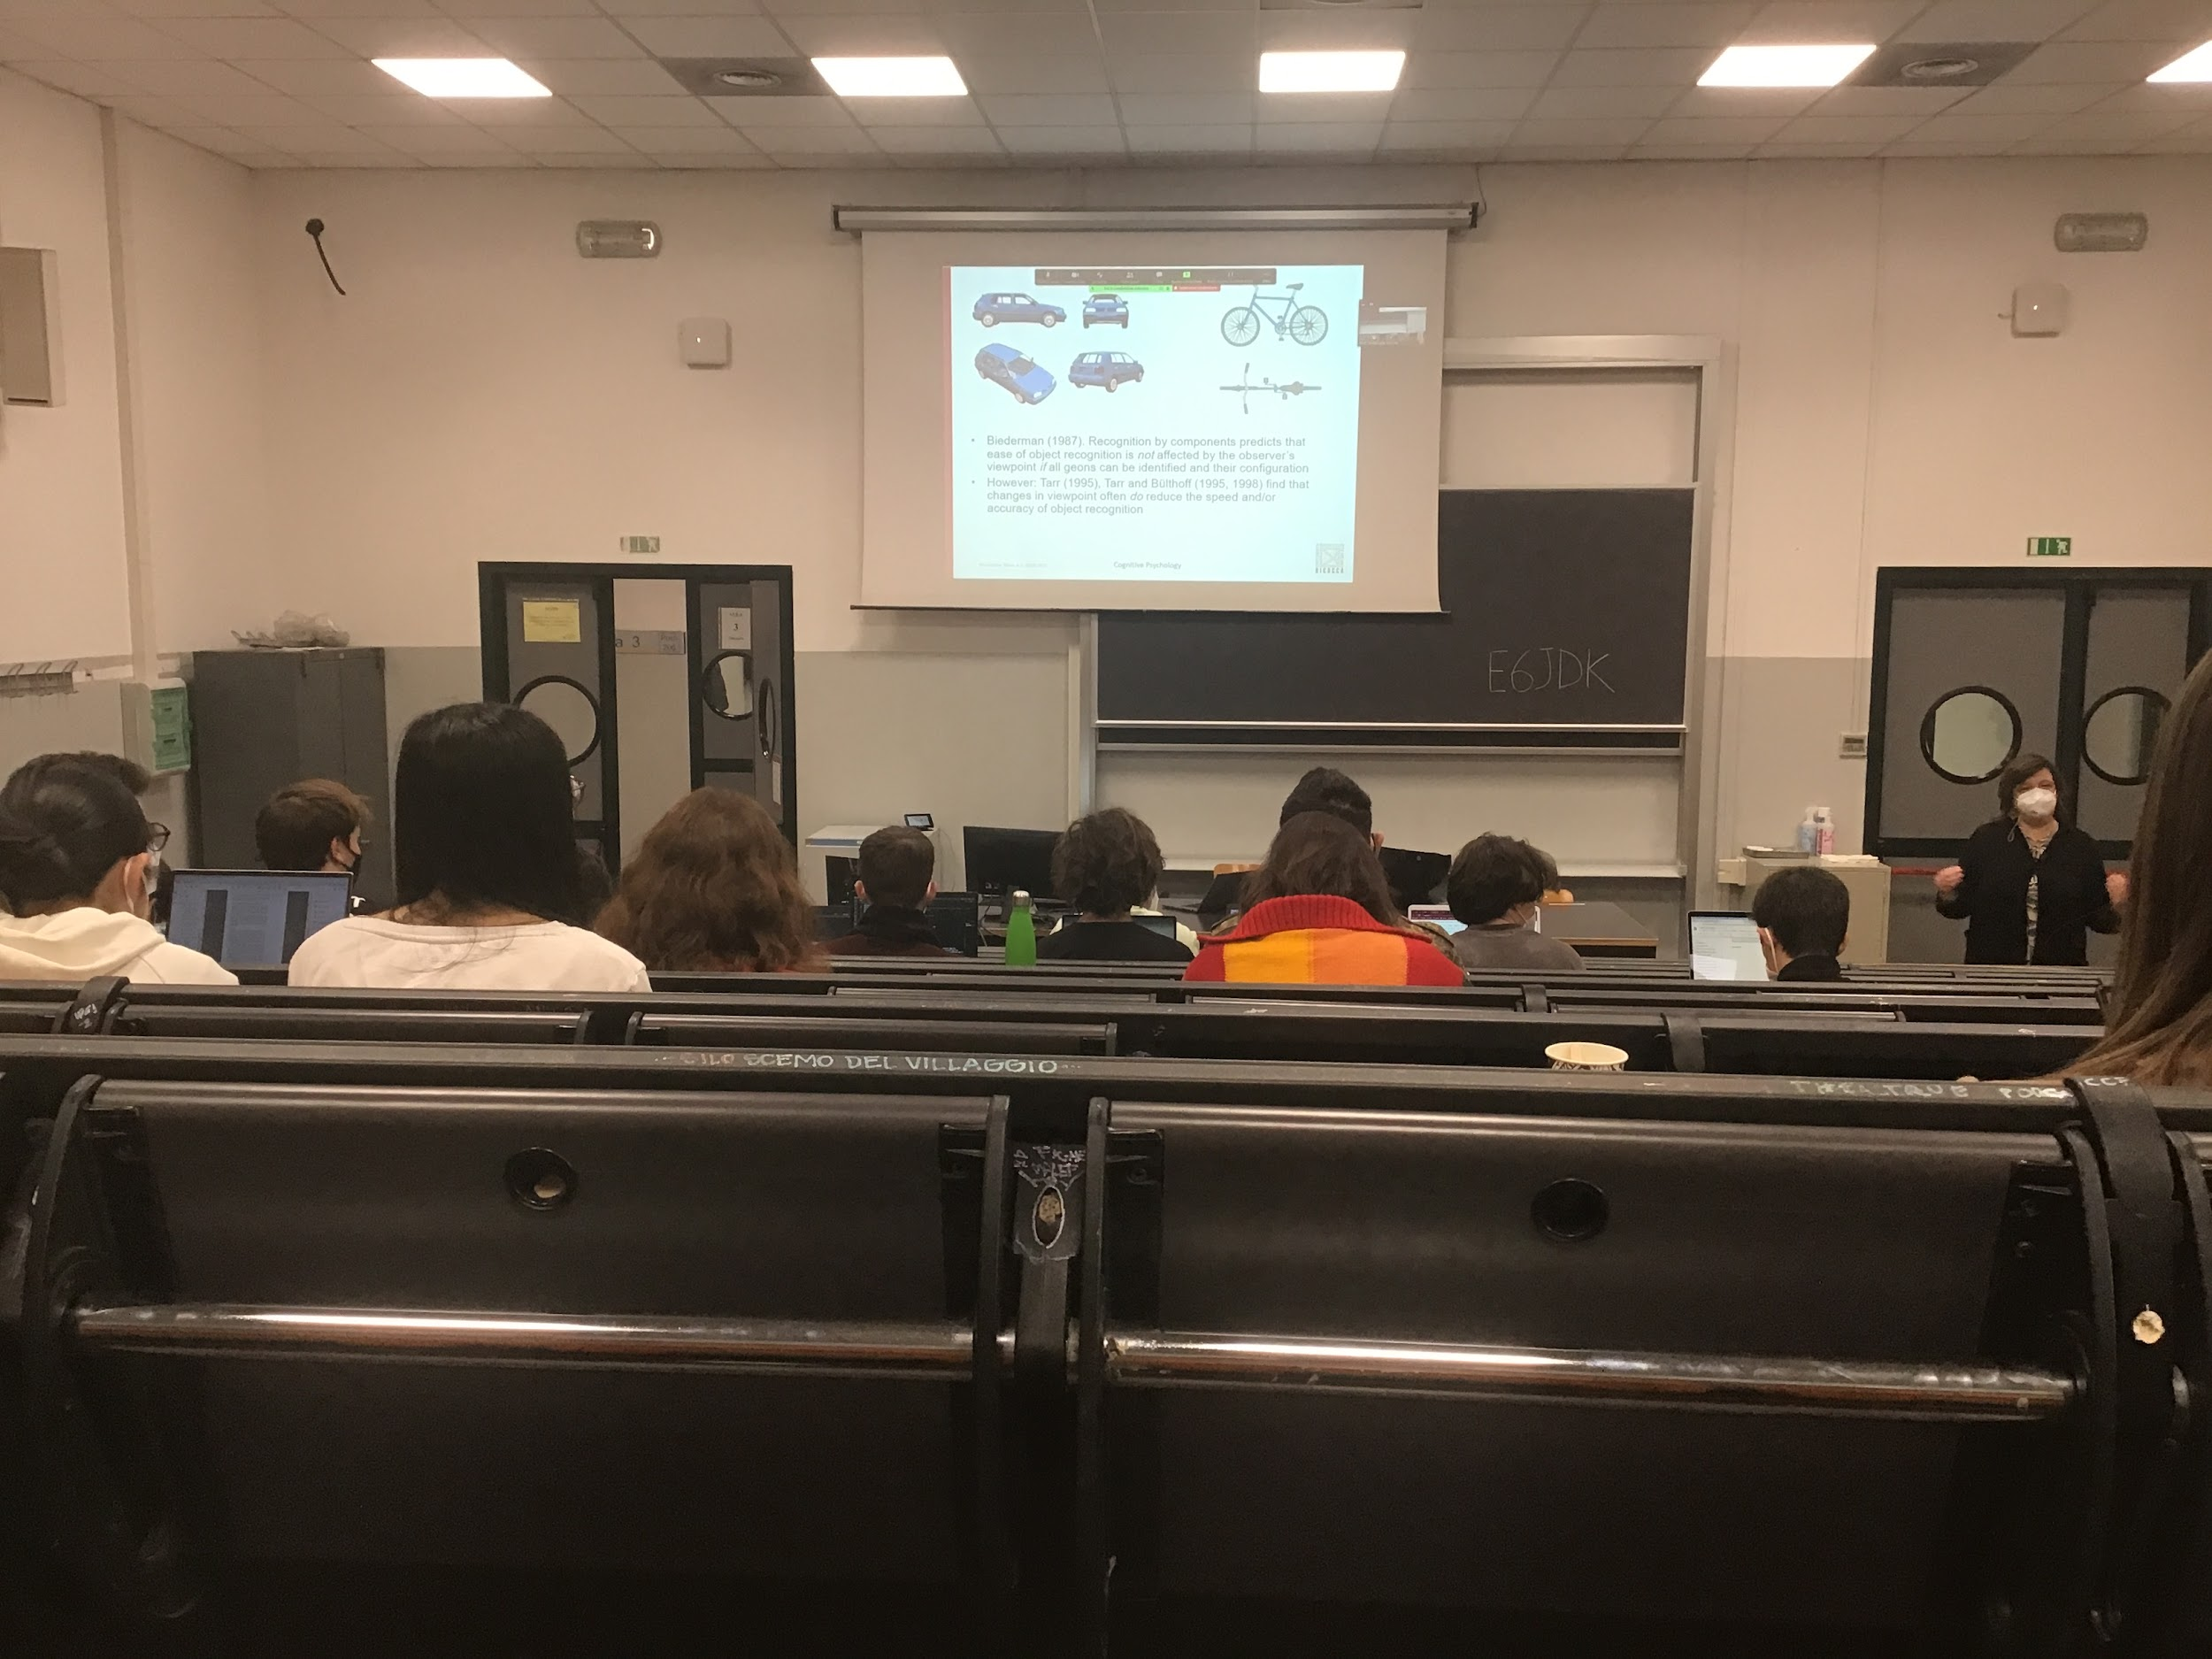

Biederman proposal: we represent object in our mind with GEOMS, you extract from the objects some parts

We have 36 parts that we are able to identity from the different images of the objects using different characteristic

The model of Biderman: object recognition is obtained using different components indipendent from viewpoint

For Bidermann: recognition is indipendent from viewpoint

Debate whether object recognition is independent (Bidermann thesis) or viewpoint dependent (T’arrabbi thesis) show that **object recognition IS viewpoint dependent**

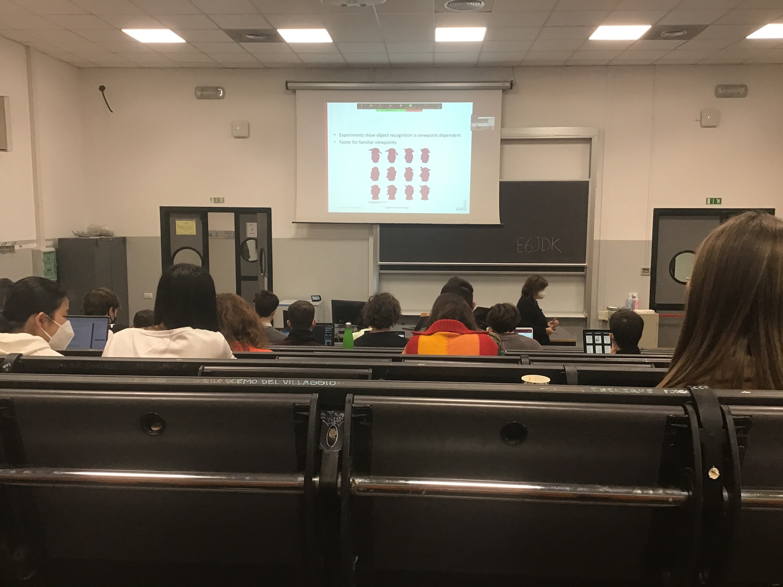

Tarrr created objects called *the greebles* 3D object made of parts, bodies with different shapes and other elements that come out of the object with different shapes (some kind of ears, nose…)

They create this new object type to demonstrate viewpoint dependency.

They teach you then names (one john, one mark…) but they are presented only in 1 way (3-quarter view) after you learn the names and you are able to discriminate between the different greebles, they change the orientation of the object your performance get worse depending on the further away the orientation is from the position you learn to discriminate the greebles

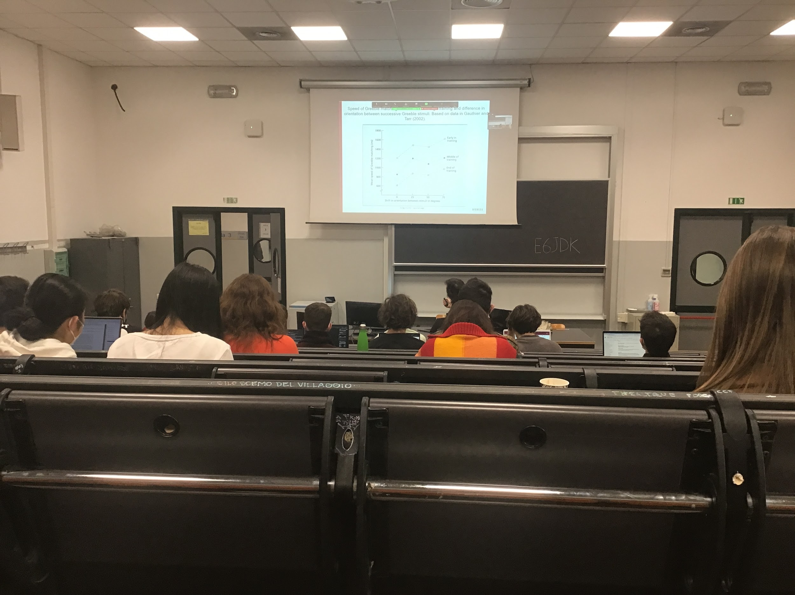

y-axis speed of recognition

x-axis angle of rotation from the original view point

The object is then rotated, when you go away fro the rotation it takes longer to recognise

All these data show that for new object (the one that you don’t know well enough) is a viewpoint dependent representation

It is also true that after you learn to see the new object from different angles at certain point you don’t find anymore those differences

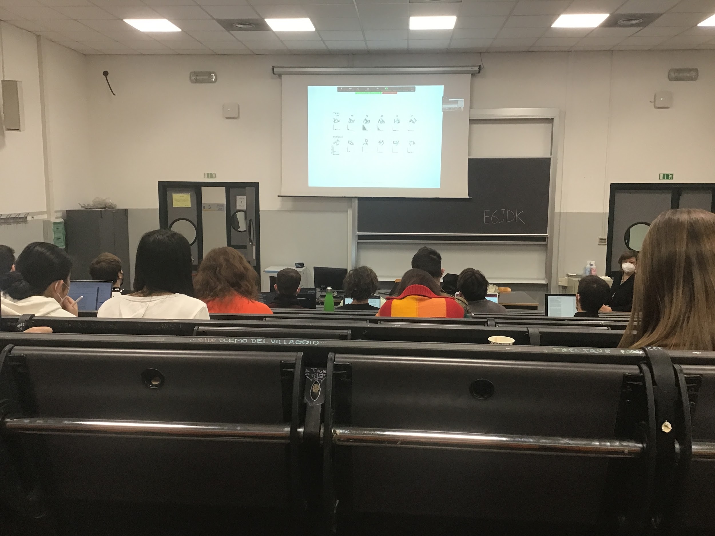

Activity in one inferotemporal cortex neuron

Same paper clip in different rotation

Seems inferotemporal cortex there is coding of objects in viewpoint dependent format

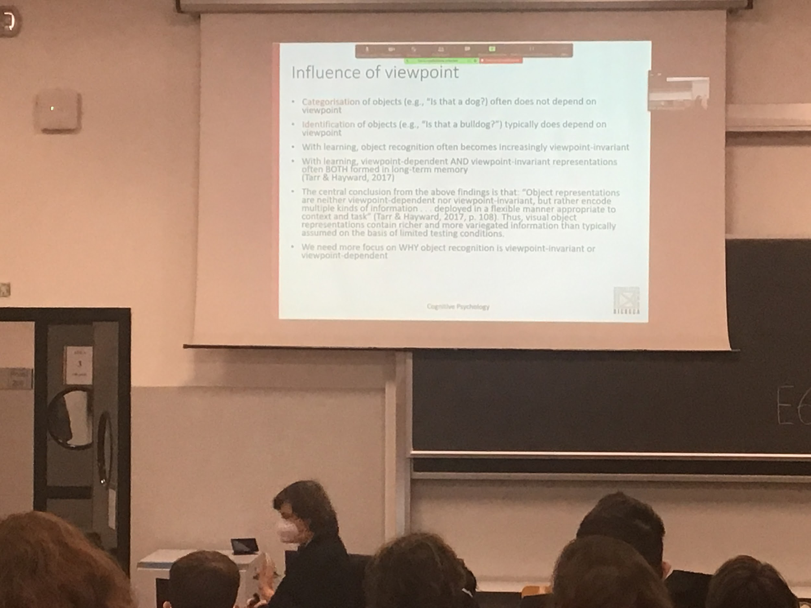

Different labels of object recognition

We have to discriminate between categorization and identification

* **Categorisation**: this is a face, this is a chair, this is a paperclip. Independent of the specific face or the specific chair
* **Identification**: when I want to discriminate a specific component of a category a specific chair, a specific face

Categorisation *is that a dog?* Does not depends on viewpoint, our ability to classify the object as a chair is independent from the point of view we are looking from

Identificationis viewpoint dependent

The proposal is that in the brain we have both viewpoint dependent and viewpoint invariant representation depending on what we are representing.

* for specific item: view dependent representation
* for categorization: we use view invariant representation

# Object and face recognition

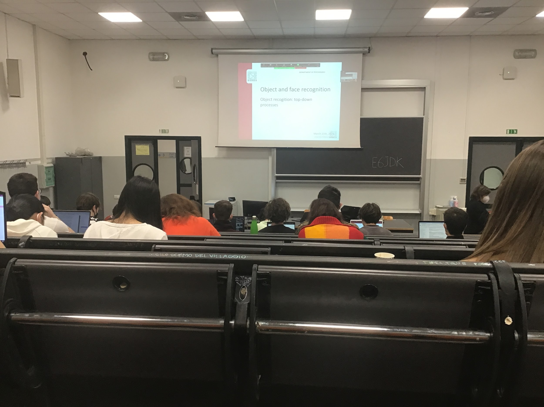

Up to now, object recognition was a bottom up process

Marr: 3 steps start from basic (border) is a pure bottom up, no previous information that gets in the Marr model

Same for Biderman, I look, I find the components, I find the relative position of the components and then I compare to memory. The informations I store in memory is useful only for recognize at the end)

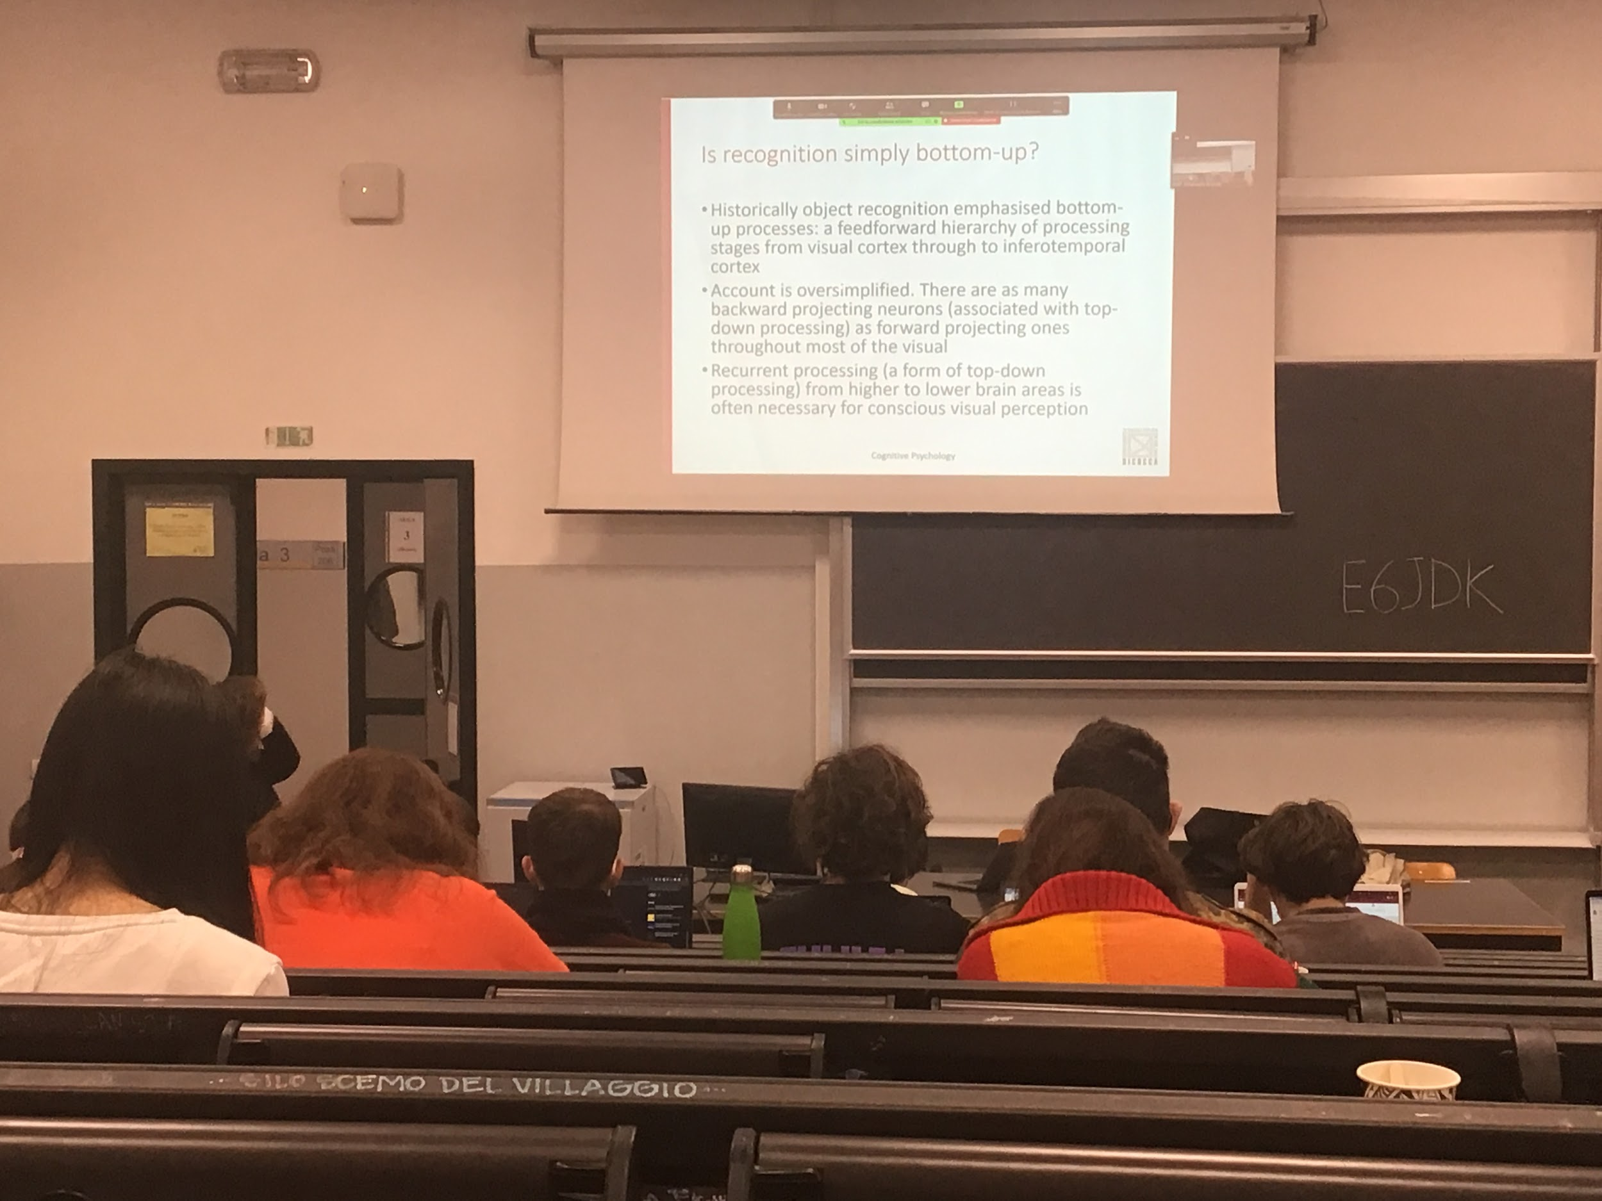

In reality there are many backward projection that go down from the higher areas down to modulate the activity

Why do we need a top down process?

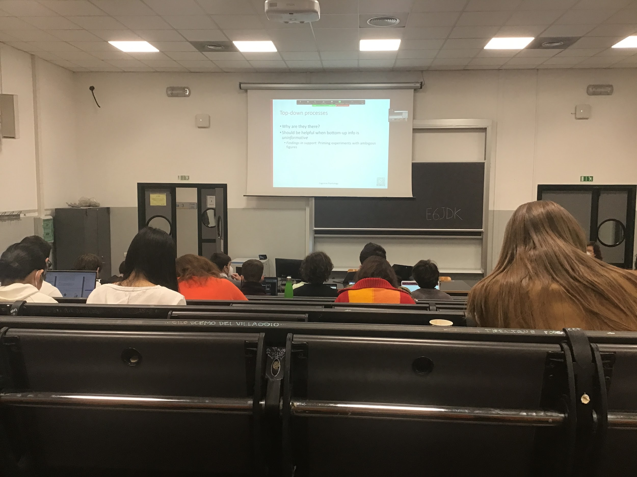

We need them for many reason

* We need a top-down process when we do not have enough information in the image, when the information in the image is ambiguous having some previous memorised representation helps me discriminate between two options

Top down processes influences object perception when the information is not clear

**Priming**:

A number is show for the first time for a very short time

There is a previous presentation of a stimulus that activity the memory and then

Second presentation ask to classify the second presentation, in the second case the response depends on what you see before

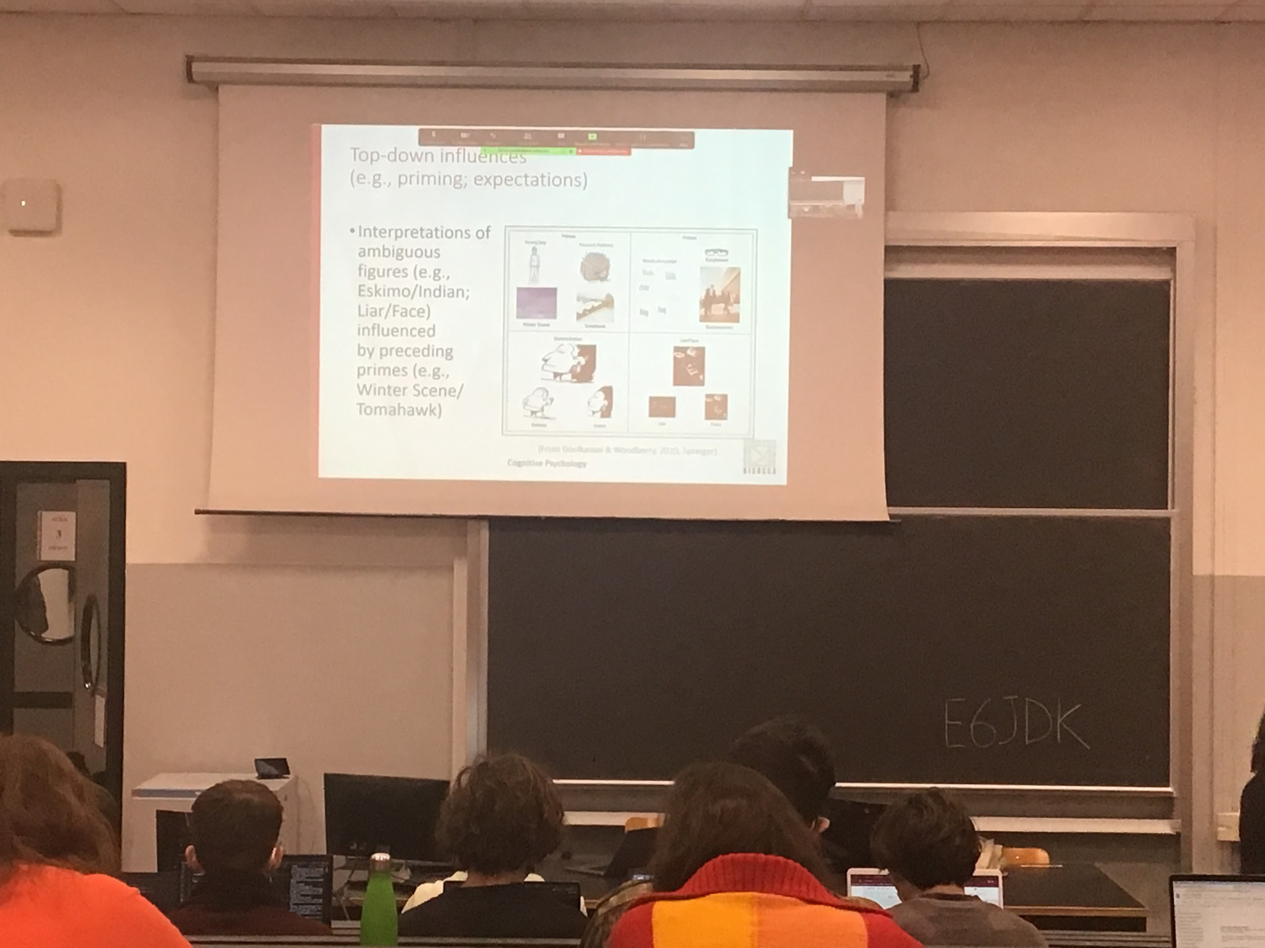

These ambiguous stimuli they either response randomly eskimo/*indian* or *liar/face*

Object recognition bottom-up can be classified in 2 ways. To show top-down processes influence these classification we show a prime before

We show a prime before, depending on the prime we classify the image in a way. The prime can be associated with a specific response, showing snow before influencing eskimo/indian responses. When you show a prime you classify the ambiguous figure faster and more probably as an eskimo. Figure guides our perception to a precise view

Top-down: you activated in your memory a meaning, and this meaning influence your basic perception

When you presents words as prime people identity better the word *liar* then it you show before people they will see the face

**Expectation of what you find depends on what you see**

You mental activation increase the important of all the informations related of what you are doing in that specific moment

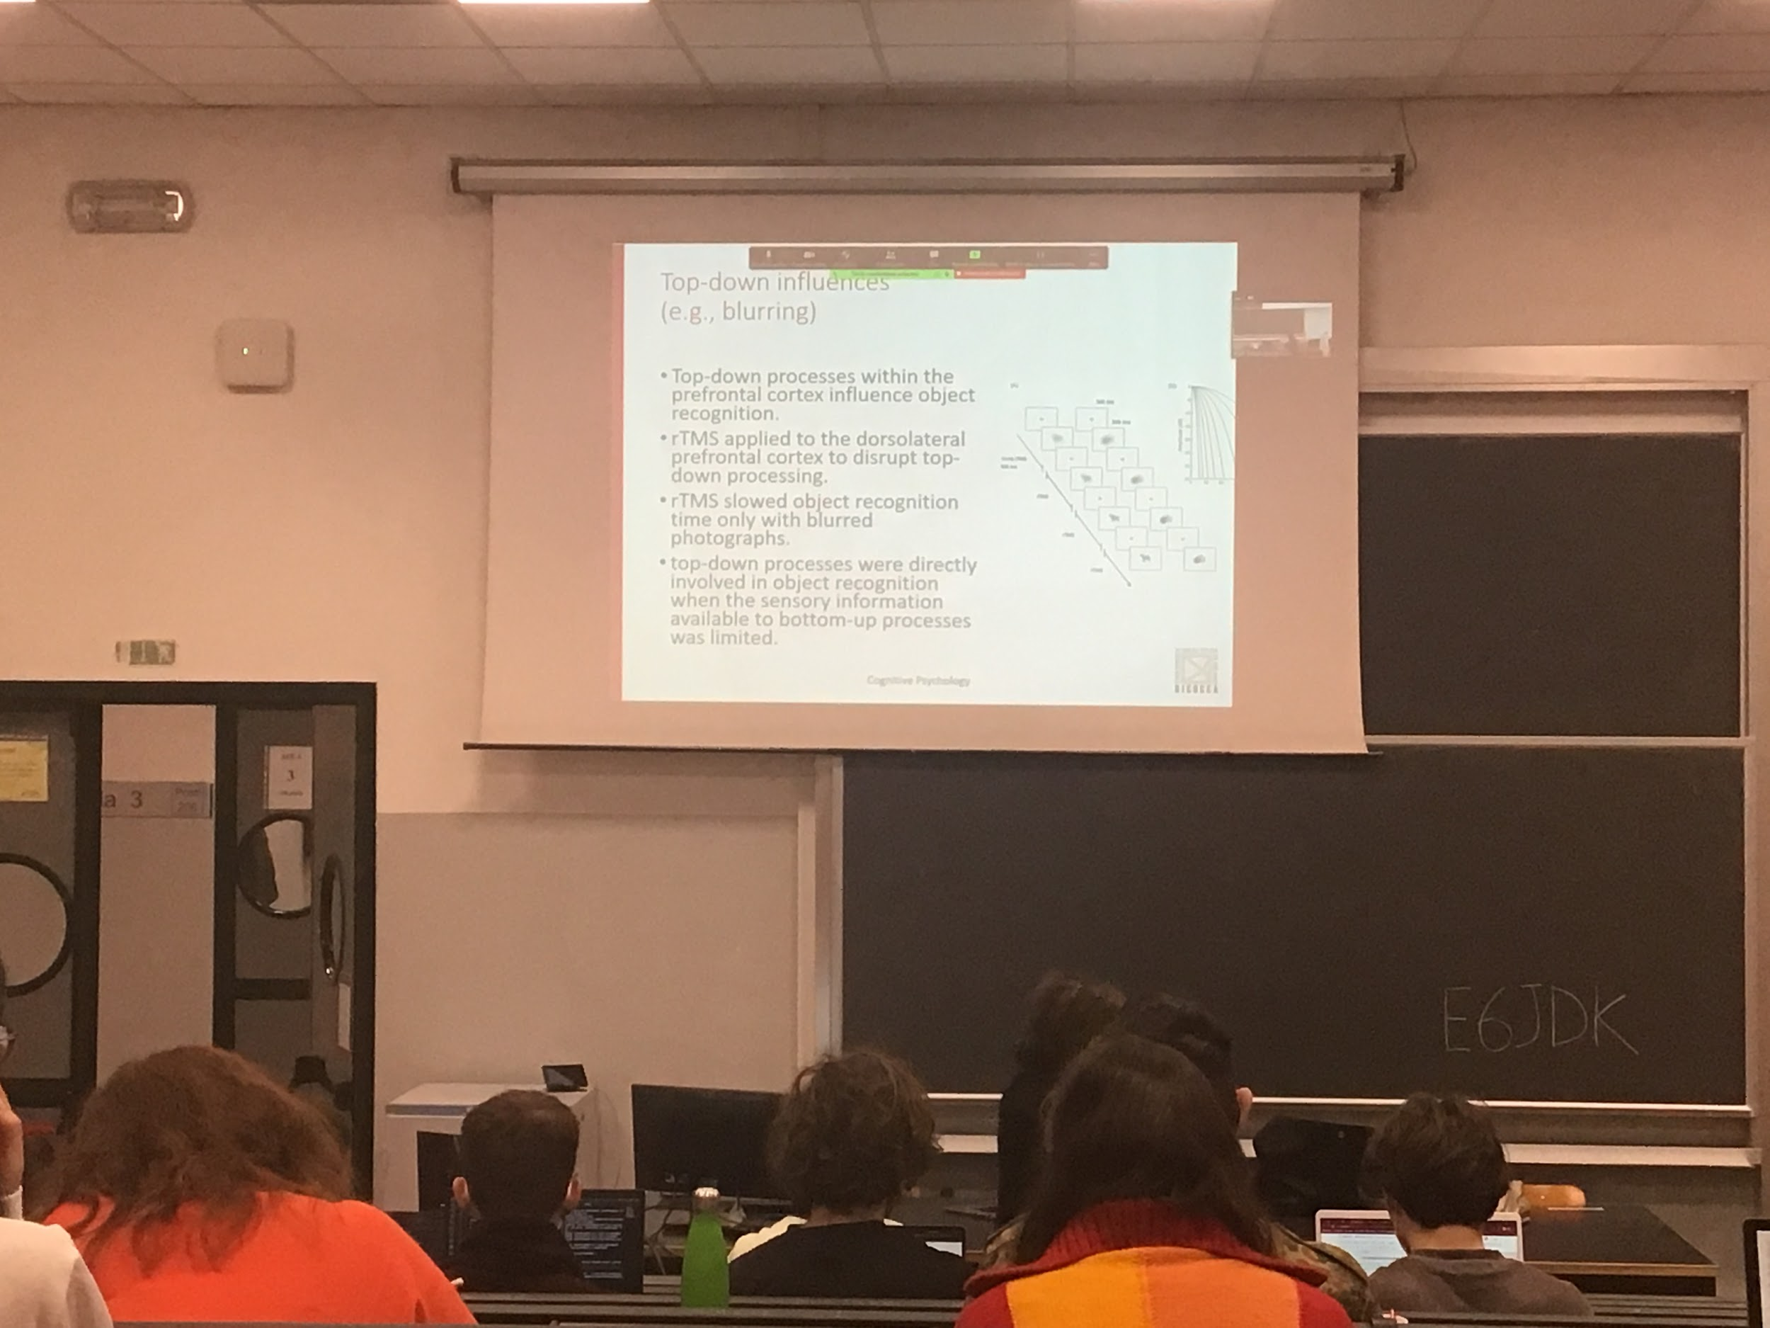

Another experiment

Instead of using priming we blur the image at different level and present people with the blur image starting from the most blur one

Not a clear picture

They show that applying rTMS to an area that regulates top-down processing then if you disattivate temporally these is no top down influence working you need a better picture to identify a dog

If I block the town down processing I am not able to recognise it, need less blur

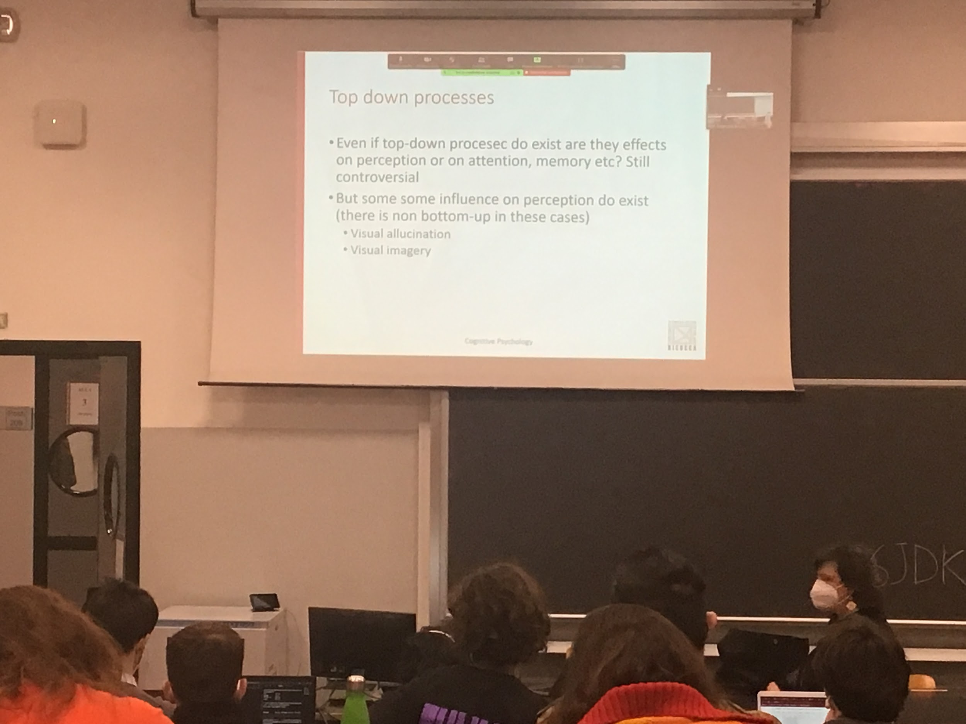

Big depeate on what top-down process works on, does it change the perception? Or does it change the velocity of accessing memory?

* **Visual hallucination**: people with schizophrenia are convinced to see something, is a creation of perception
* **Visual imagery**: We can close our eyes and imaging some visual space (like a room) and it is a perceptual representation

Exist some kind of influence of top-down process on perception

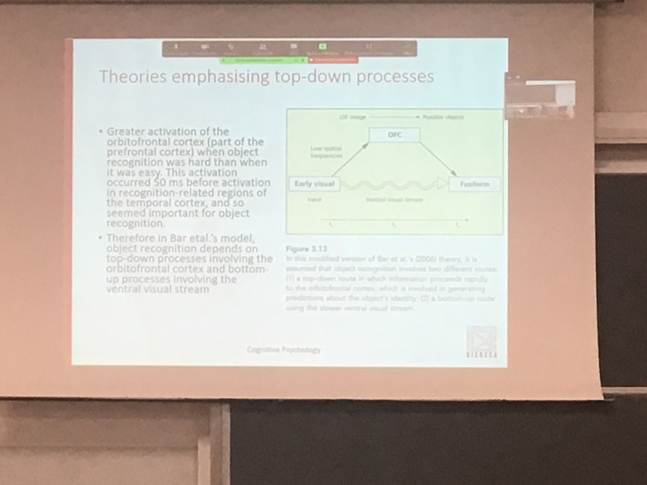

Theory that focuses on the idea that higher areas do influence our perception

Bar model:

The early visual input is coded slowly in the bottom up standard but there is a faster root that travel on the magnocellular pathway goes directly to orbital frontal cortex

This representation is much faster than the other process and this fast representation help us interpret the information that we are coding more in detail in the other room

Fast process that give the gist of the scene and a slowest process that code the different object in the scene

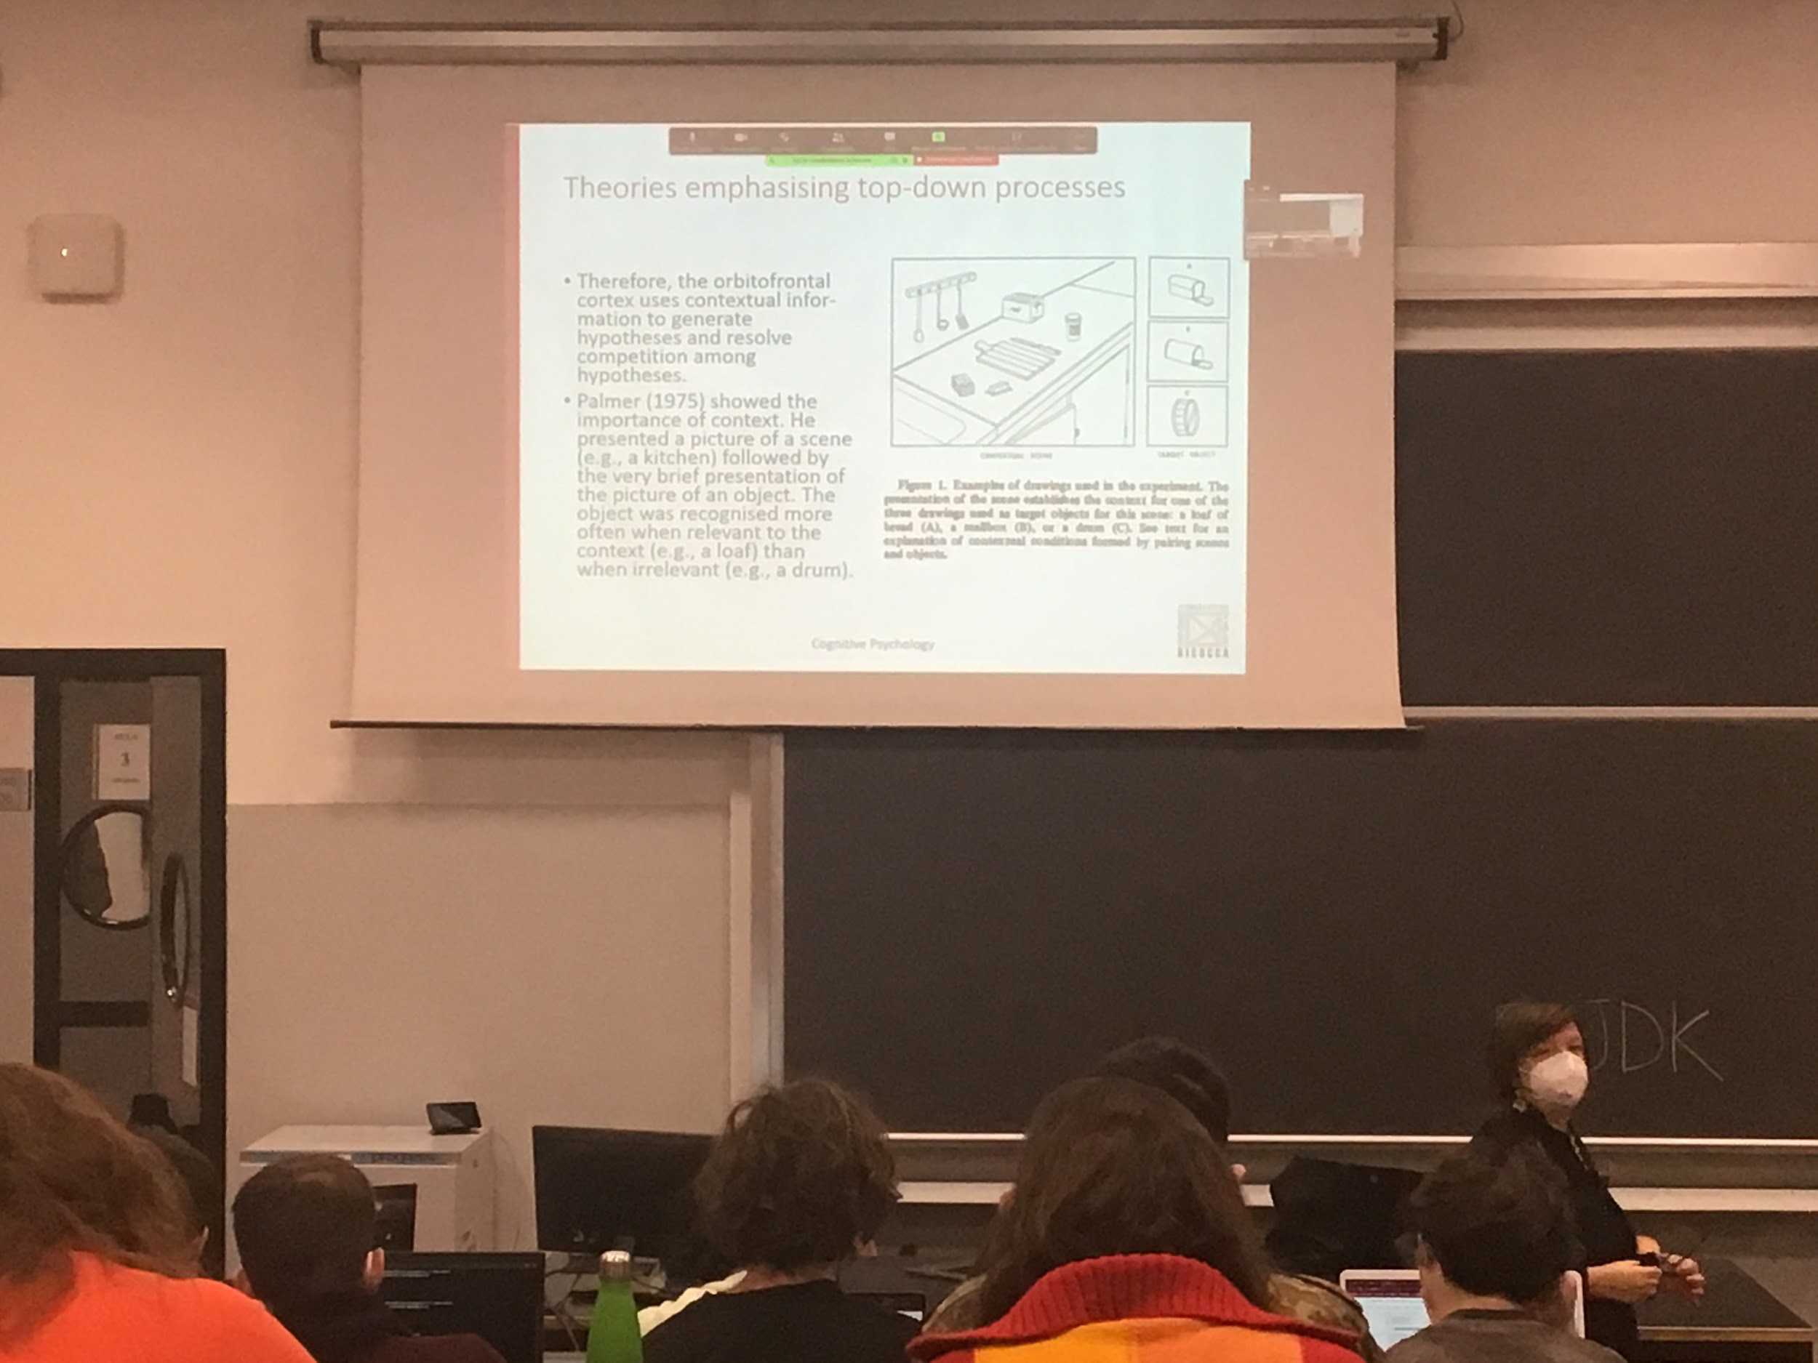

The general information about the scene modulates our perception

Some object are relevant we expect the bread loaf to be there, a mailbox and a drum no

With brief presentation we are much faster after I see the kitchen to recognise the bread than to recognised the mailbox and the drum

The first image that is the prime (the kitchen) prime in the mind a representation of the kitchen and everything that is related is coded faster and better

Show that there is top-down processing

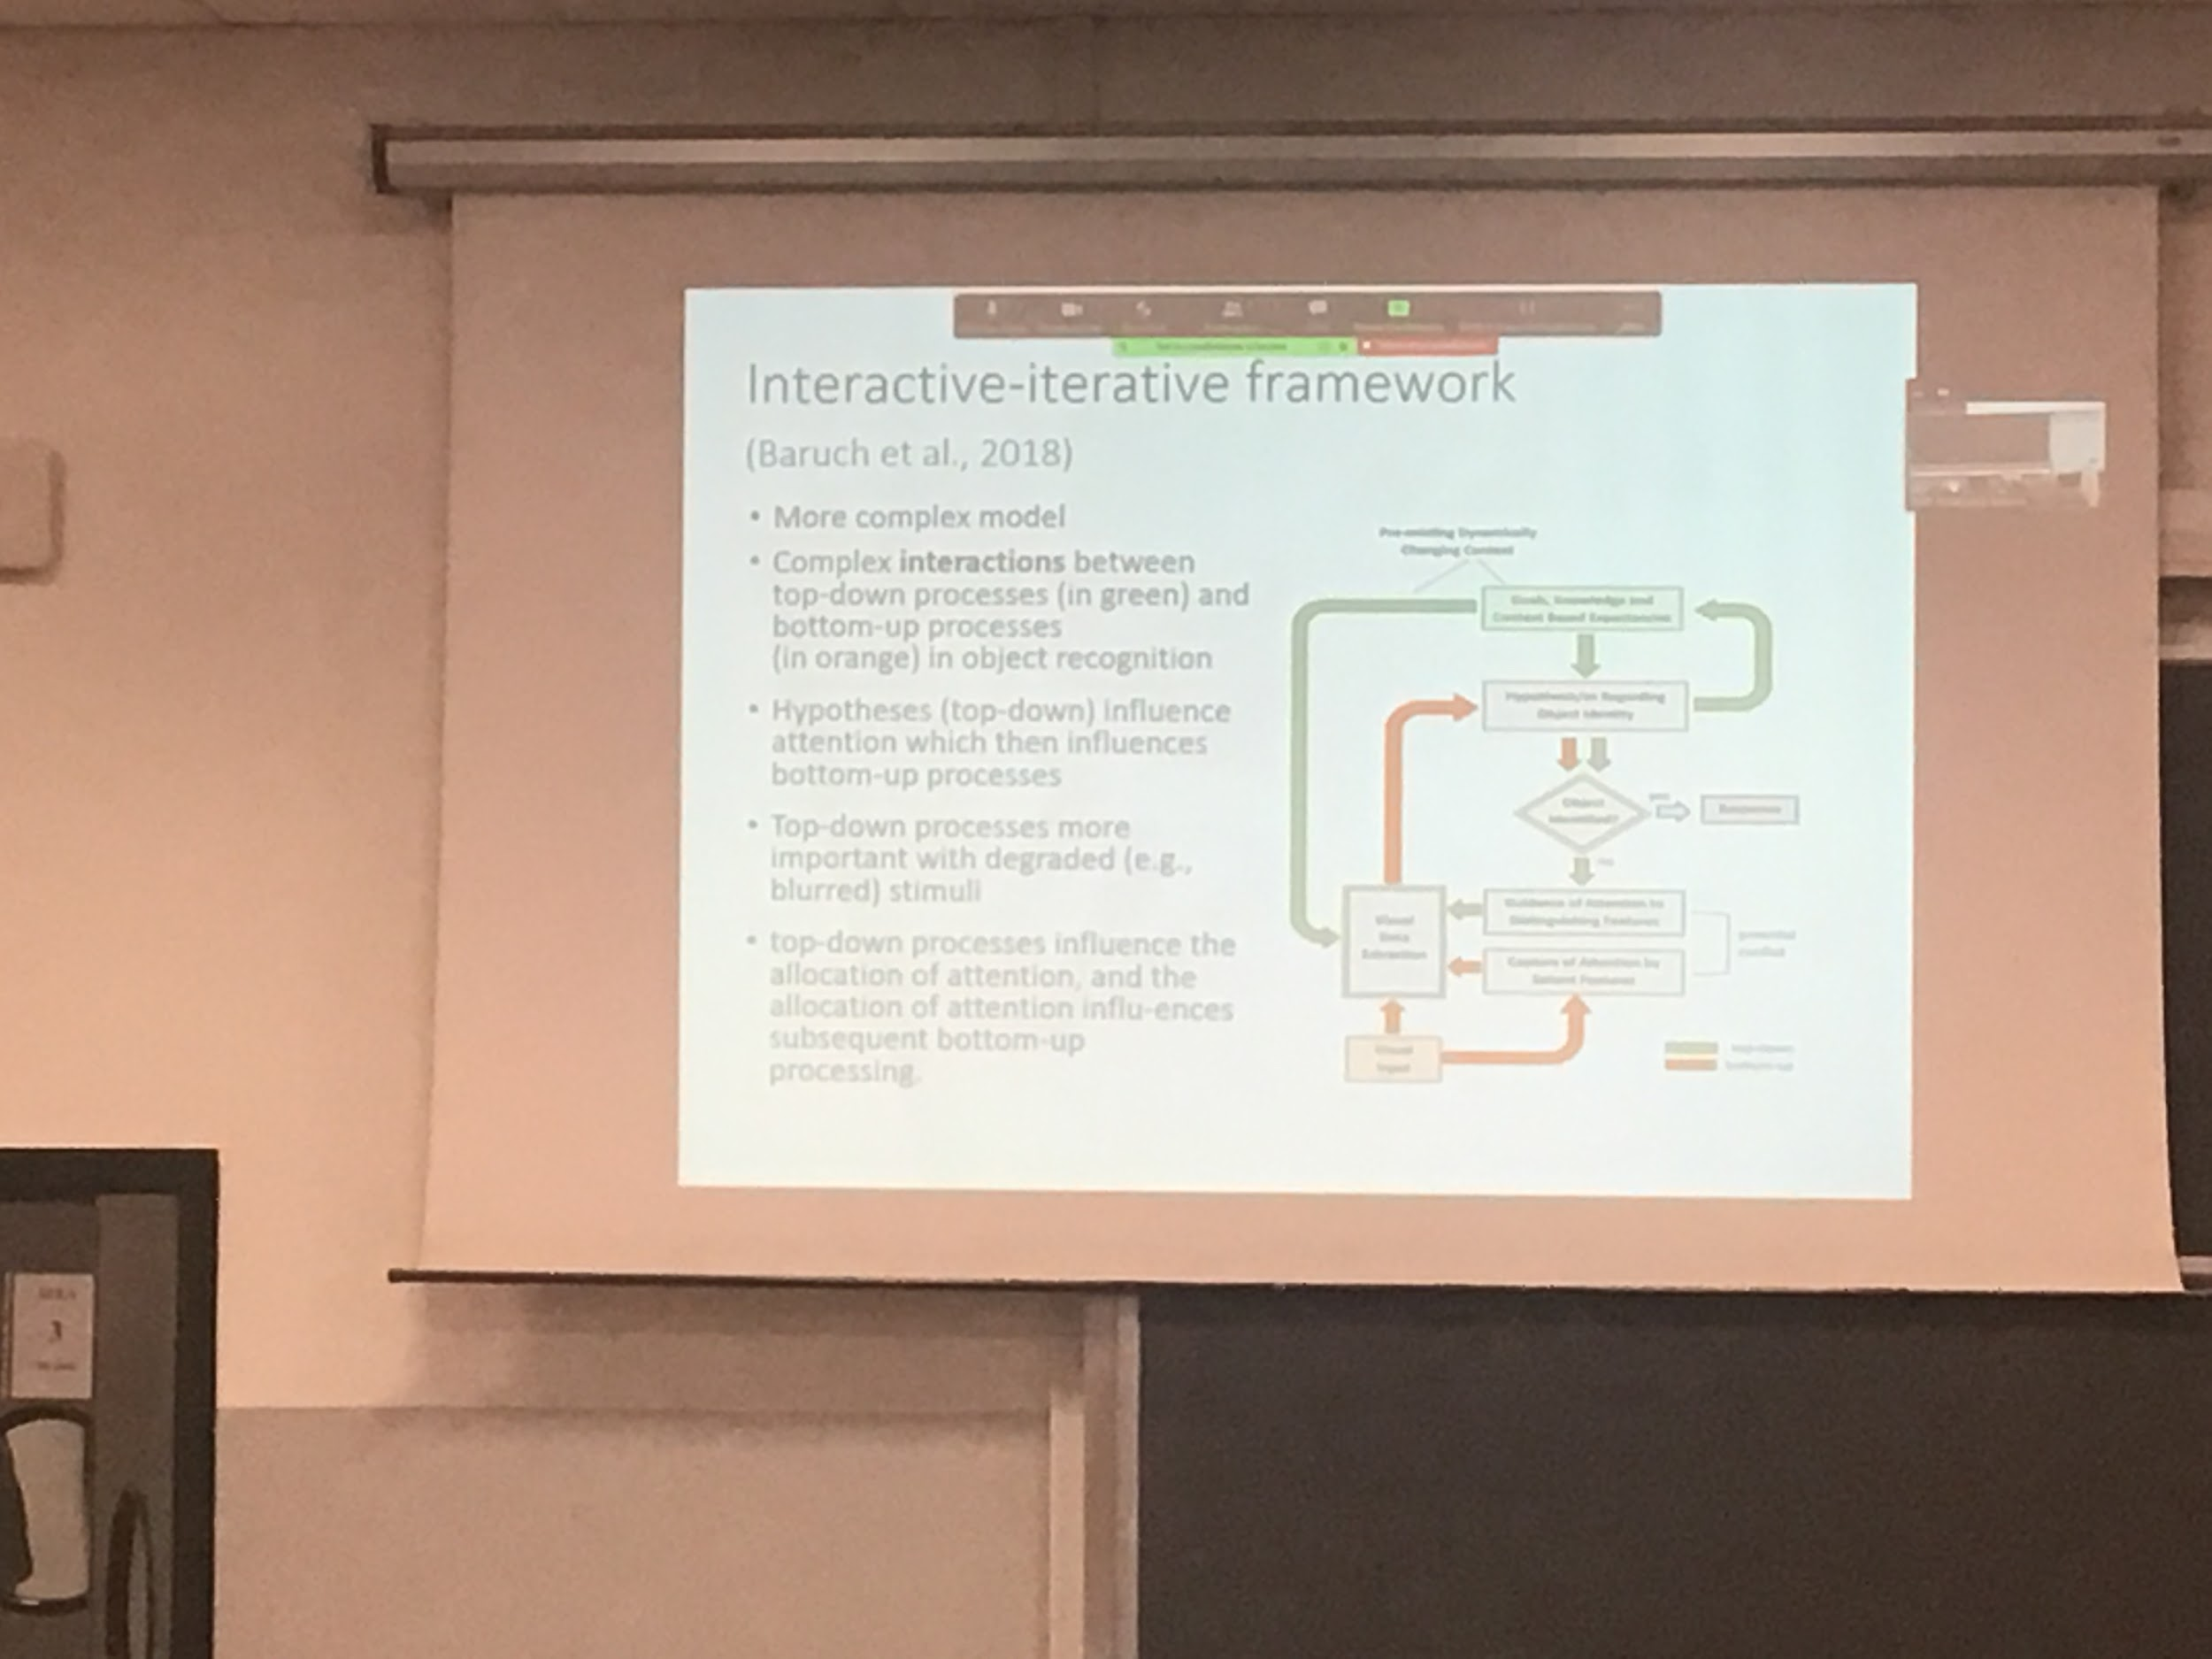

Models have become more and more complex. On the image there is the **interactive-iterative framework** proposed by Baruch

There are complex interaction between top down (green) and bottom up (orange) these model when implement can show that top down processes are more important with greater stimuli

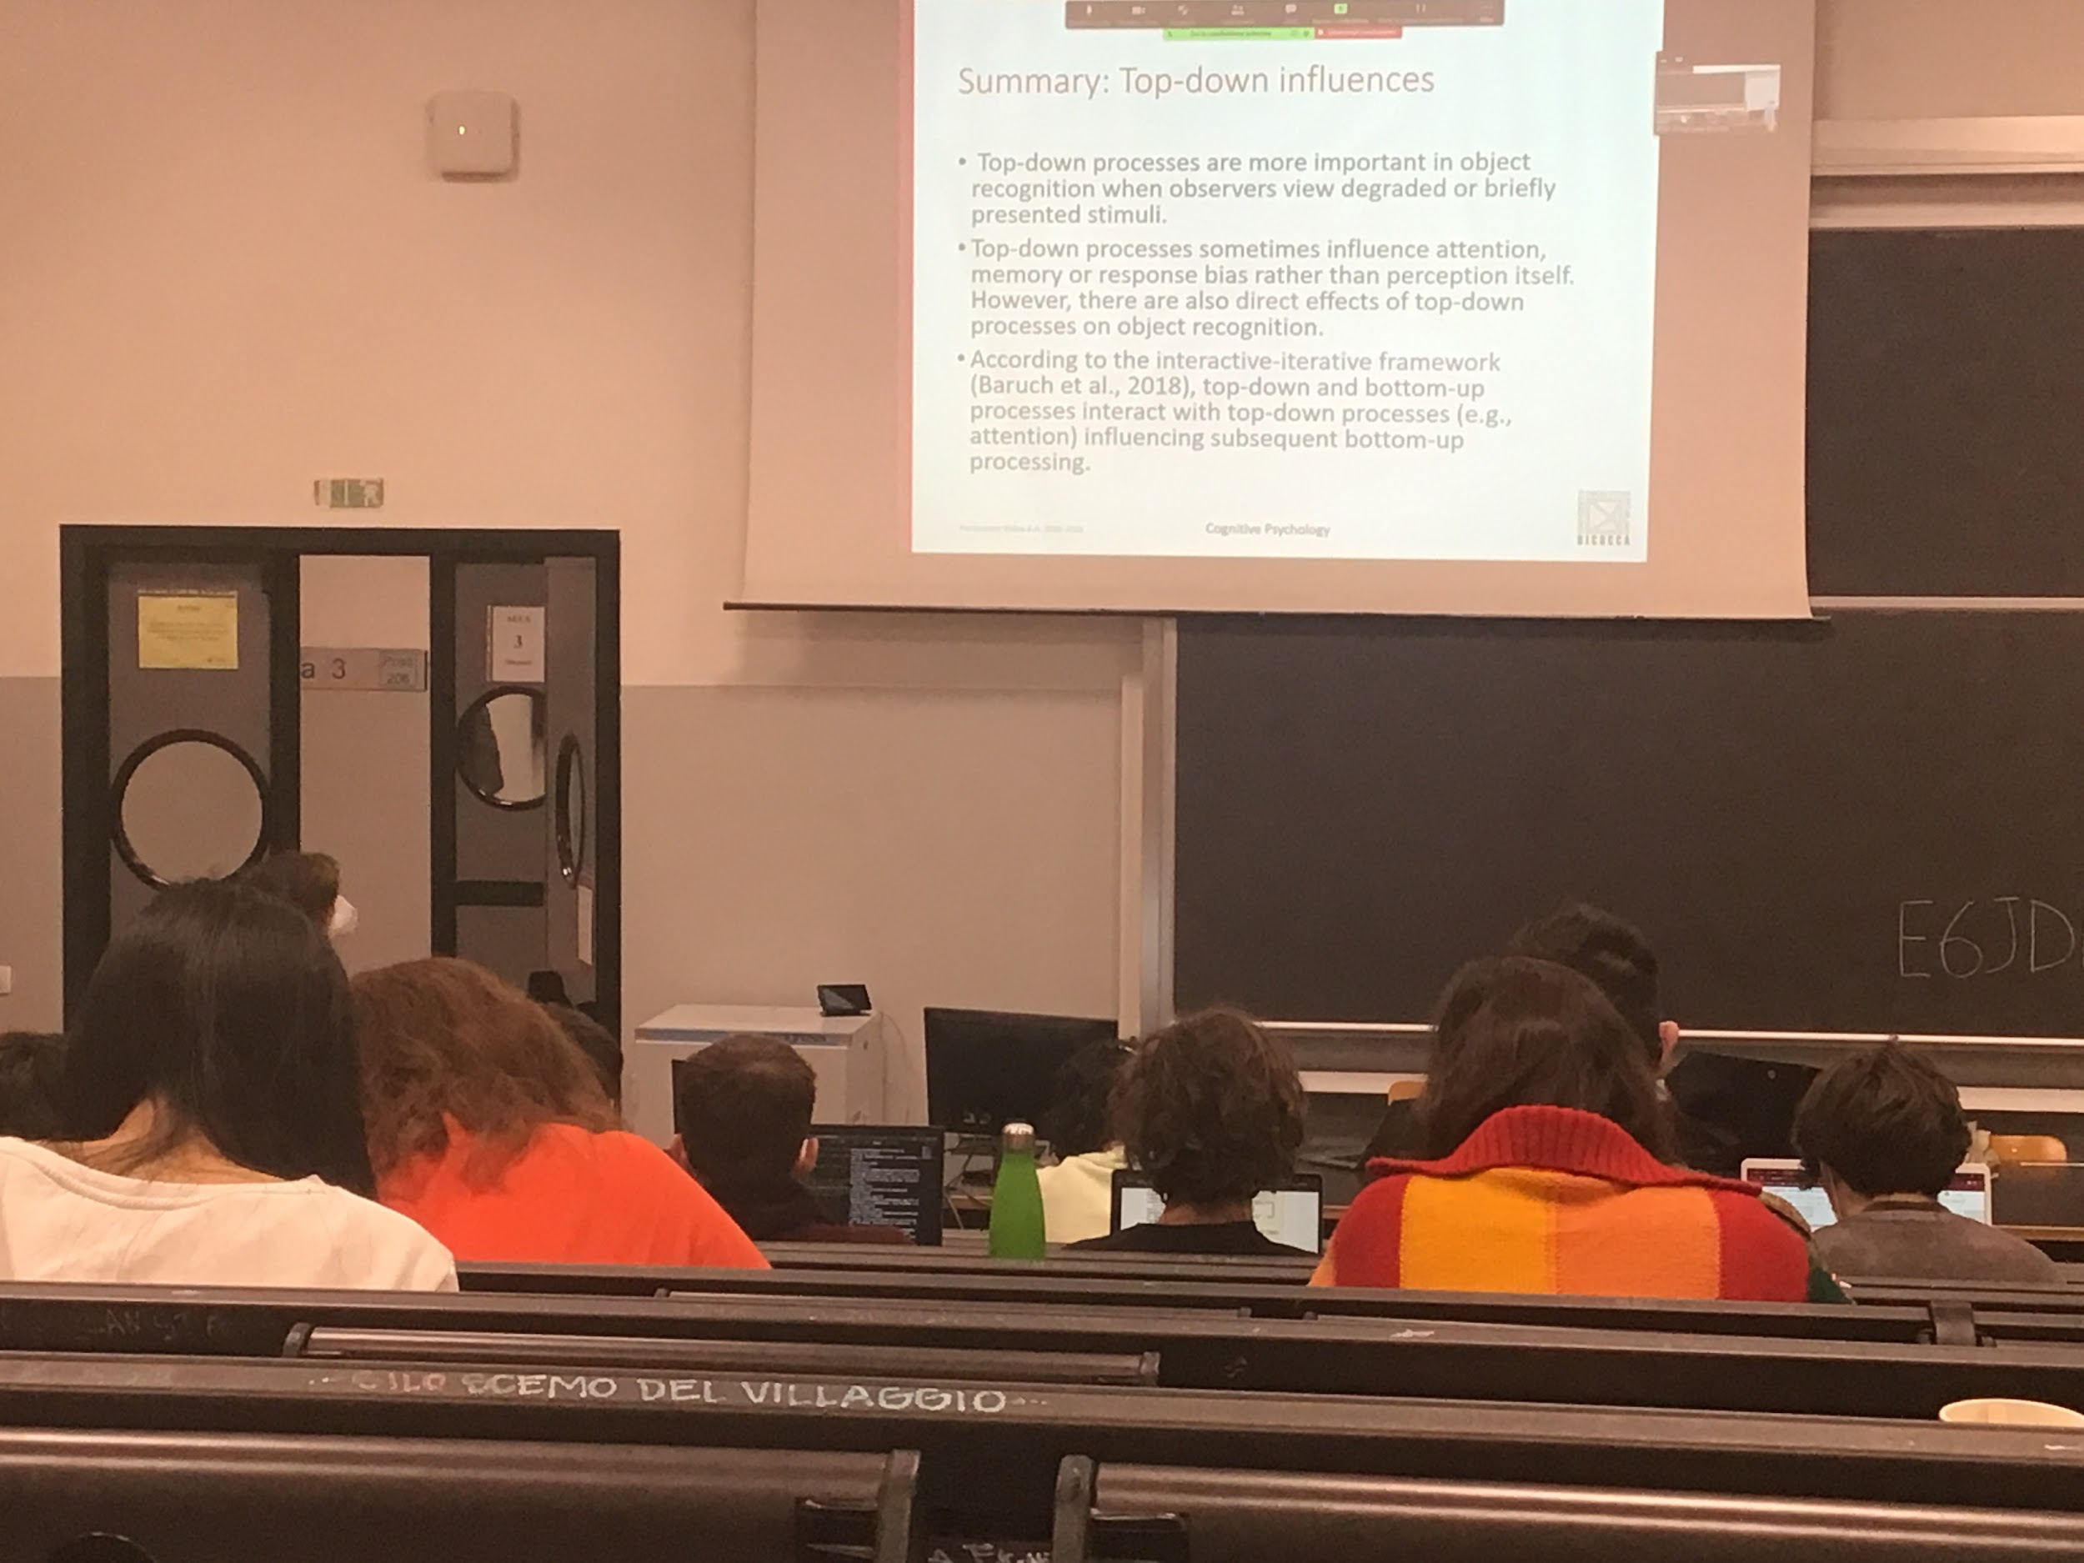

Top-down influences are more important in object recognition when the stimuli are degraded or presented briefly. If in front of me there is someone I know is easier to recognise I don’t need help from my experience

Need to have help from what I know when something is not clear

There are some cases of direct presentation

# Object and face recognition

**Face recognition**

Two parts

* face perception
* Visual images

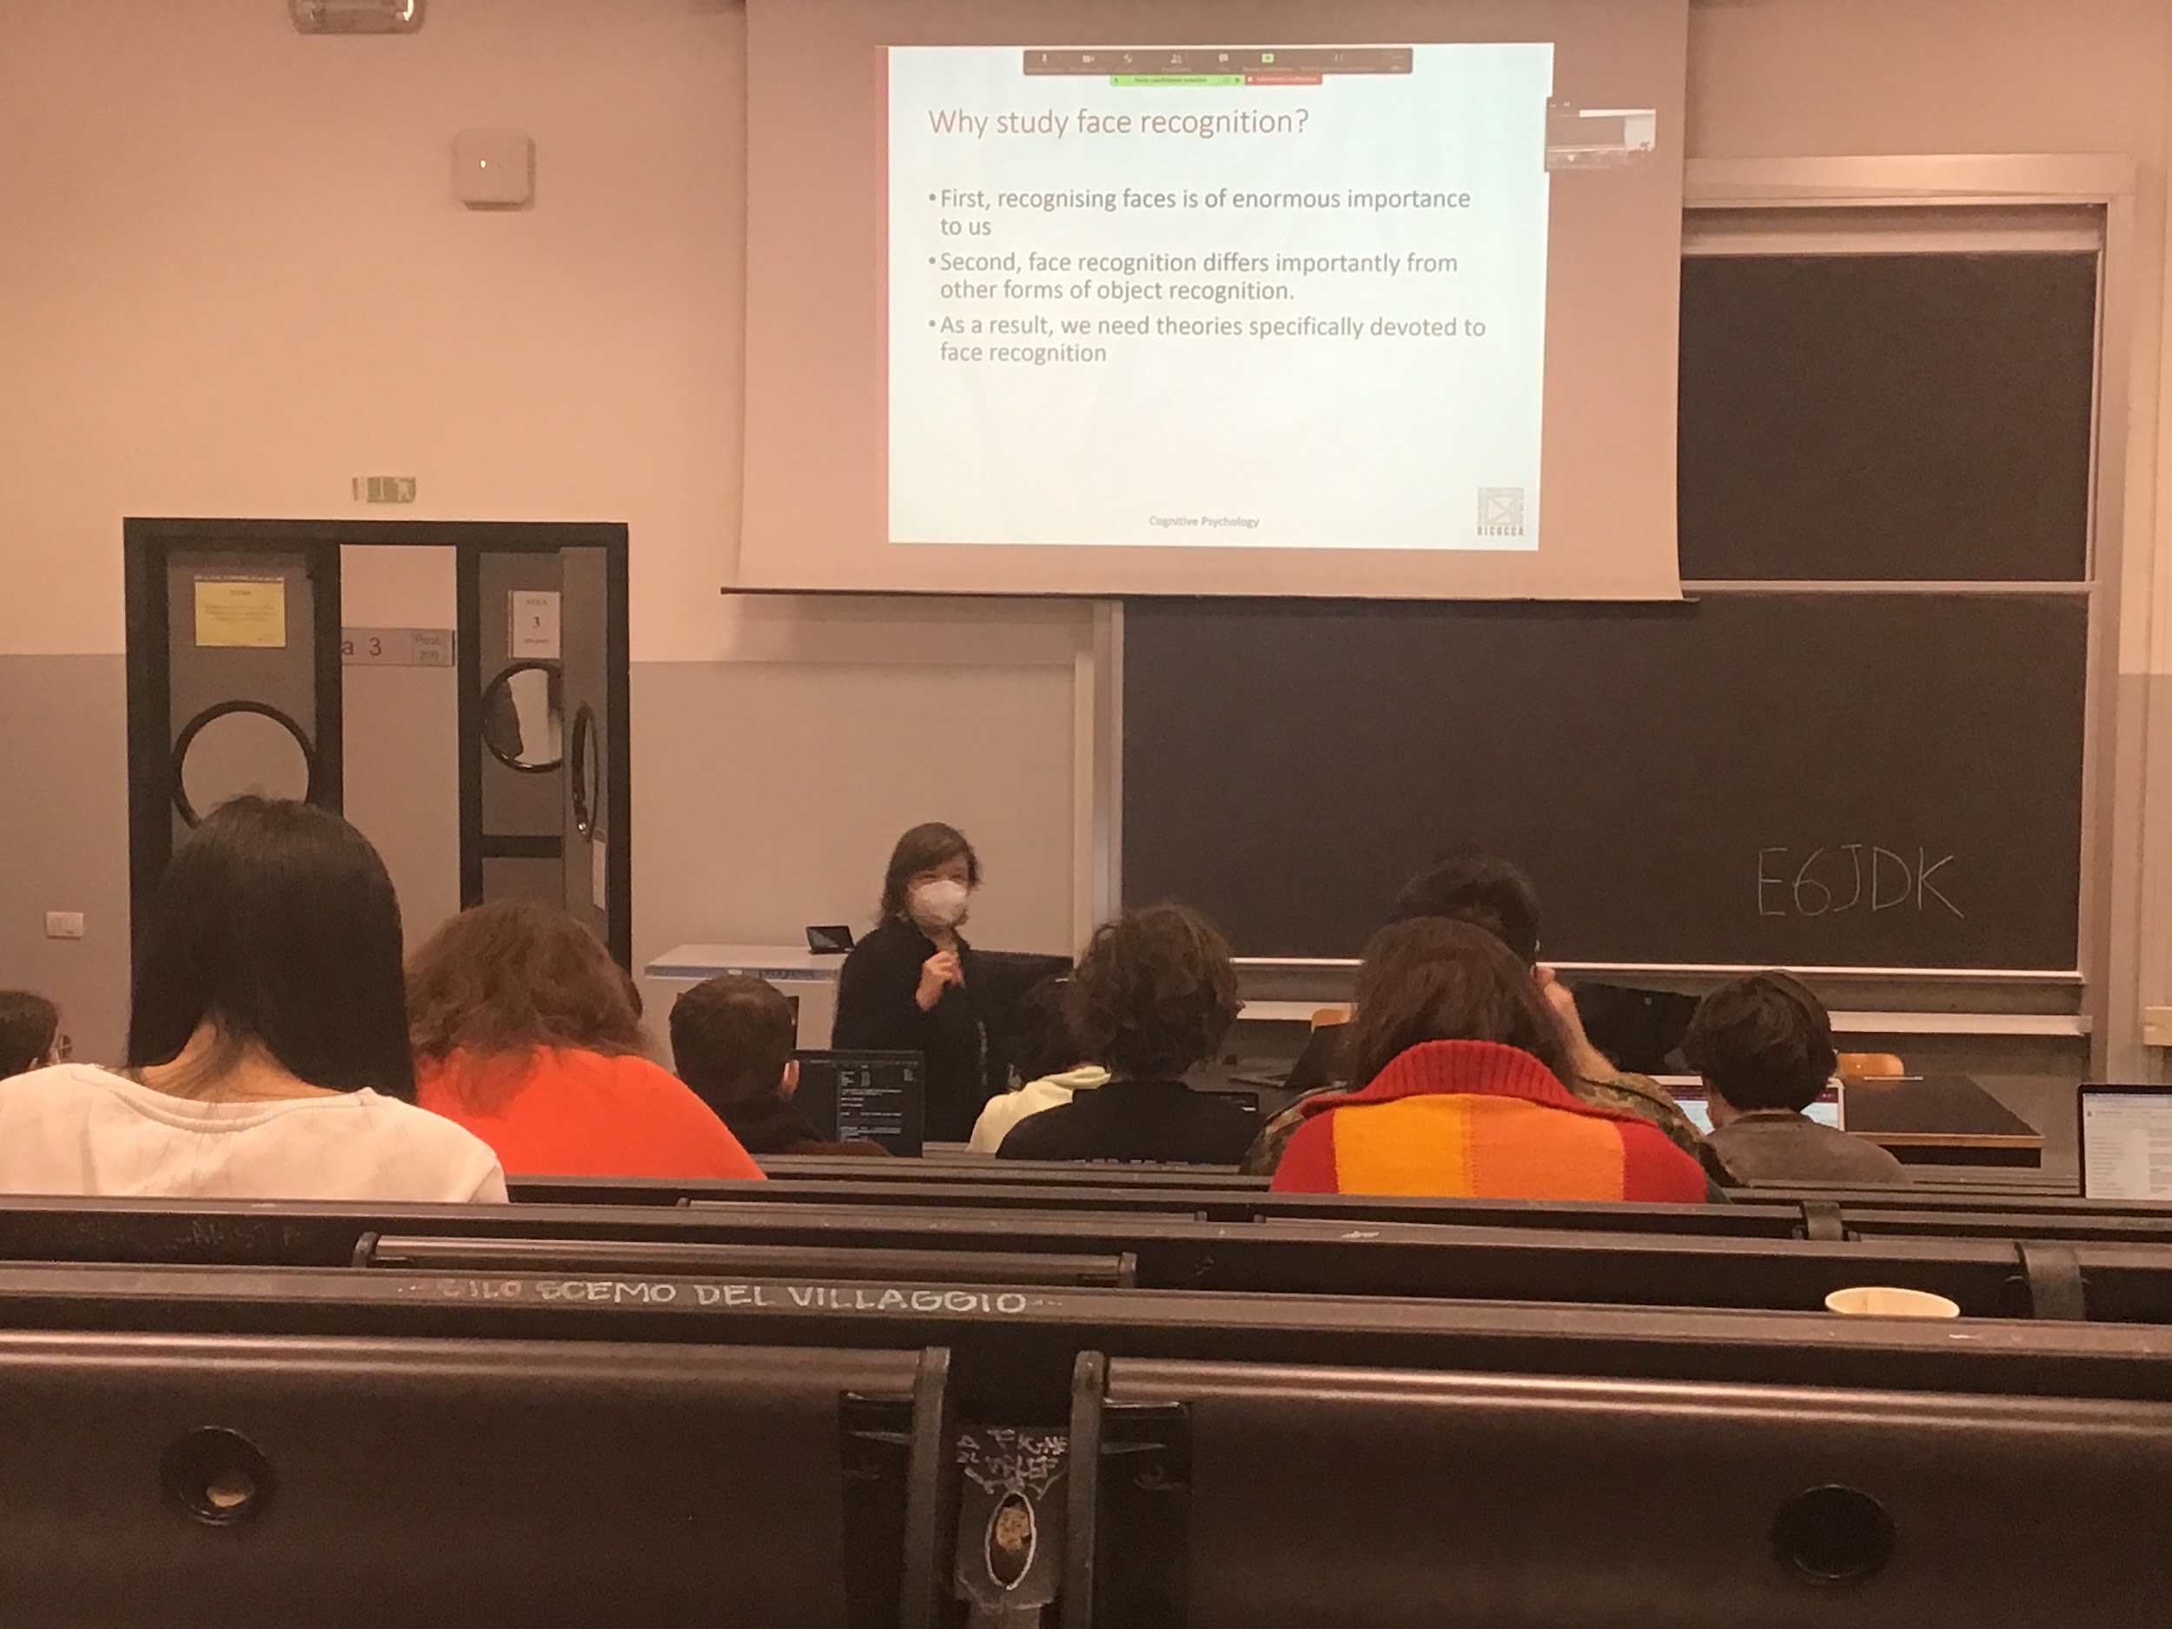

Faces of others individuals are extremely important for us, in some case is vital

Face recognition is a level of classification, is identification (viewpoint dependent)

Is much more than the most other object recognition processes

Is is analysed in the brain in a different way

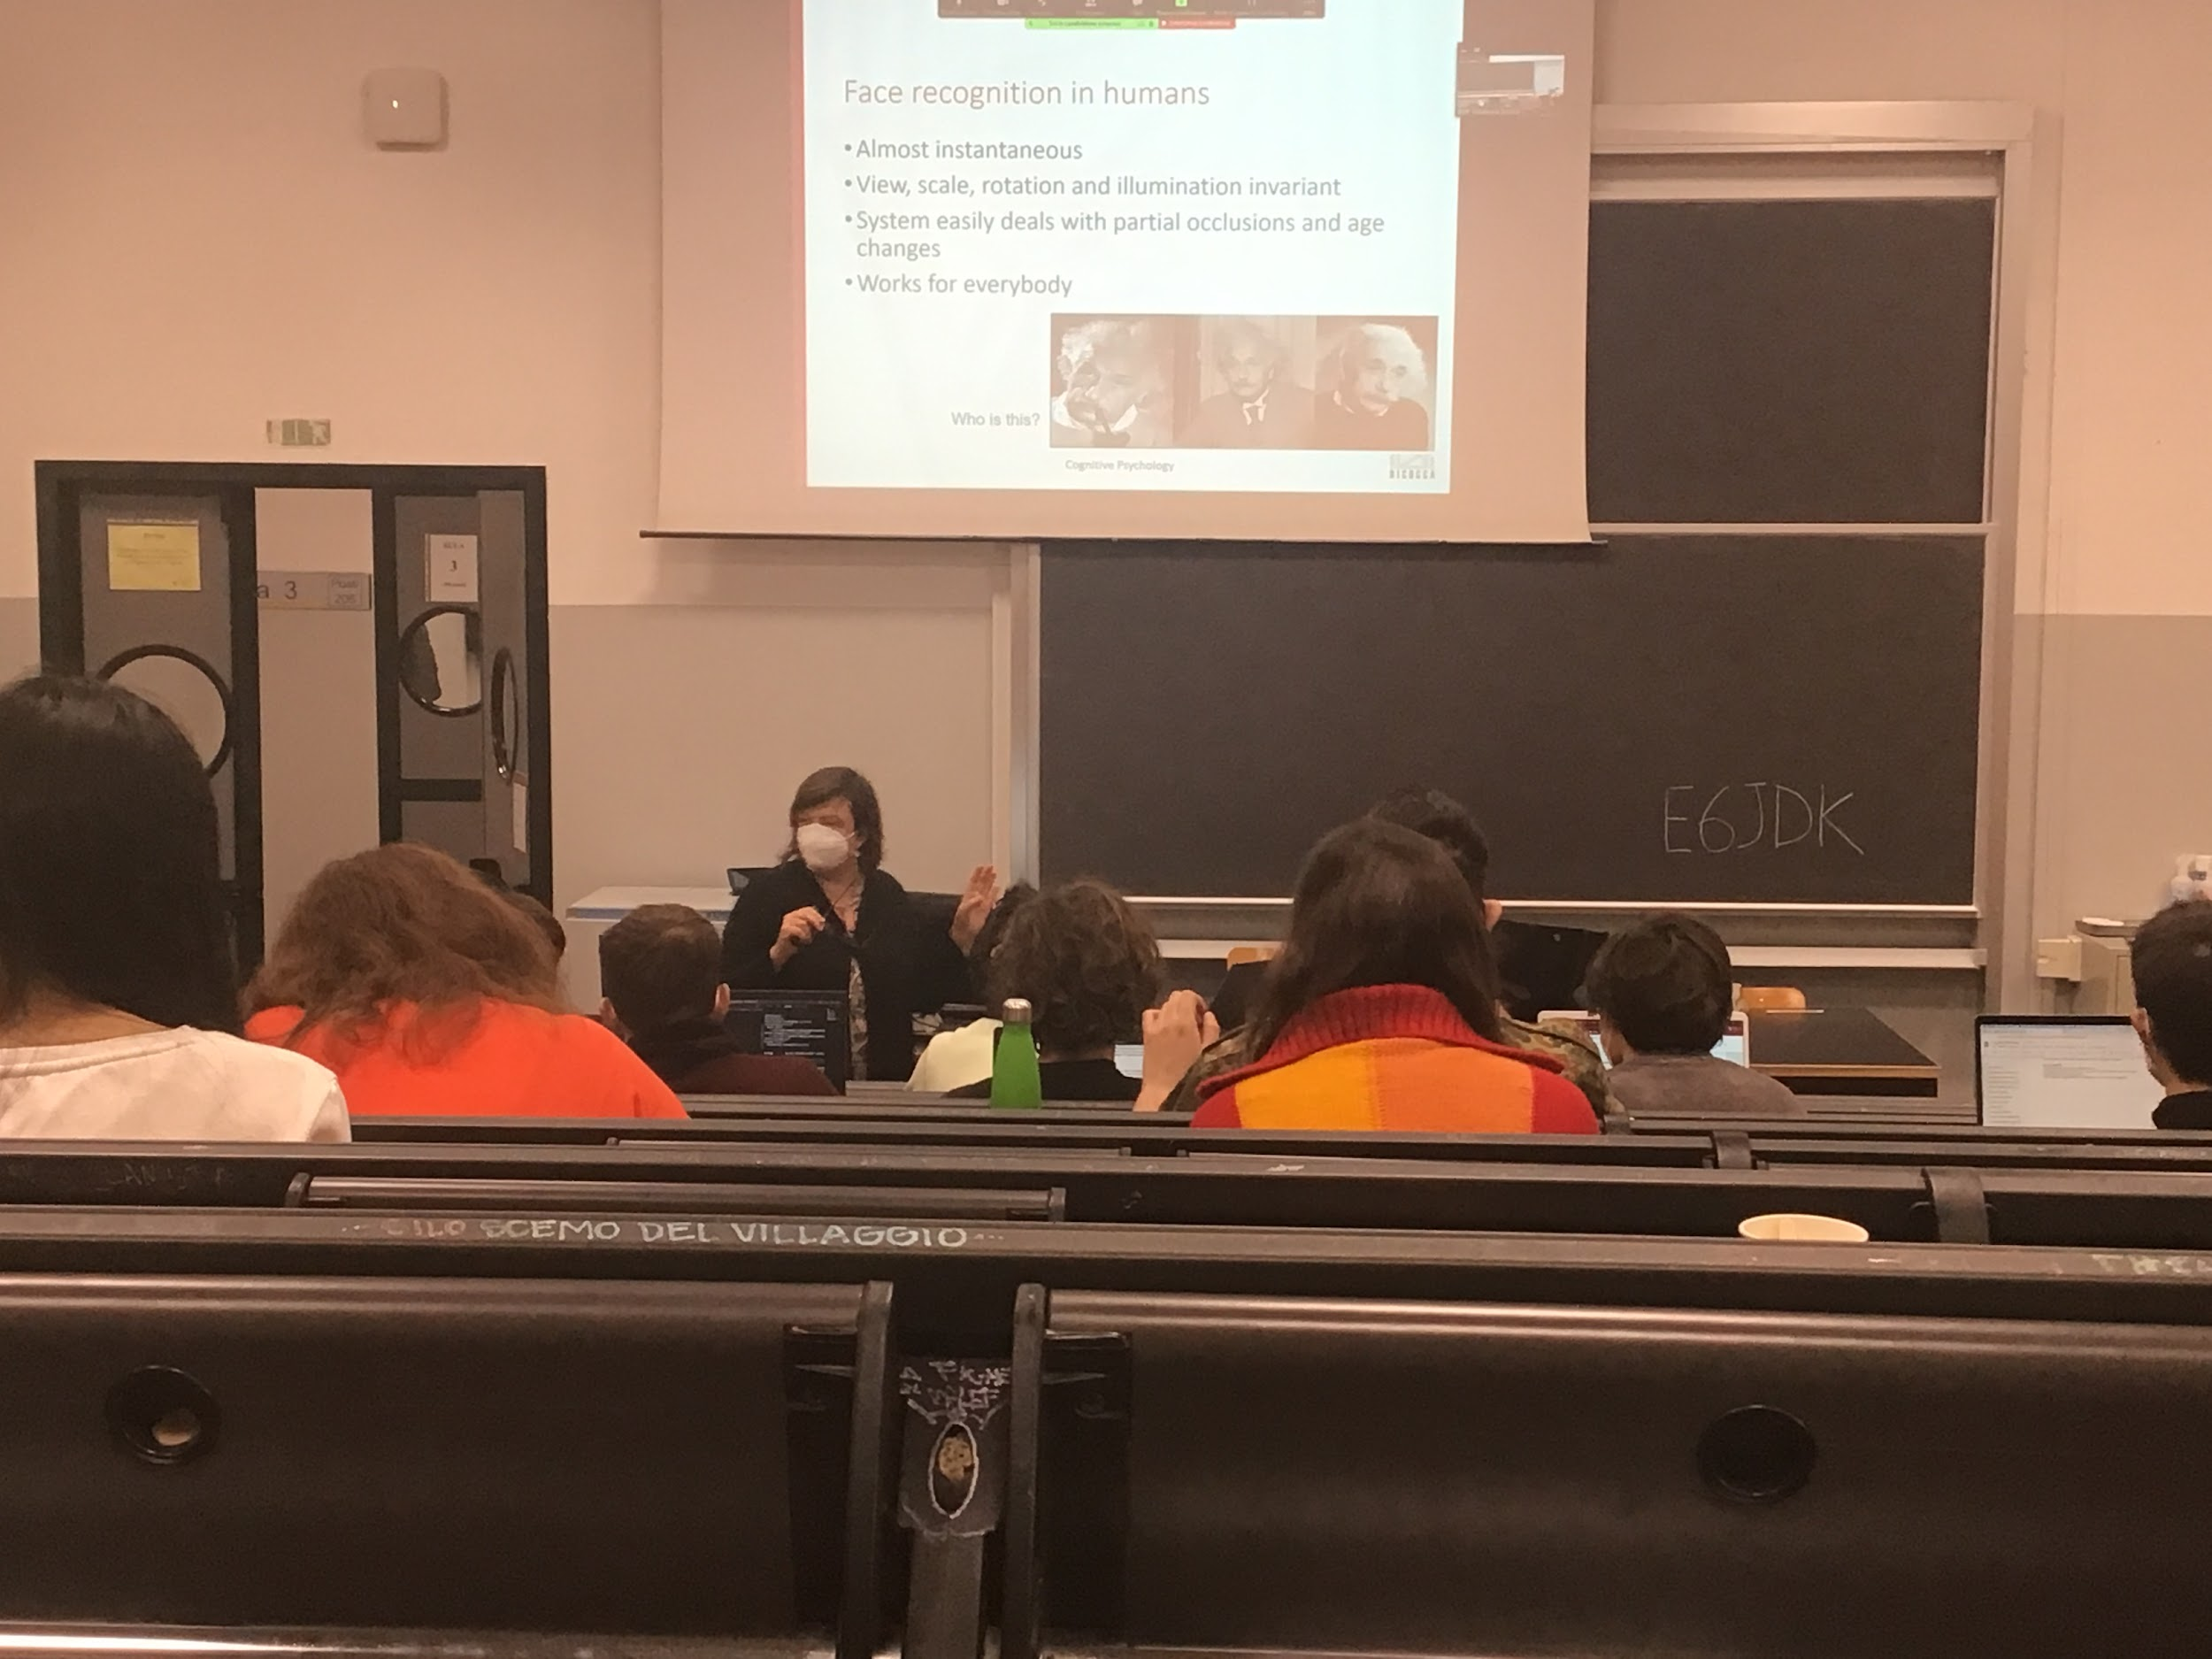

We are very good at face recognition, even if the face is rotated, with different illumination we are able to recognise faces…

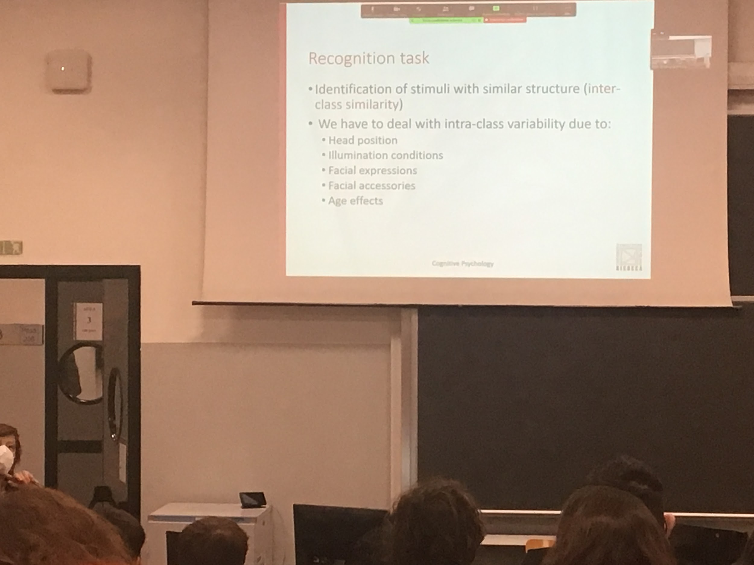

Faces are very similar to each other

Two eyes, one nose, two ears…

All identities are very similar. We have to deal with **inter-class similarity** and the same face also if angry and sad… can change

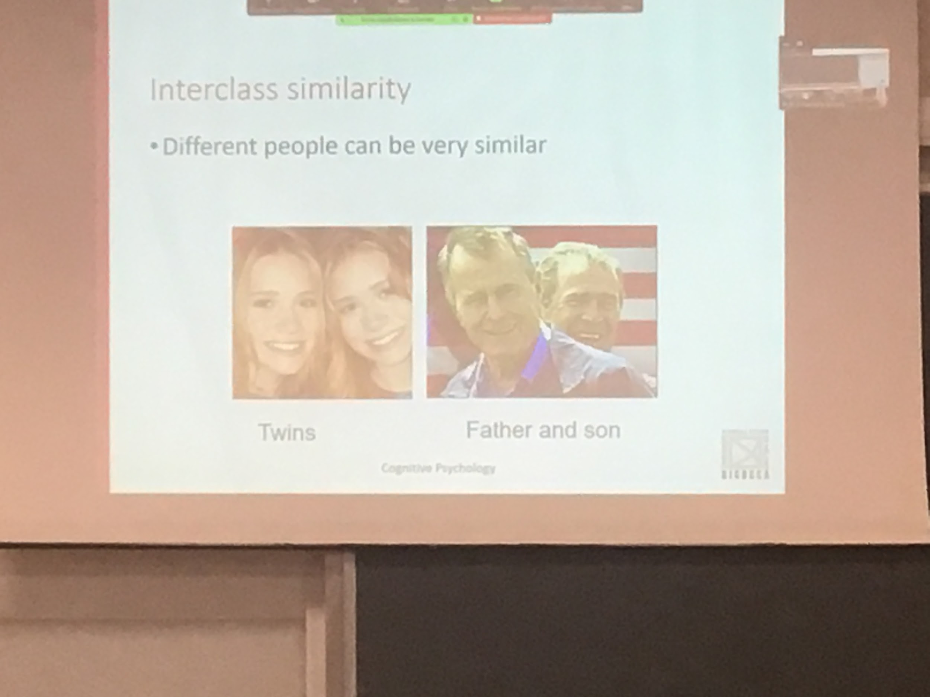

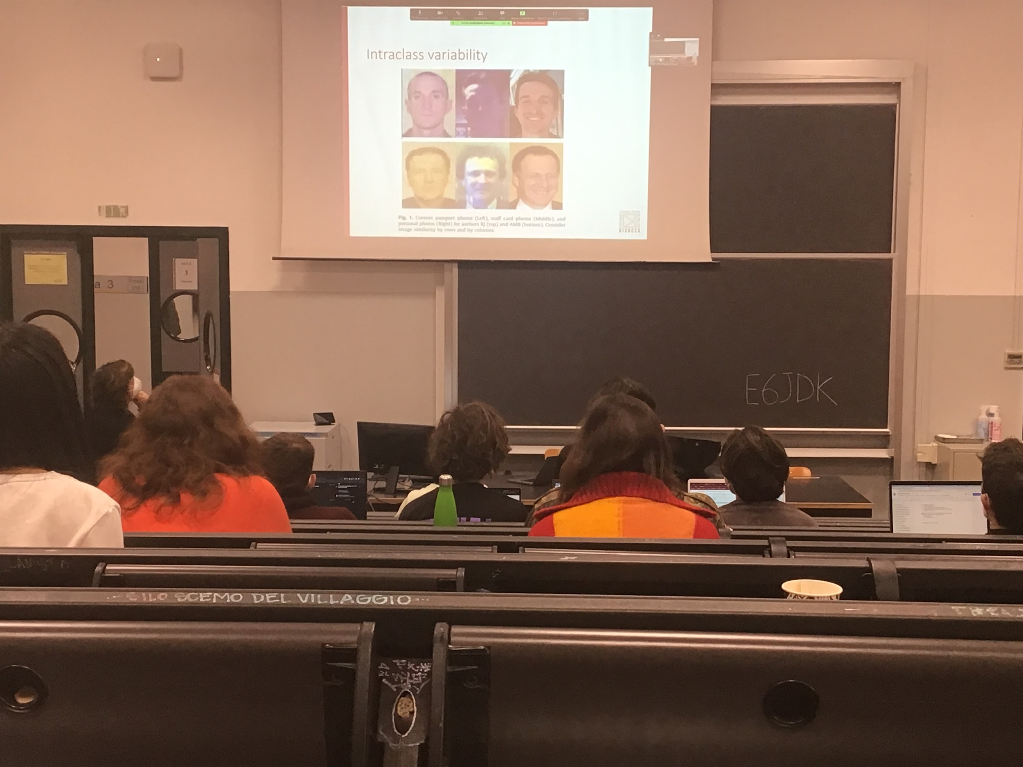

These interclass viability makes it difficult for a system to asociatiates two pictures to the same person

We know

* we are very good at it
* We use a specific type of representation that does not respond at all to the Bidermann idea. If we apply Bidermann recognition by components of two faces we identify parts. Is not what is done by us in face recognition

We use holistic coding

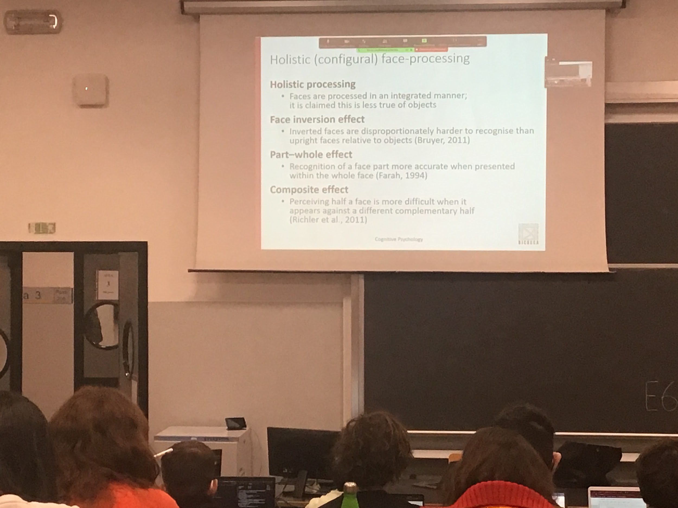

Holistic: We code the face as a whole, we use the global information

How can we demonstrate that we have holistic coding?

We use holistic representation

To prove we use holistic representation:

* **Face inversion effect**: if i show an object upside down our speed or recognition is the same, faces are very different, if I show upside down pictures our ability to recognise faces decreases a lot. When I rotate the image our general structure of the face these configuration does not work anymore
* **Part-whole effect**: if I identify different types of nose, if I show multiple one and ask which one is the same as the first one? If I do the same task for the entire face we are much better at recognise the nose inside the whole configuration
* **Composite effect**: if I have to recognise the top up part of a person in isolation or with a bottom part of a different person we are much worse to recognise when the two faces are mixed

PARTE 2

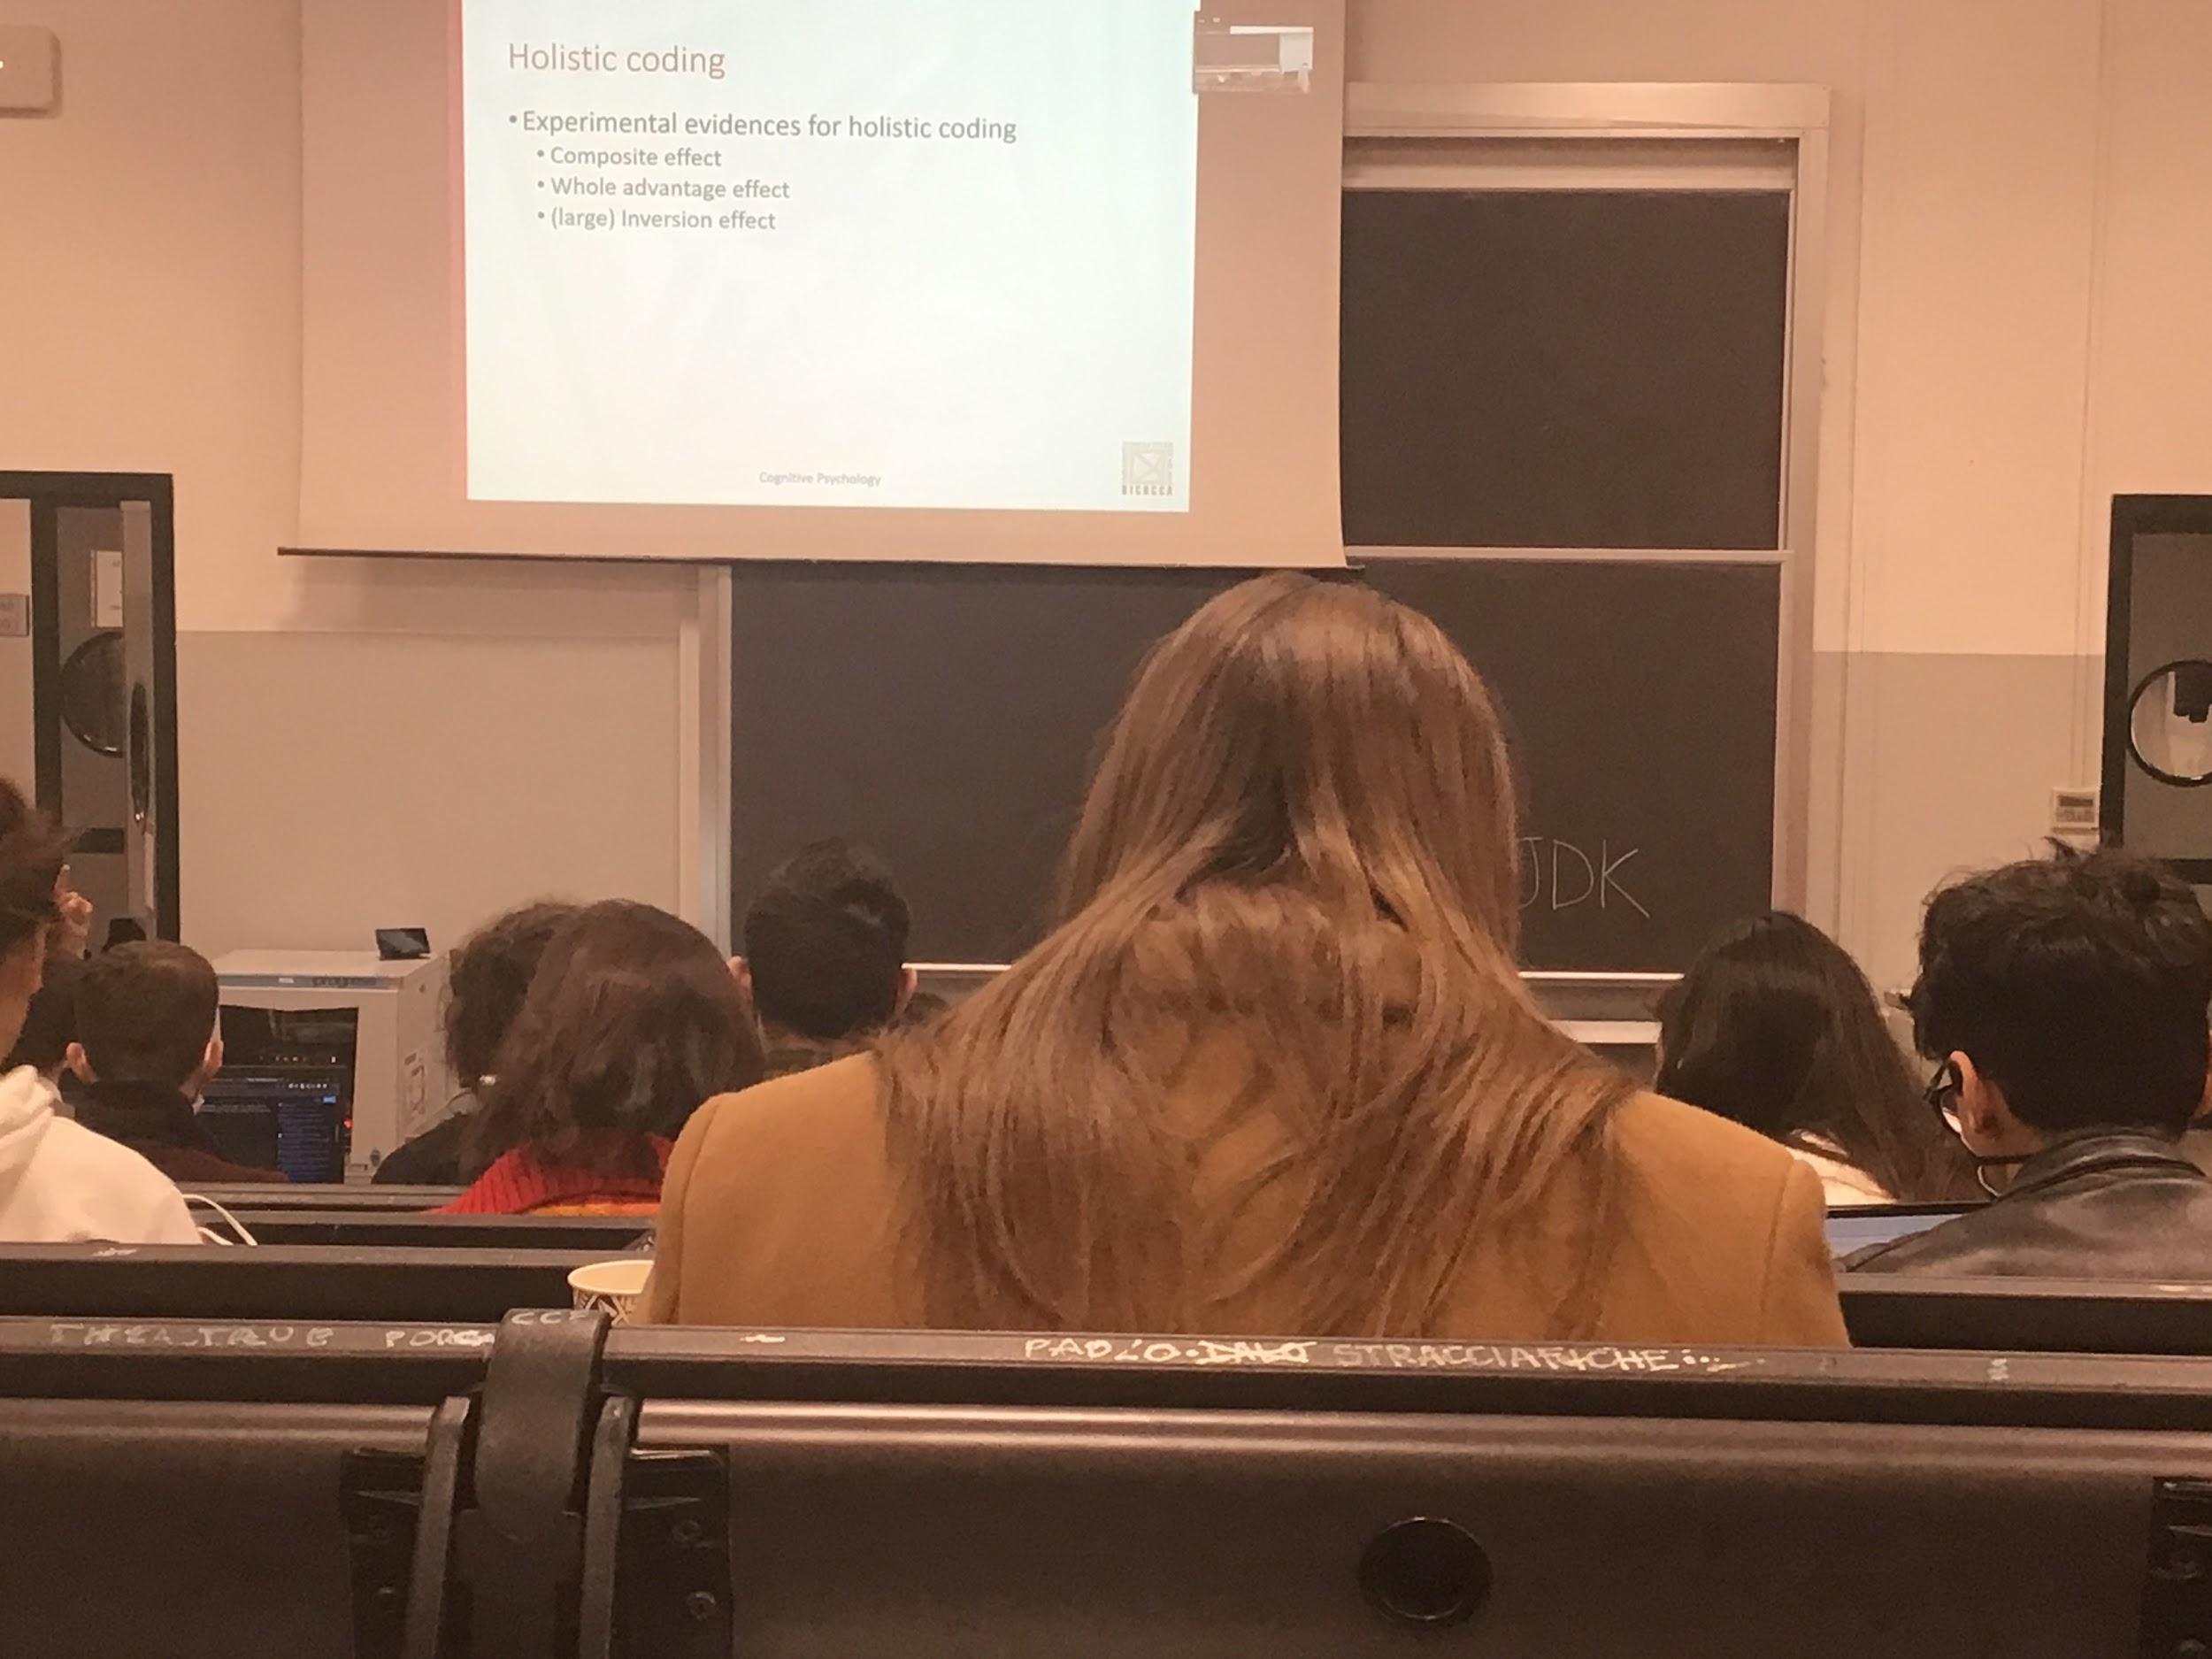

The level of recognition and perception are much higher in the face

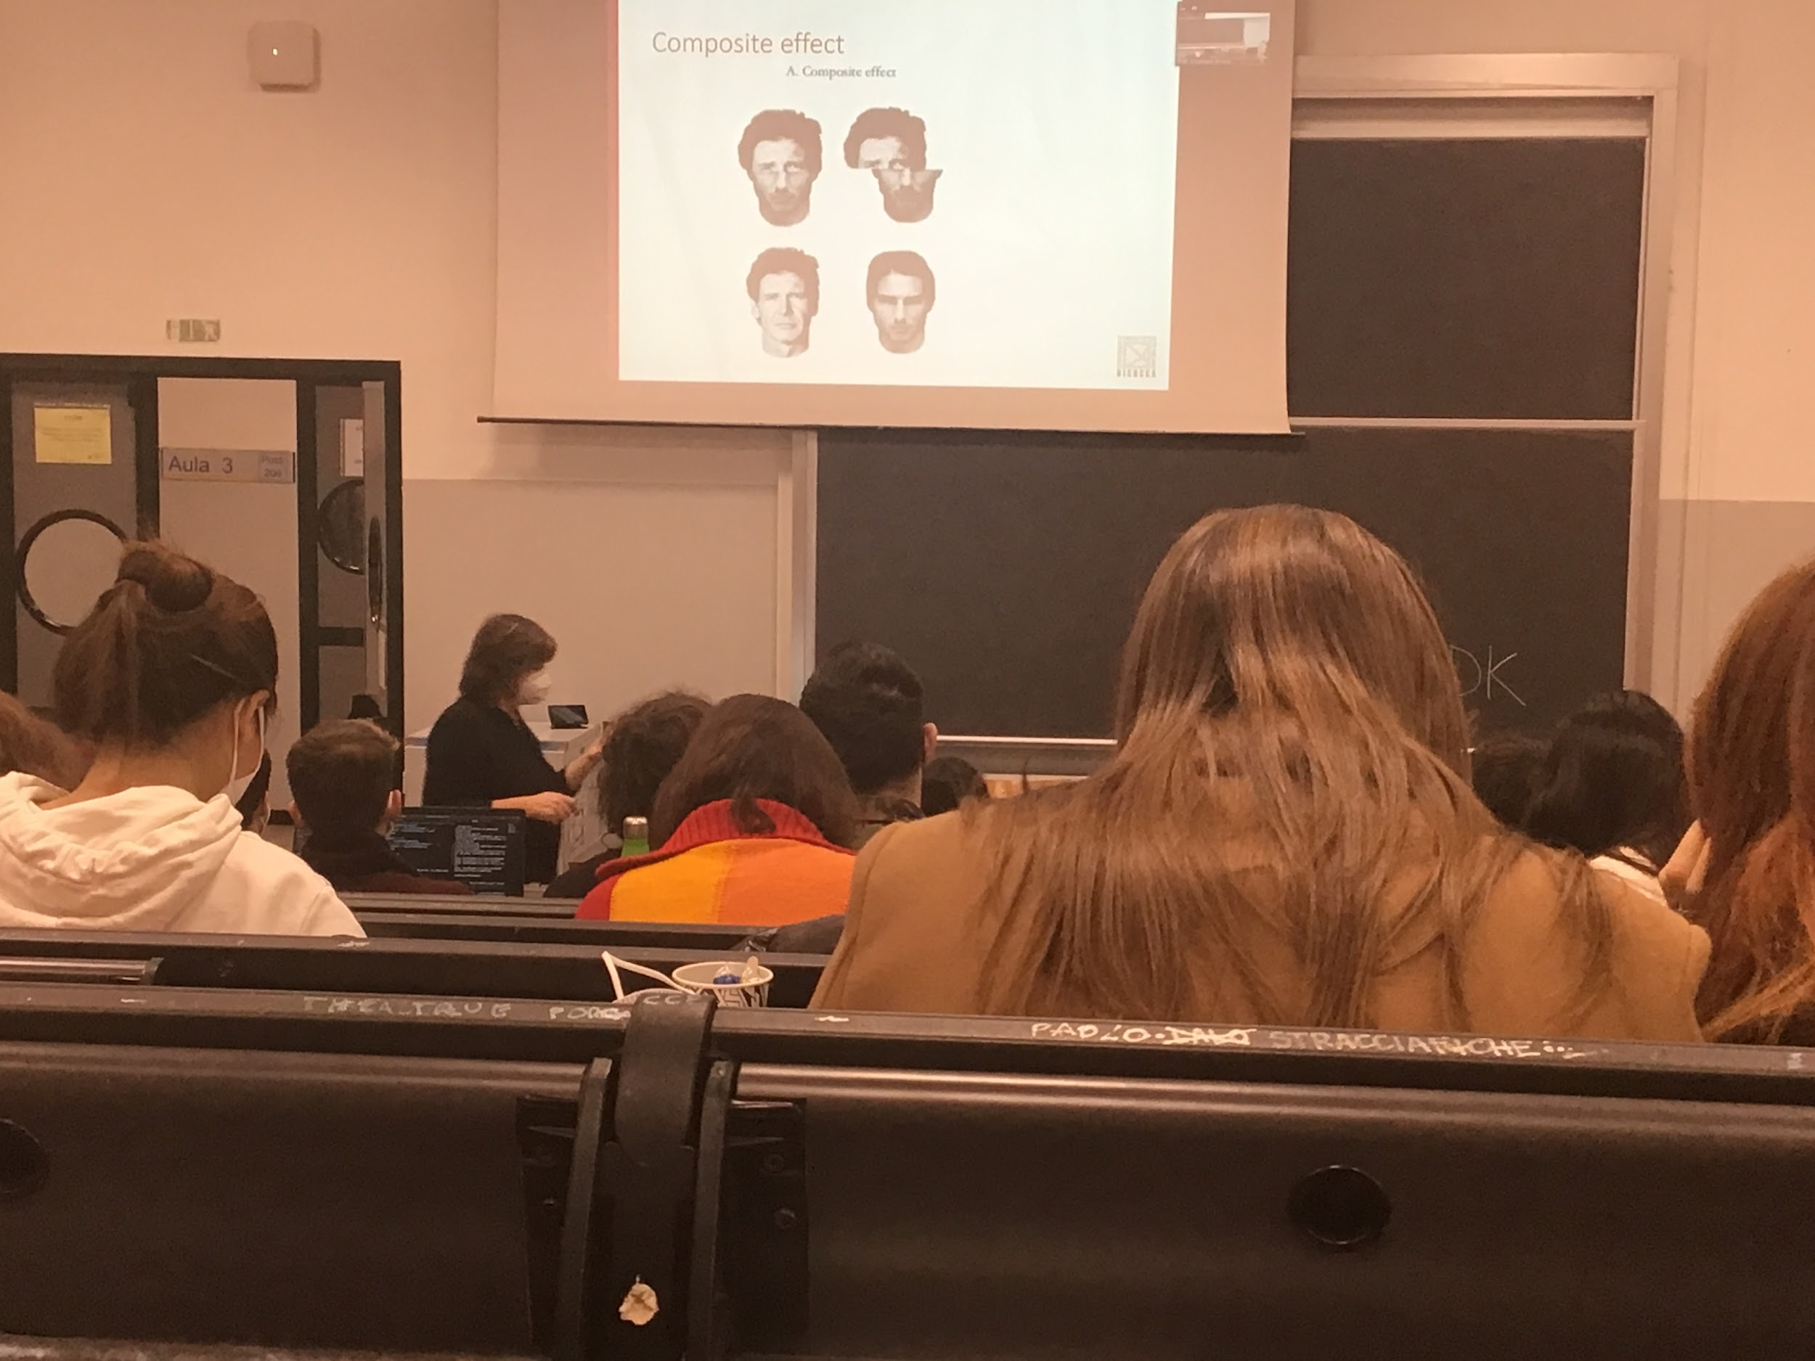

Task: recognise the top up of a face

Ask to memories if the top part is the same or not in two configuration

* in one case I align the top part with the bottom part of a different person
* In one the two part are not aligned

I create some kind of global representation of a face that influences my ability to recognise the top up part. The time recognition when the bottom and the upper part are aligned is much longer than when it is not aligned

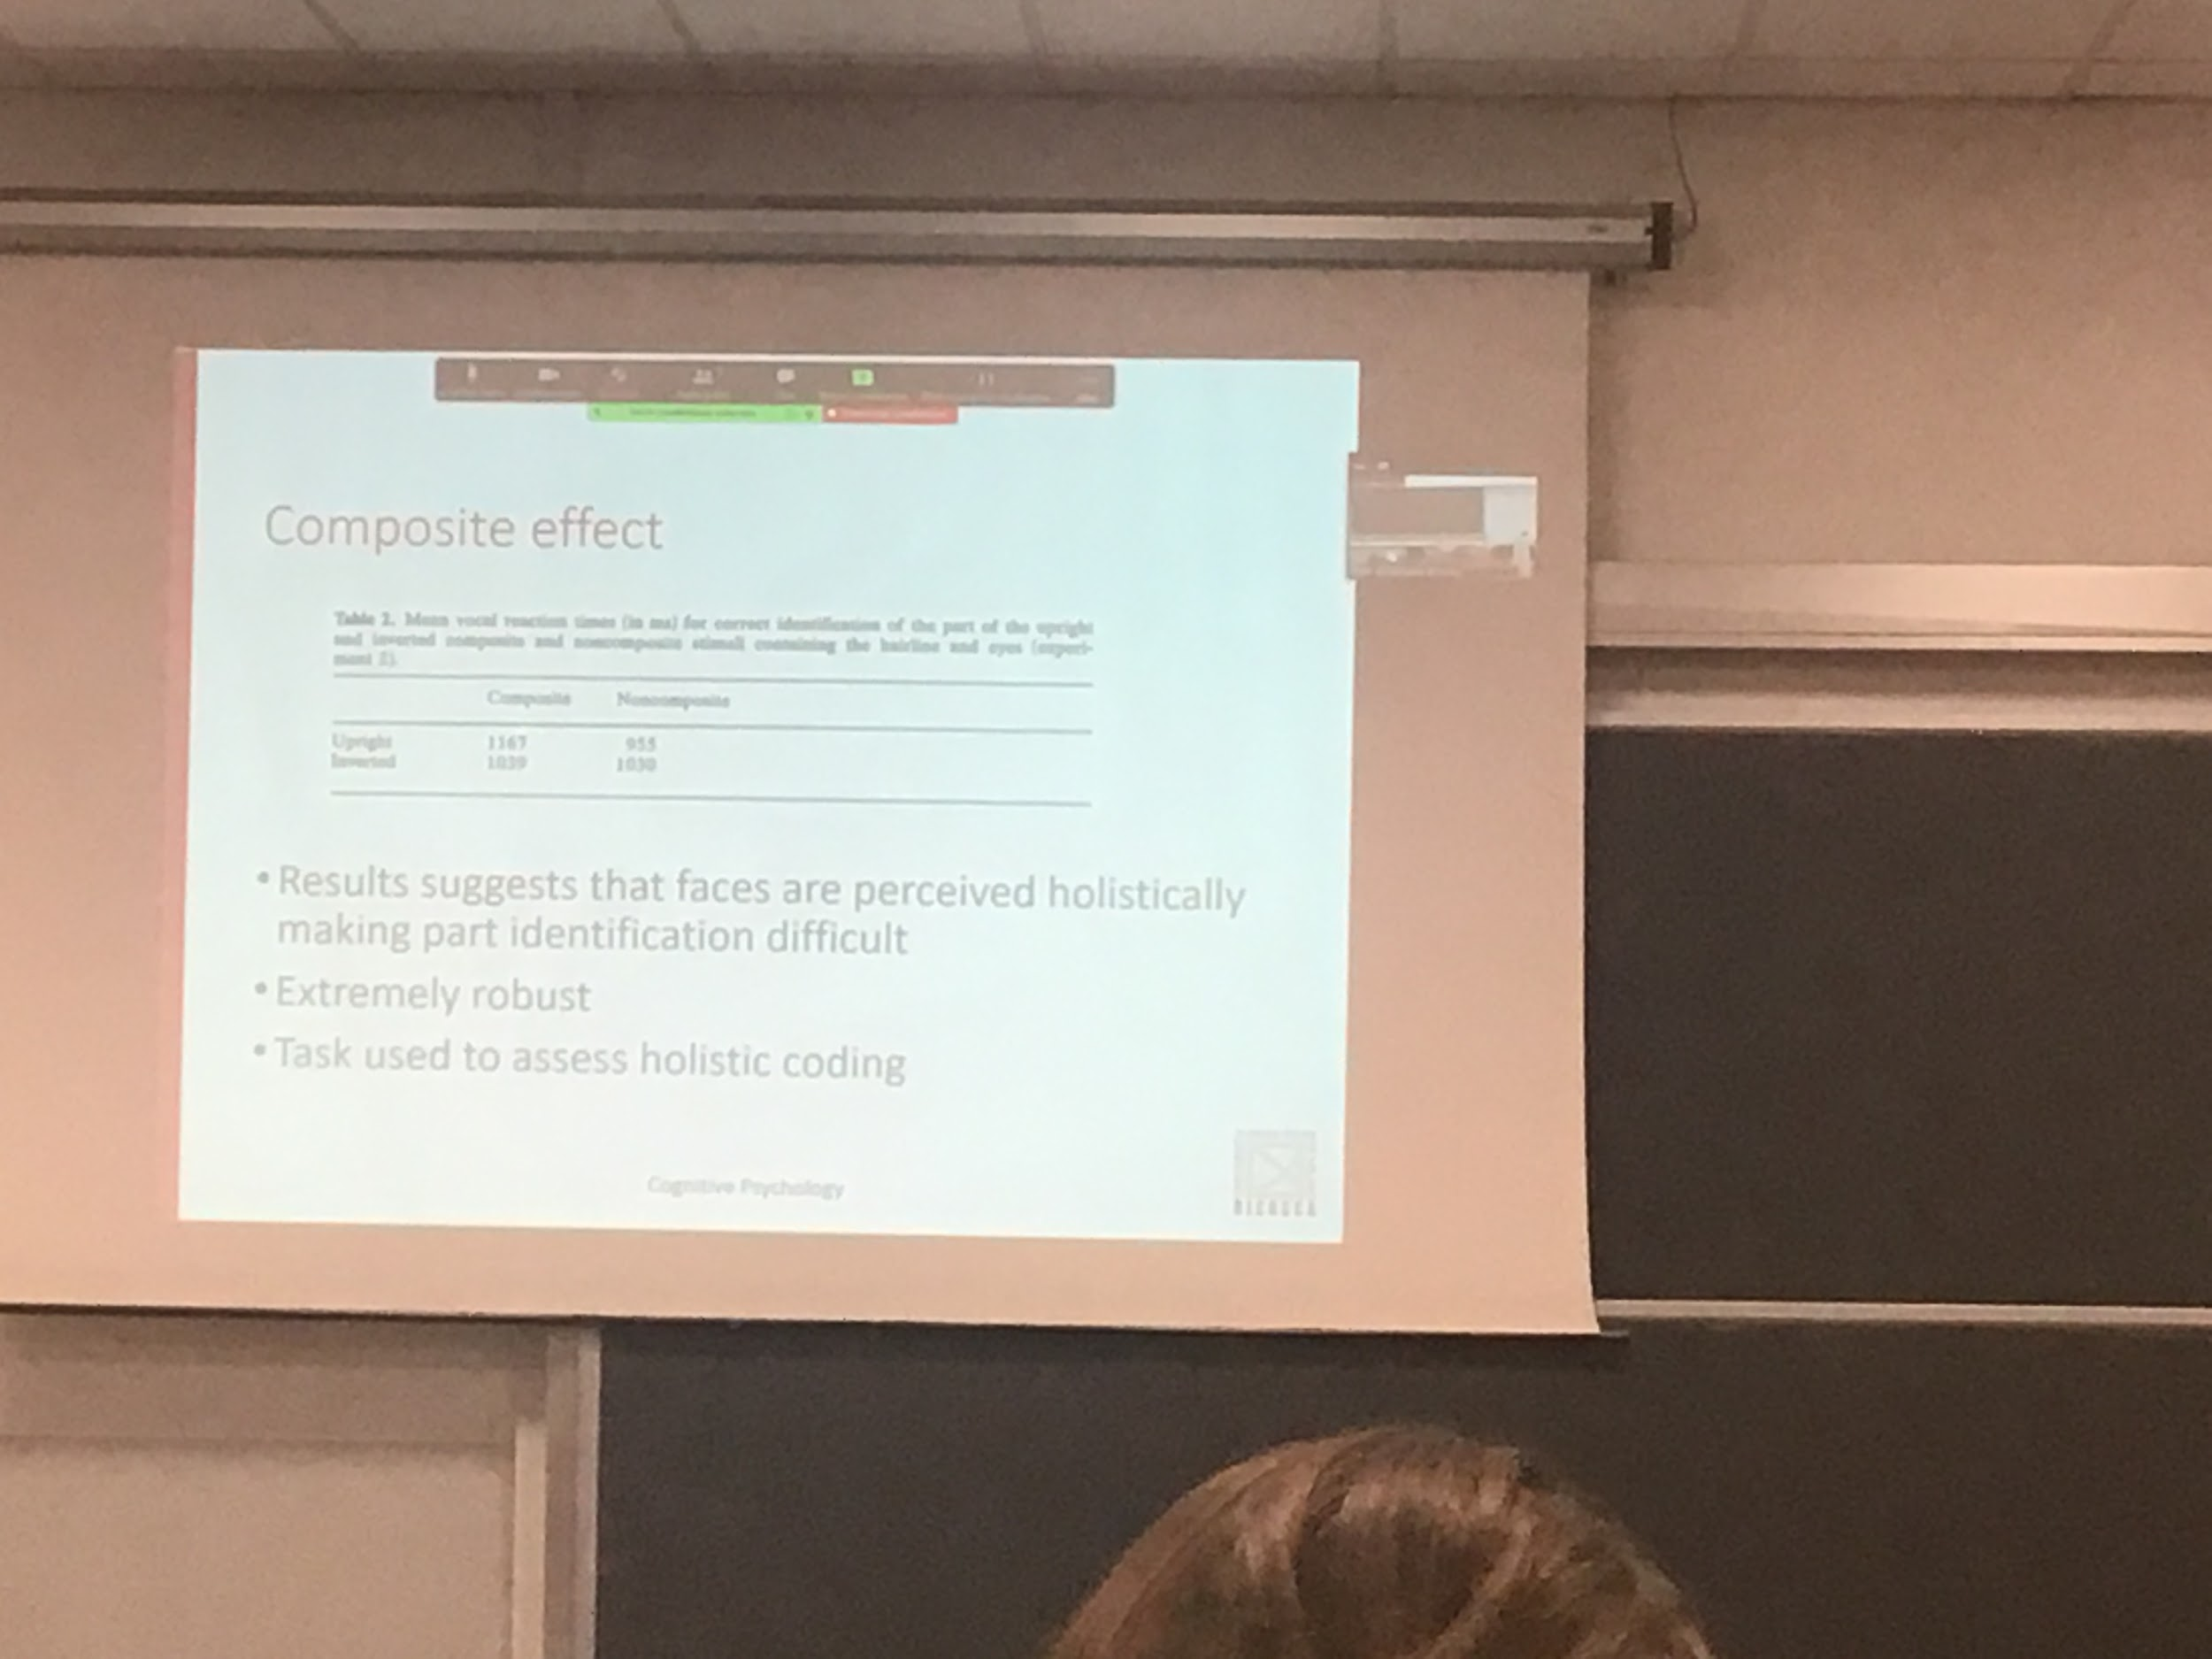

Extremely robust effect

Used most of the times to test if specific face stimuli we have holistic coding

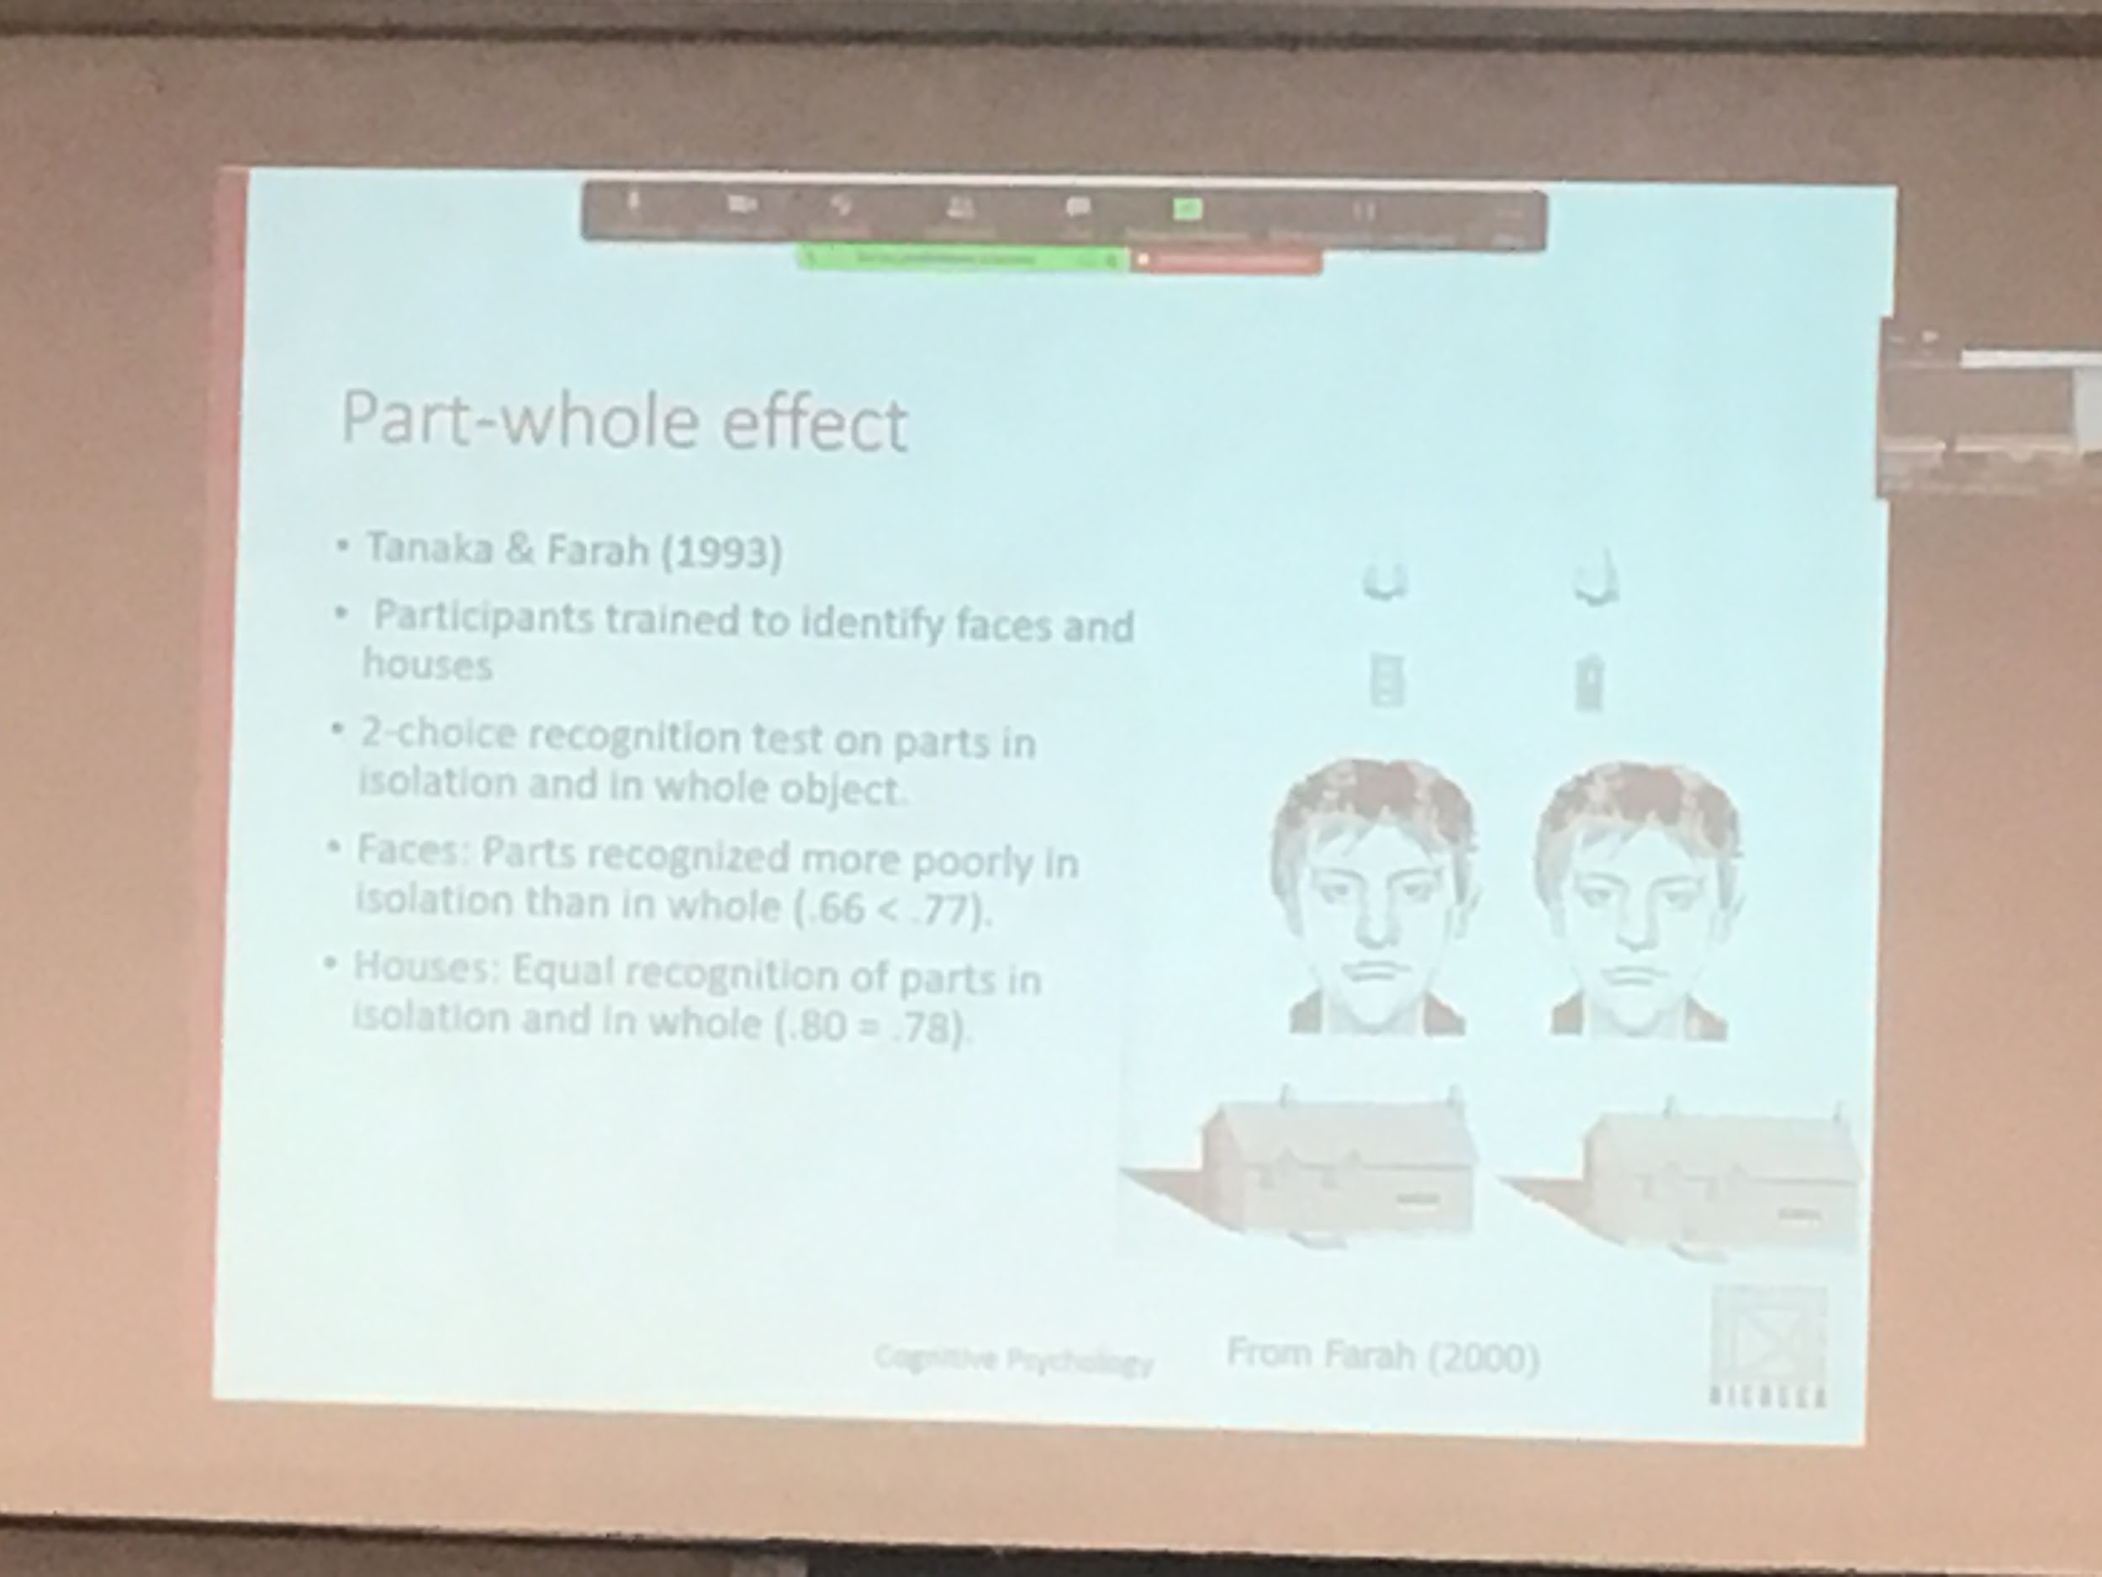

Part-whole effect

Have to recognise faces and houses, test ability to recognise part in isolation of the face and part of the house (nose or door of the house).

The only difference in the two woman person is the nose and the only difference in the house is the door

In the case of houses we have the same ability to recognise objects when presented separately and when presented in the context. While for faces we are worst at recognising when it is presented alone than when is presented inside the face

Data in favour of holistic representation

Means that we are so good at recognising small differences whiting the face

Also if I move the parts (nose instead of the eye)

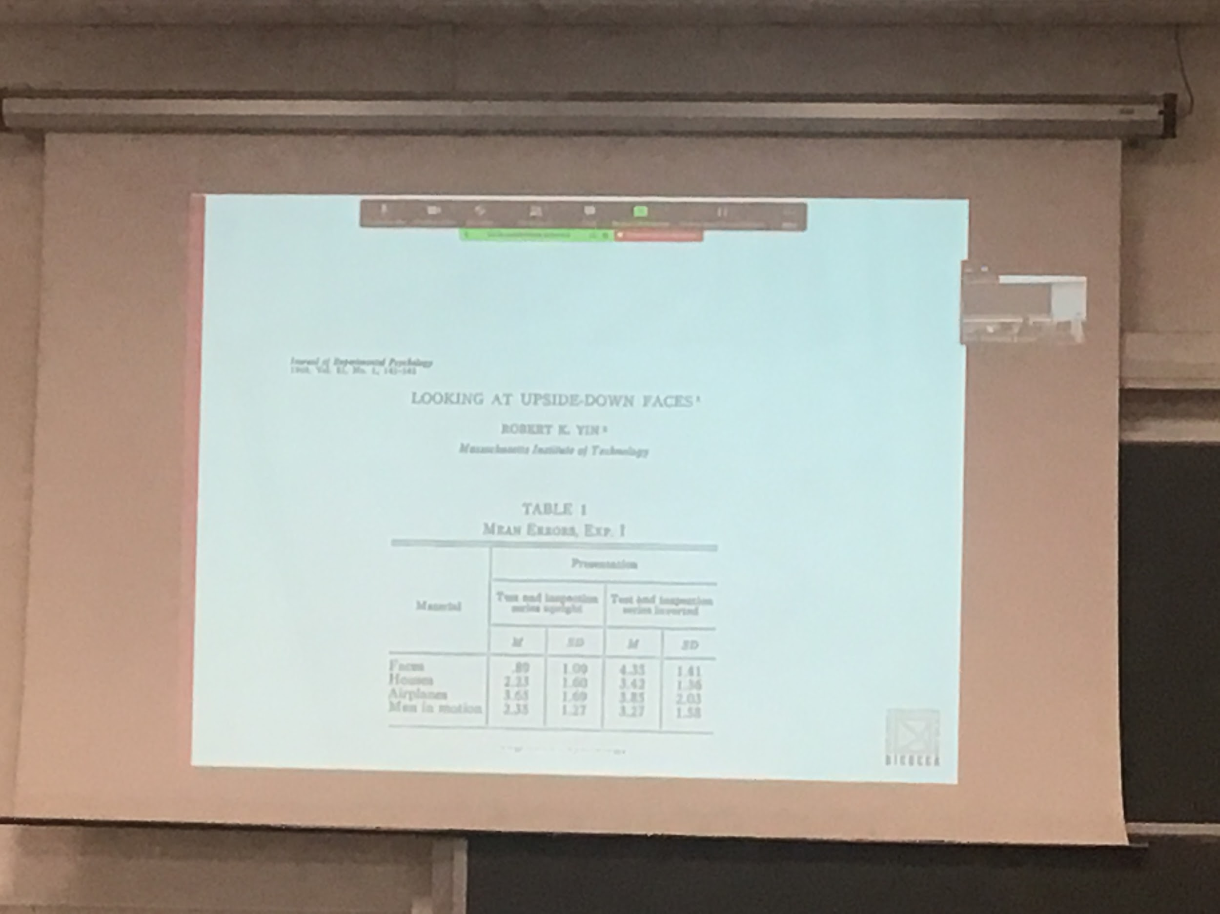

Inversion effect

Present in other type of stimuli but much stronger with faces

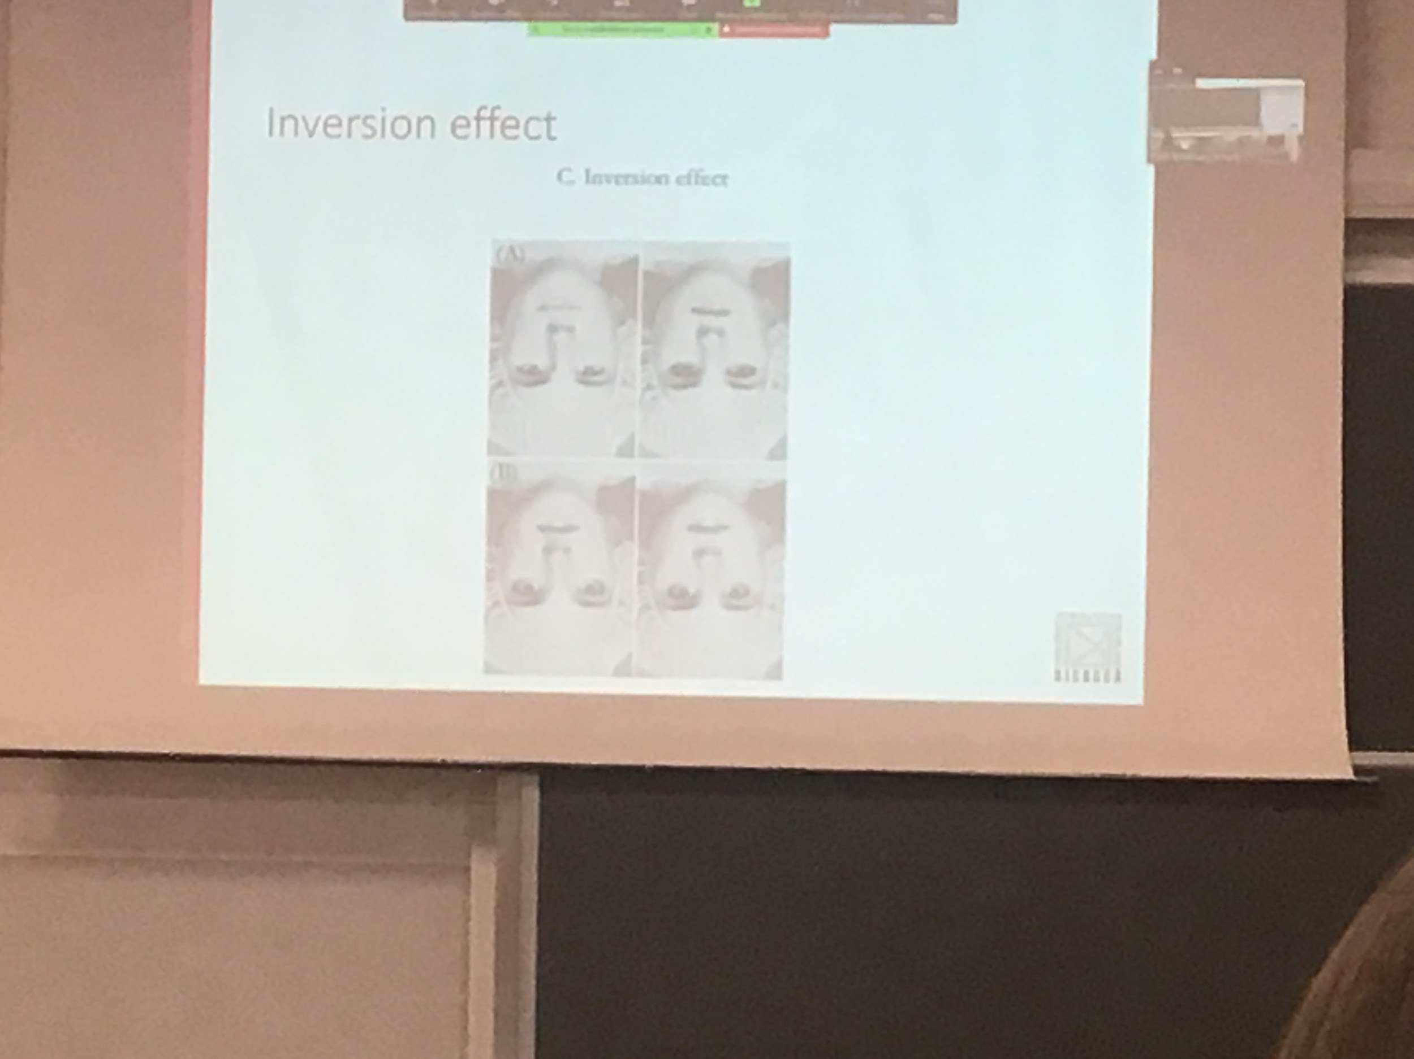

If I ask people to **discriminate** between the **two couples** when the face is **upside down** people **takes longer** to compare the two faces

The discrimination when the two faces are positnate in the normal way we are much faster to discriminate

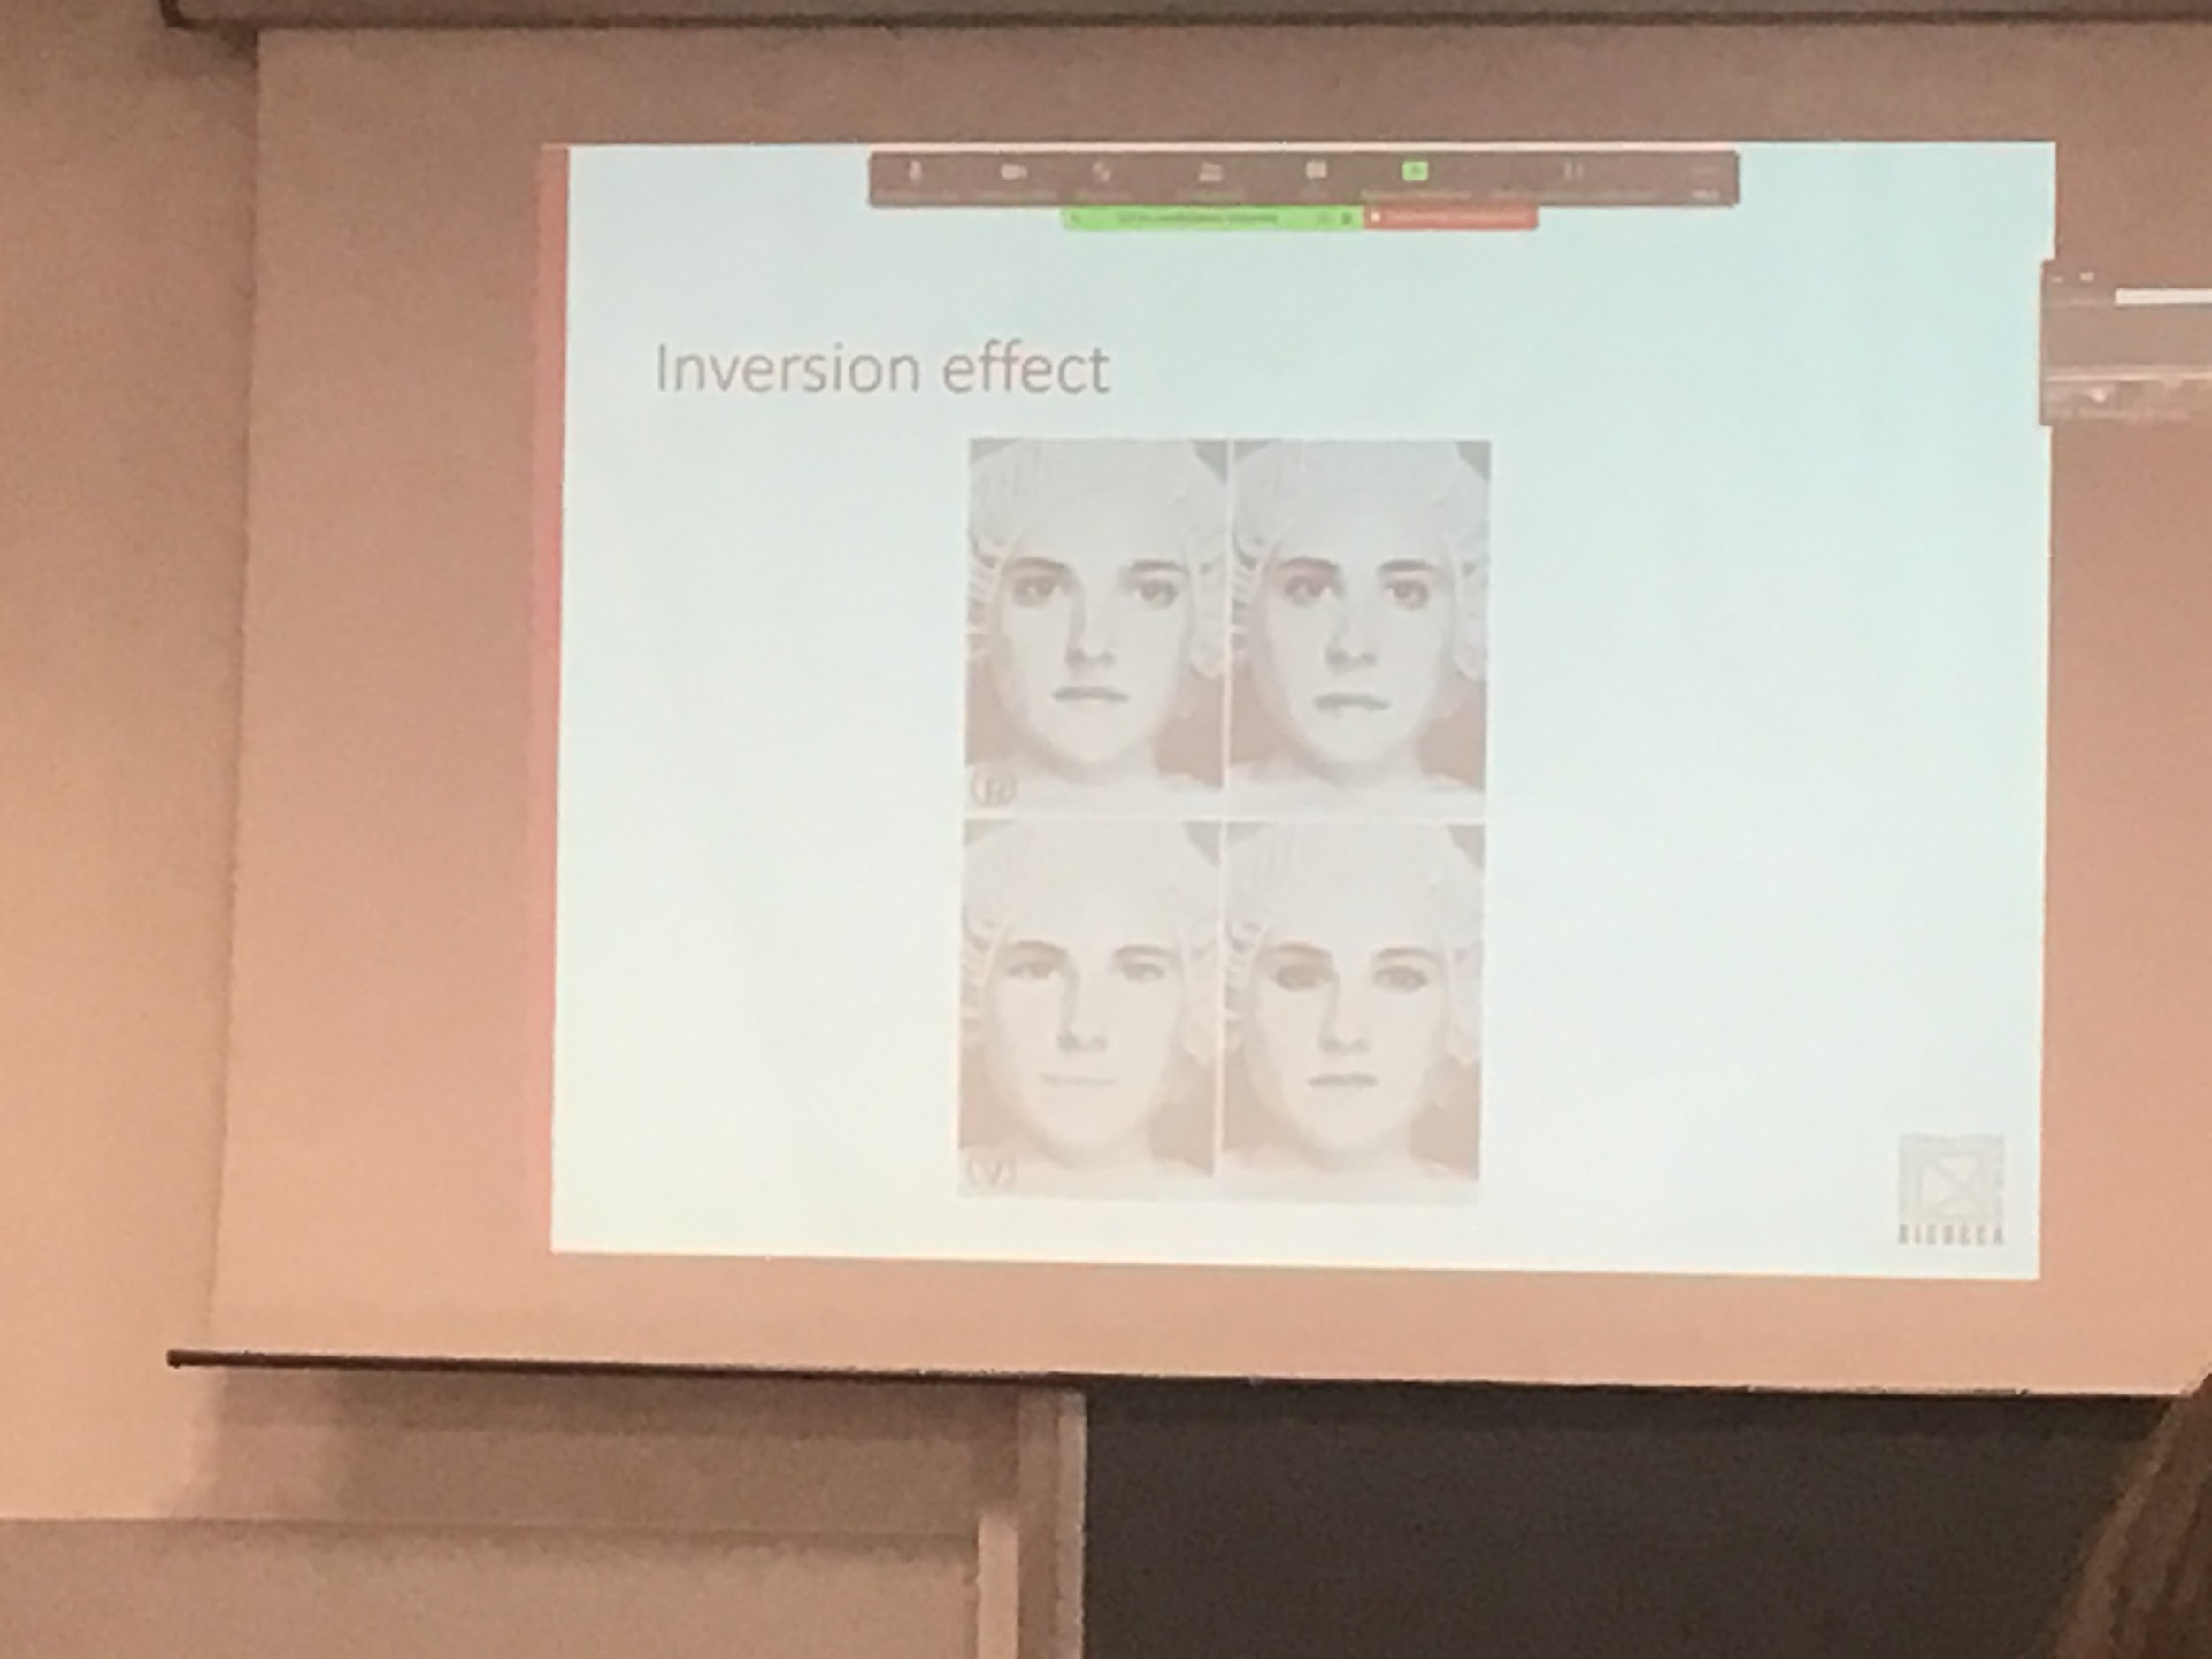

Having the face in the standard position your system codes this information optimally, able to discriminate differences much faster

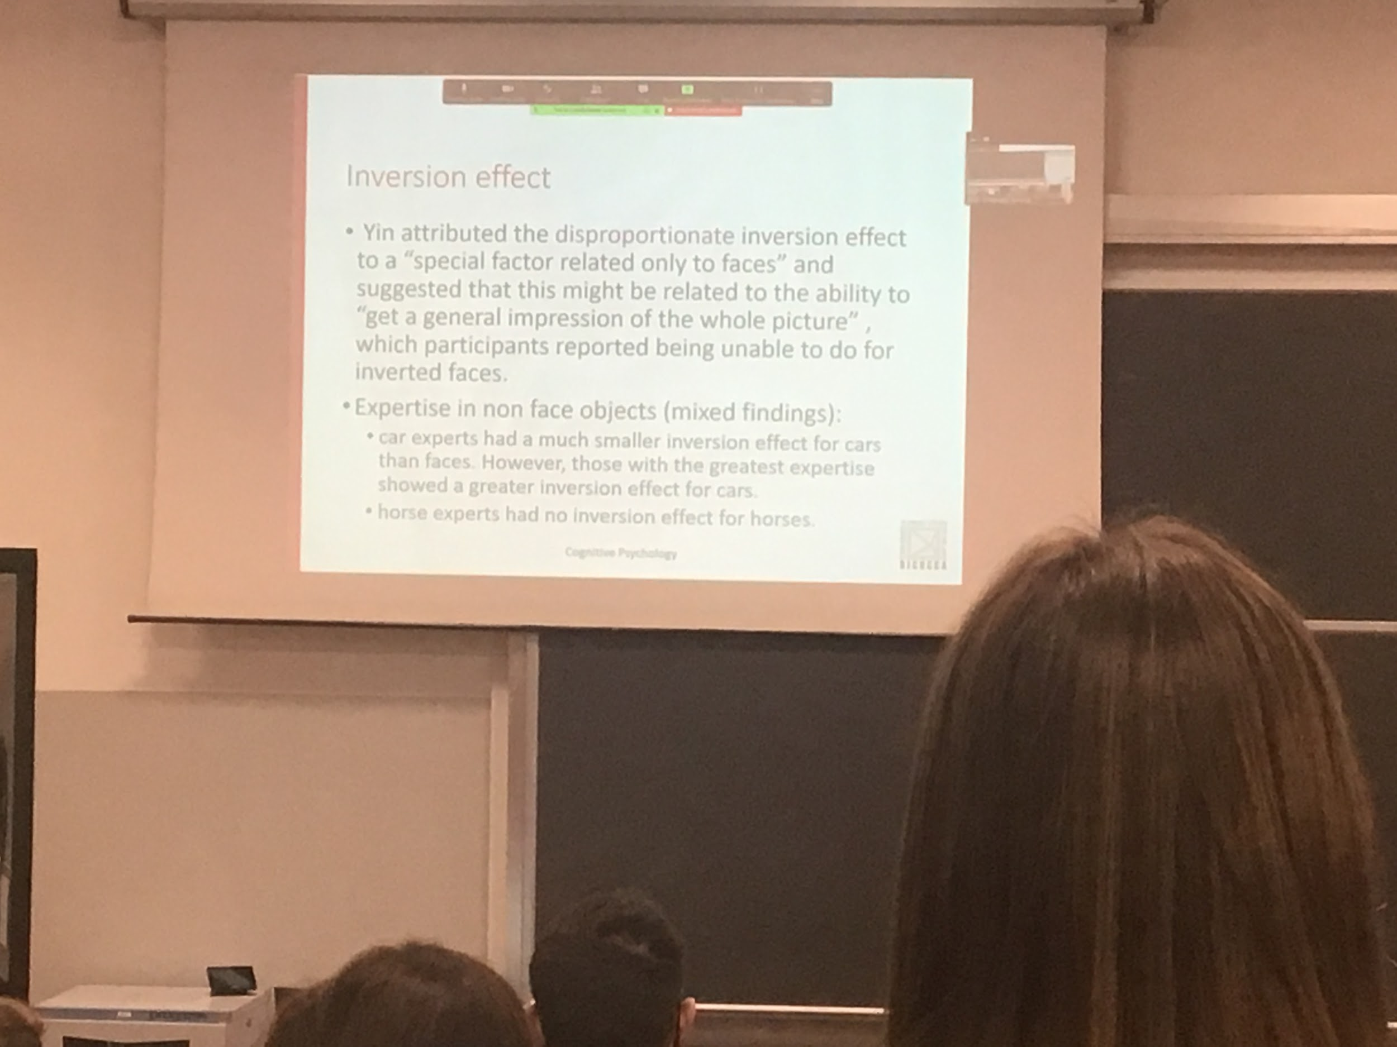

There is inversion effect in everything but in faces is much stronger

We are able to get the general impression of the whole picture (holistic coding)

Why do we have holistic coding for faces? Is it innate (brain build in such a way that faces have a specific area where they are coded) or are we very expert in faces (maybe we saw many faces and we become experts with this ability) ?

If we were experts we should have this property also with different types of objects and many experiments have been done but we have mixed findings. In some cases very expert car dealers (that need to recognise many cars) have a larger inversion effect than people that don’t work with cars. But horse expert seems to not have this effect. Not clear

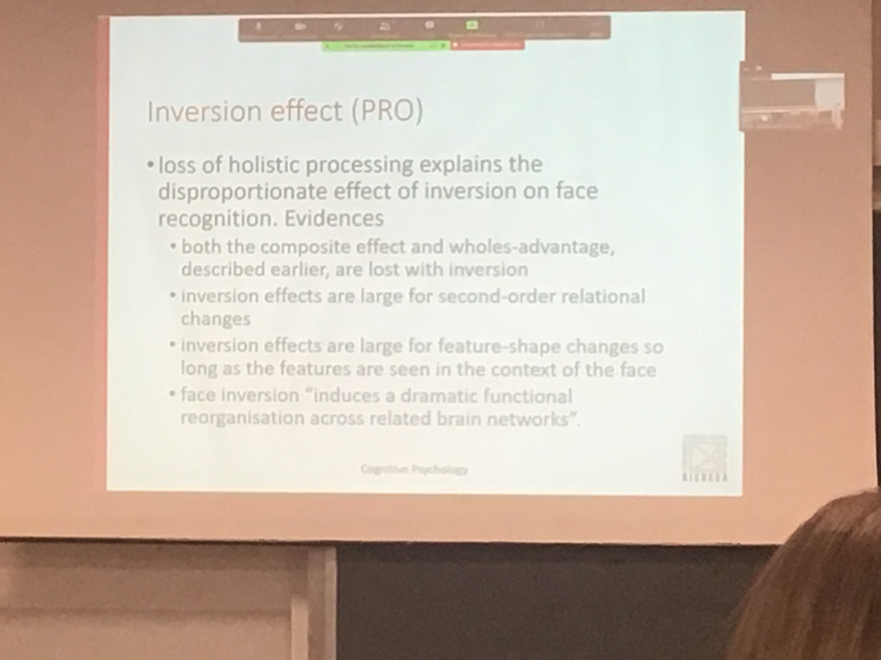

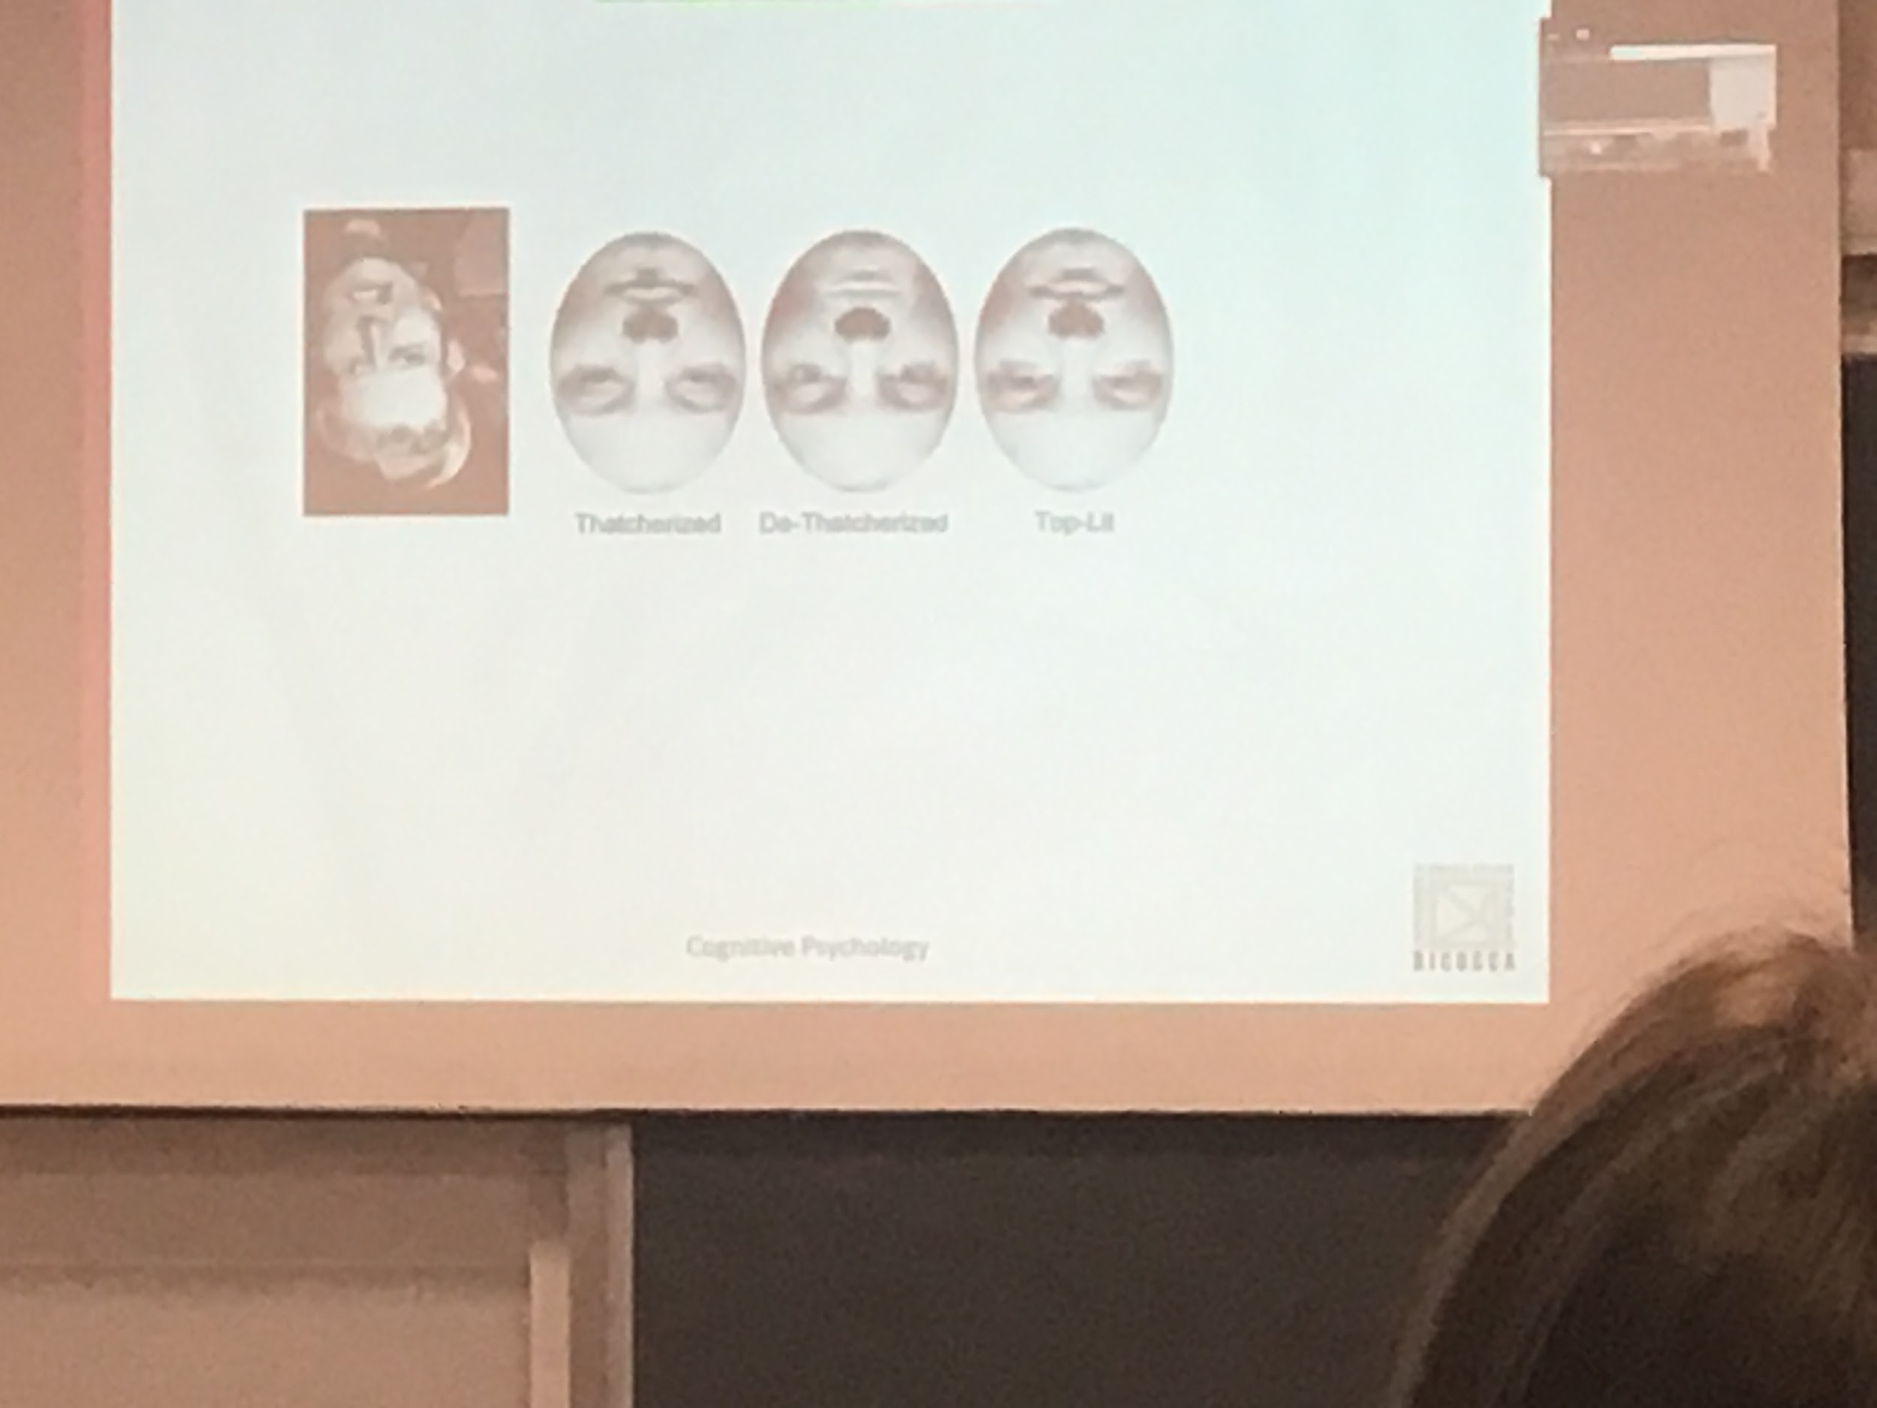

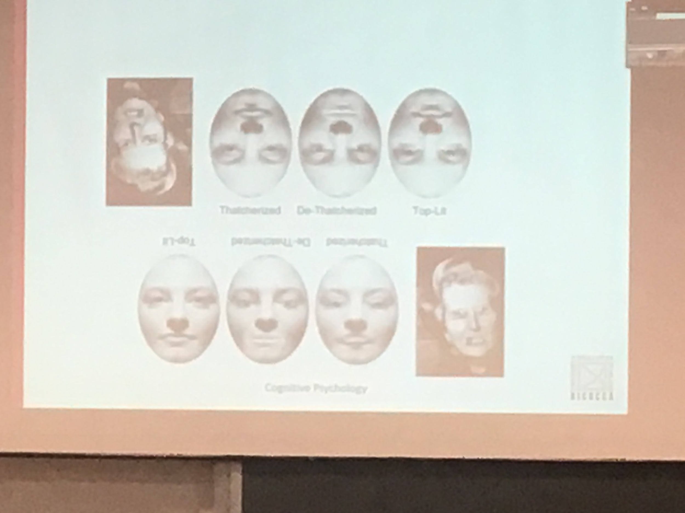

If I register your brain activity when I show you upright faces or when I show inverted faces, the activity in the brain is completely different

There are different processing units that process faces

Mouth and eyes are rotated 180 degrees but in the flipped face we don’t see it very well. You can recognise the inversion of the eyes and the mouth when is in the standard form very easily, but when the faces is inverted is very hard to see them

In the upright condition our representation of faces is global and holistic and much more detailed that when the faces is upside down

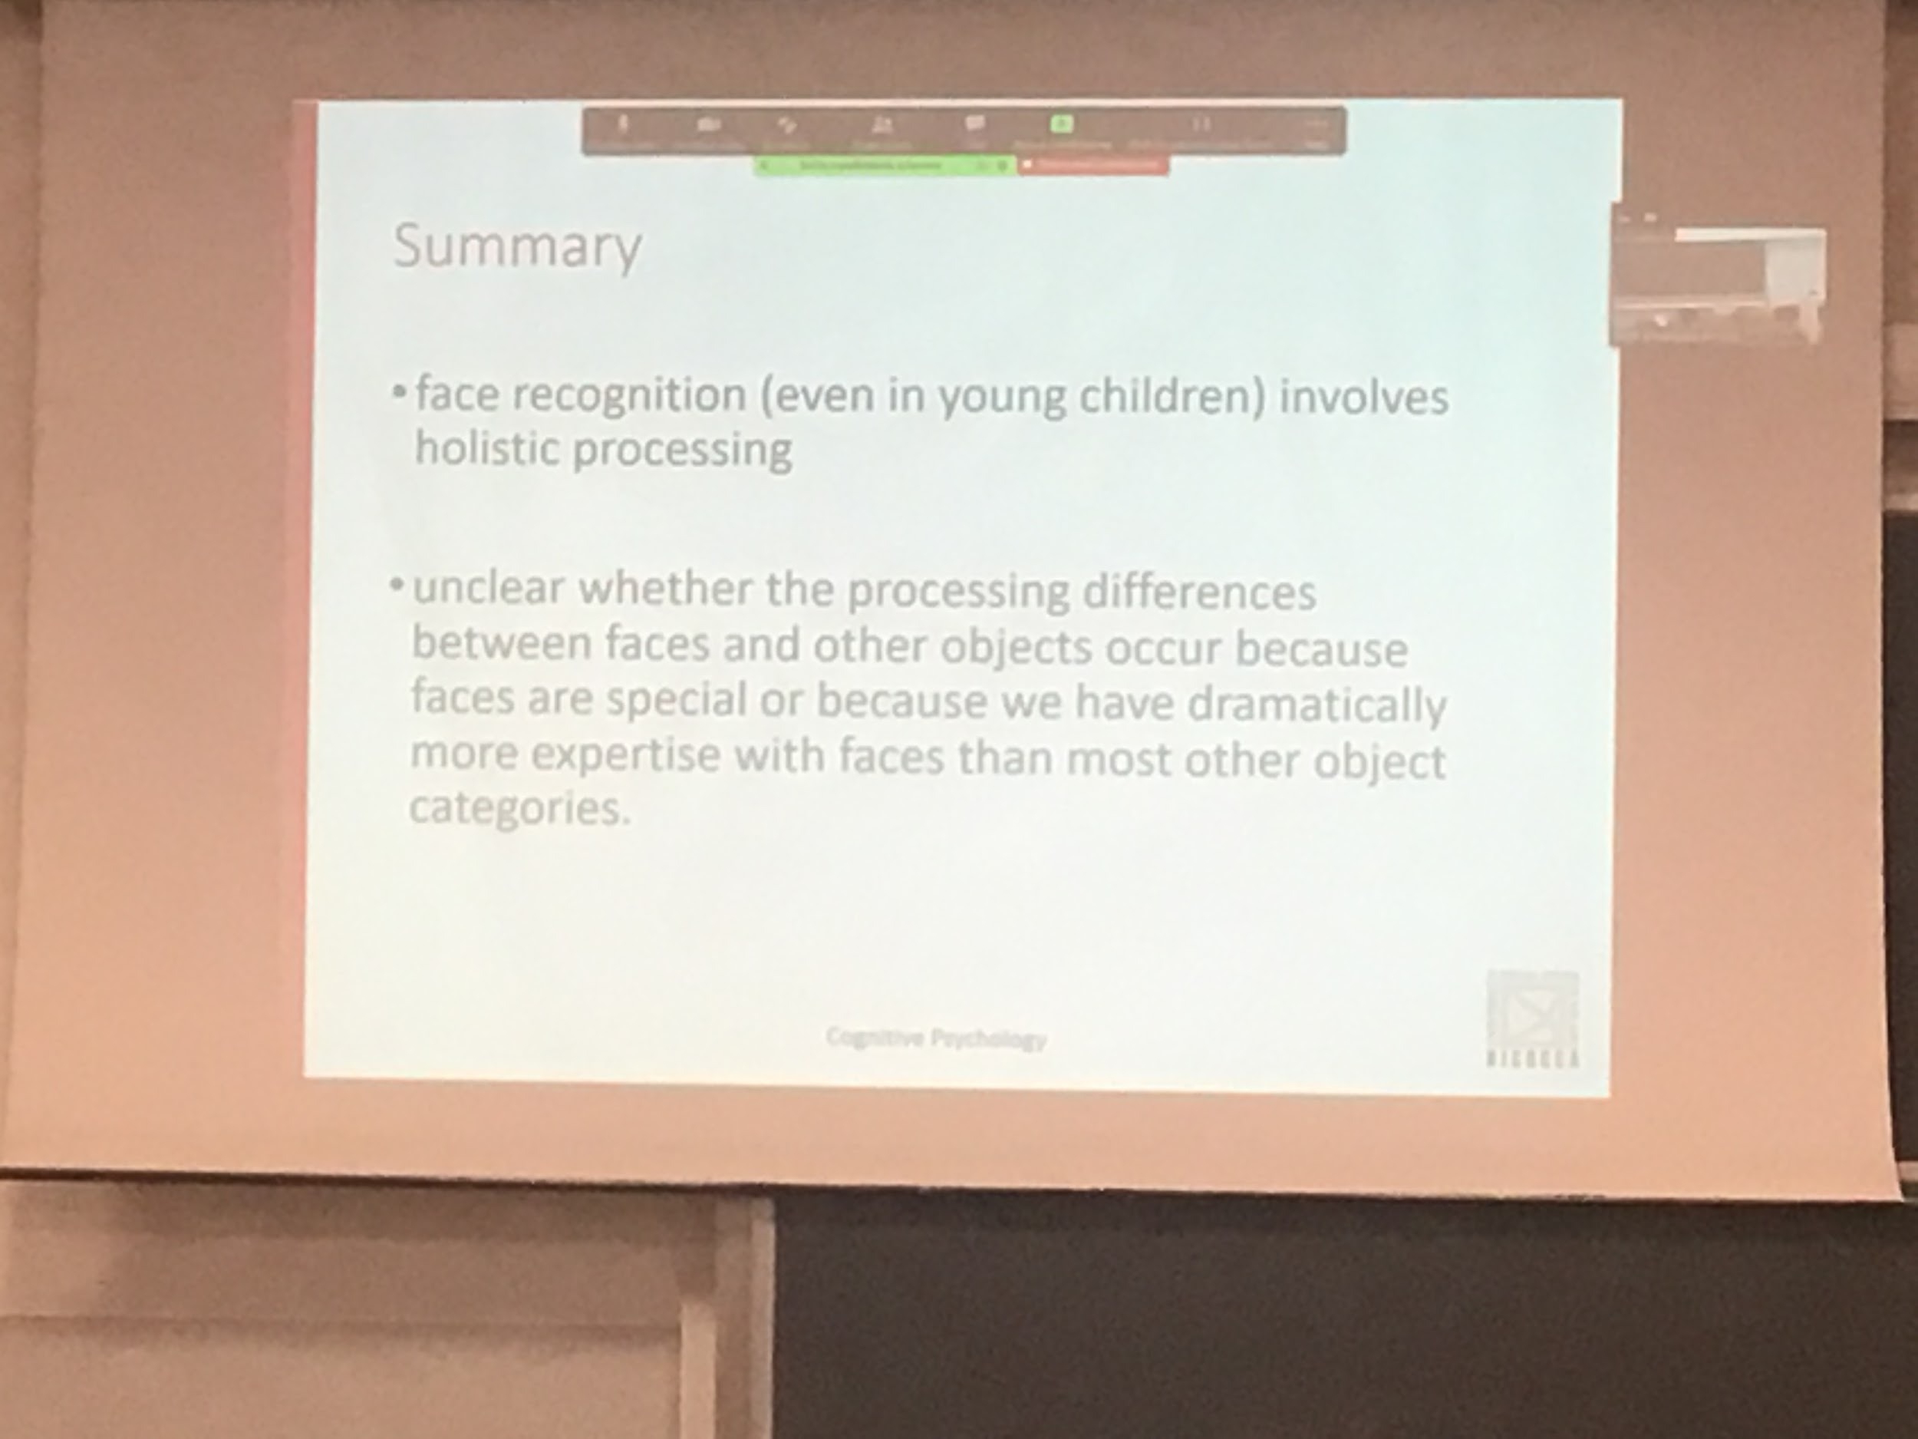

Holistic processing also in children, not clear if that is do to expertise or special status of faces we are born with

To better understand how face recognition work: we have to look also at defices

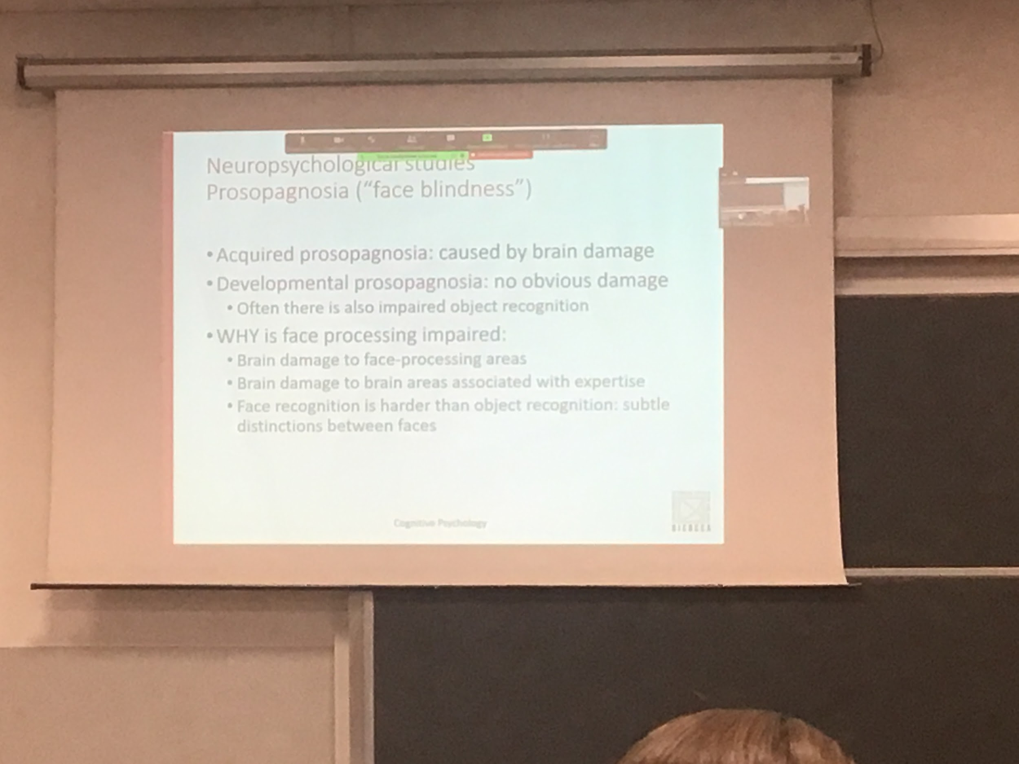

Two different types of prosopagnosia: inability to discriminate faces

* **Acquired prosopagnosia**: have some brain lesion and after that you are not able to recognise faces
* A larger population of people have **developmental prosopagnosia**: inability to discriminate faces looking at their faces, mostly in man, male are mostly unable to recognise faces. People realise that they have prosopagnosia later, and can recognise people by the way they walk or dress, talk…

Most of the times people with prosopagnosia have same to object recognition

There are in the inferotemporal cortex that definitely codes faces

Faces recognition is more difficult than object recognition, the differences that we have to recognise are smaller

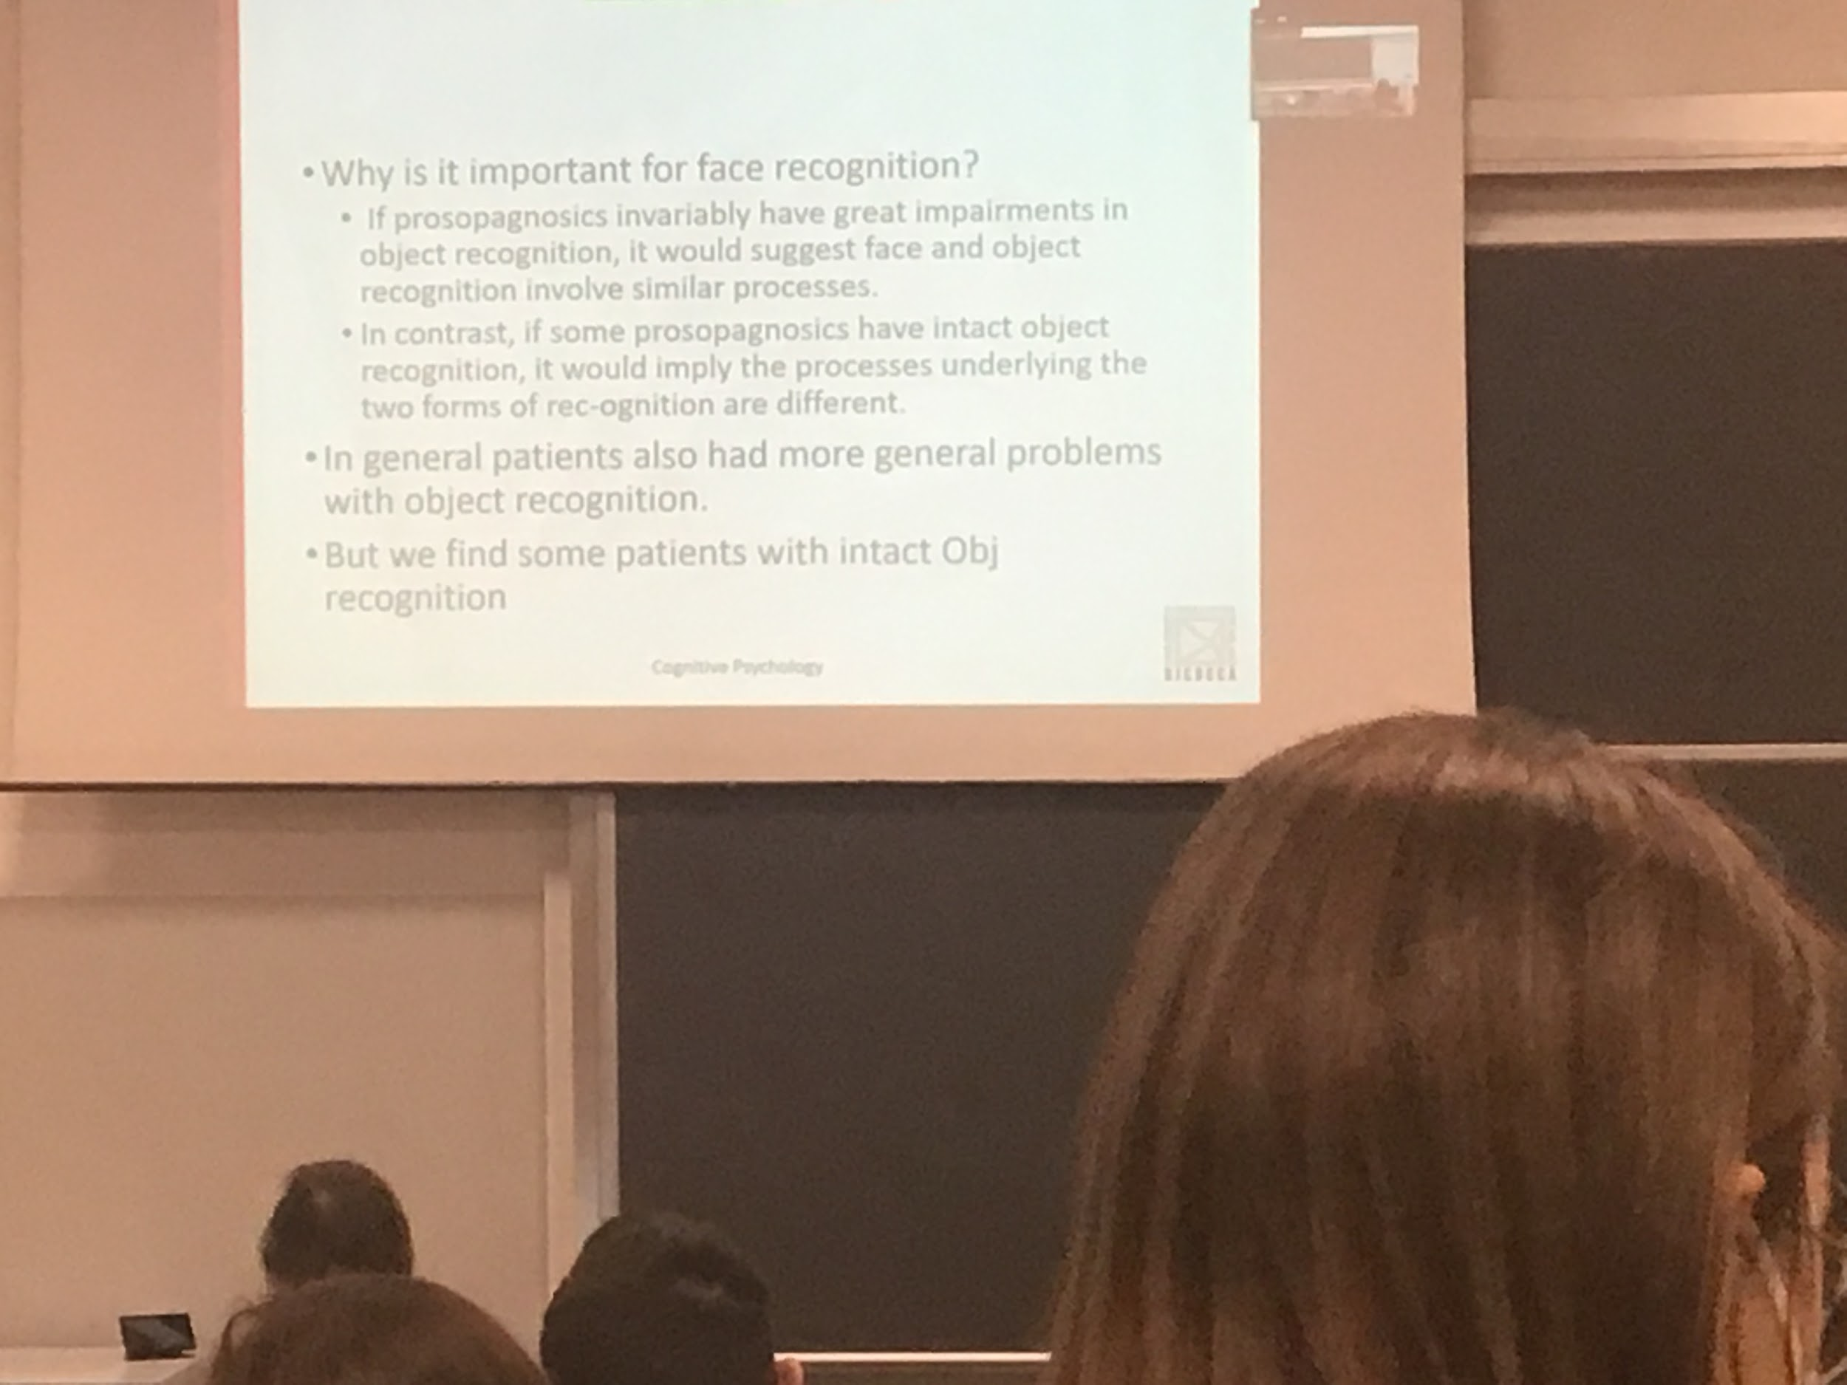

Study people with prosopagnosia: this can help us if face recognition is dedicated task in the brain or if is simply different form of object recognition

We find some patients that have no object recognition deficit at all but only face recognition deficit. Show some kind of specialisation in object recognition

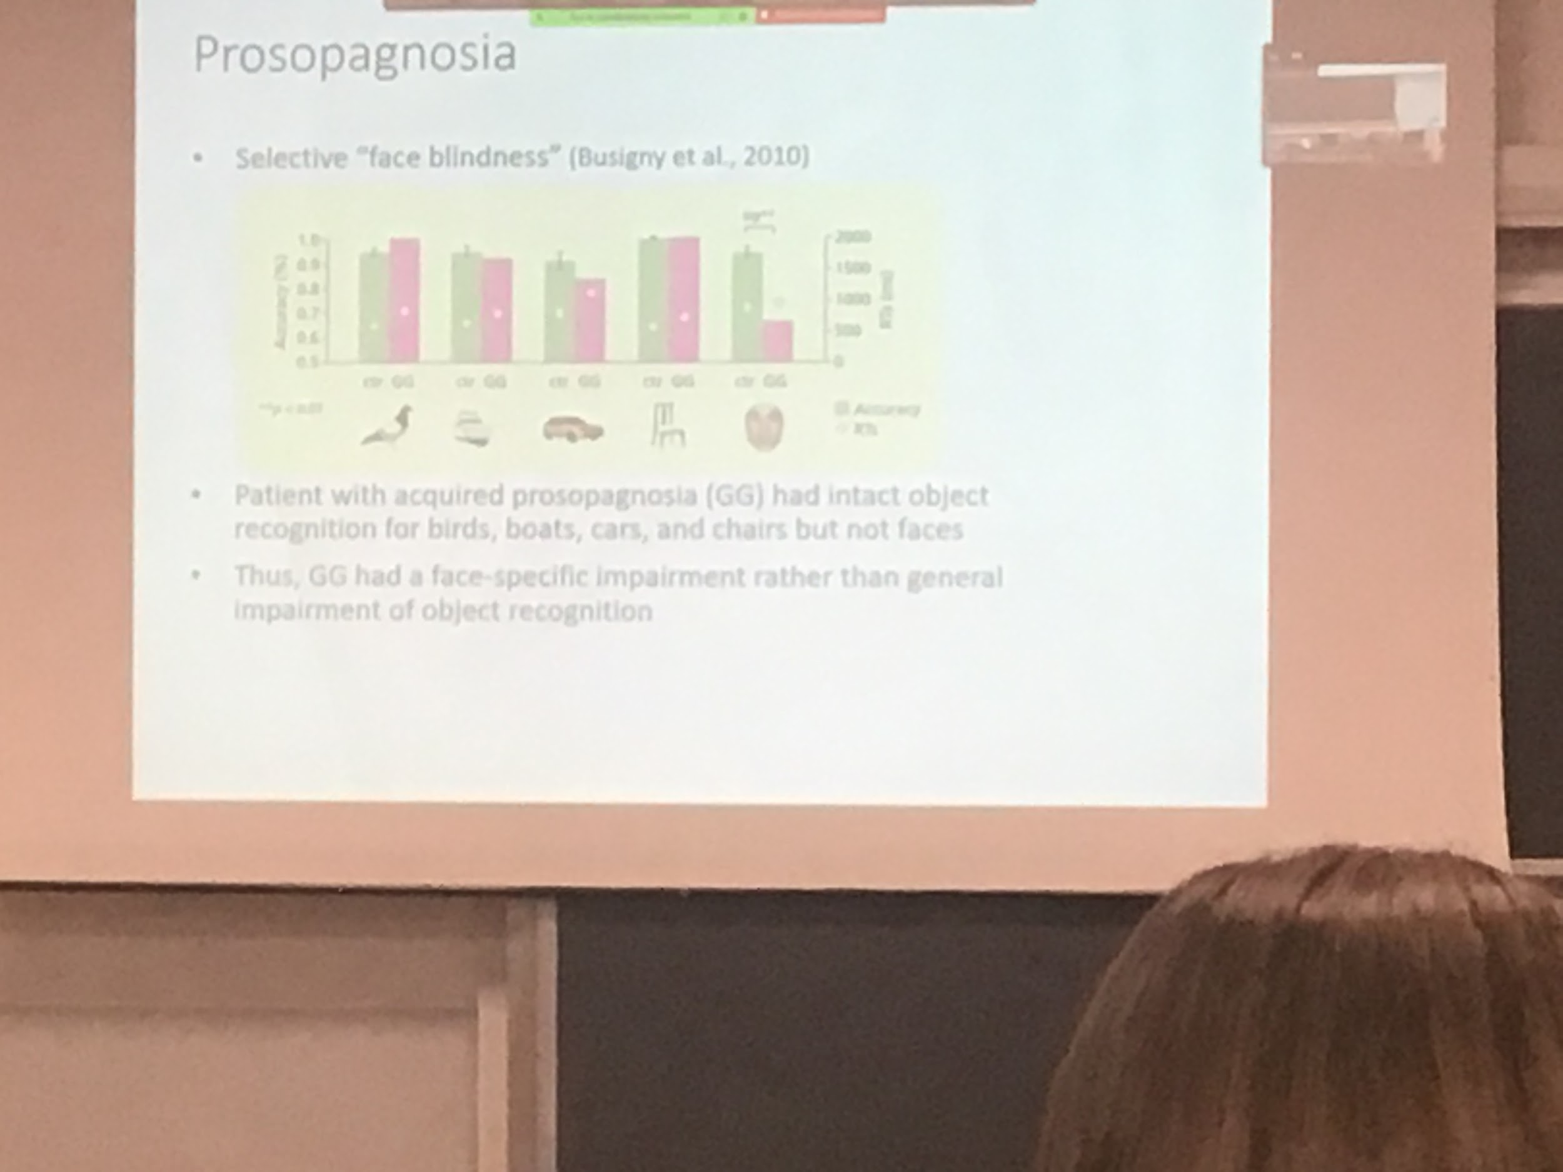

patient GG, bars are accuracity. Green bar is control, pink is GG

Only case is on faces this patient has a deficit only in face recognition. Prove that face recognition is special in the brain

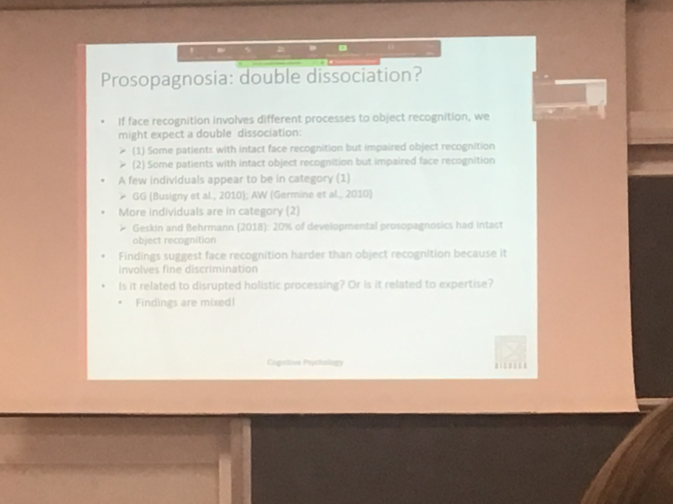

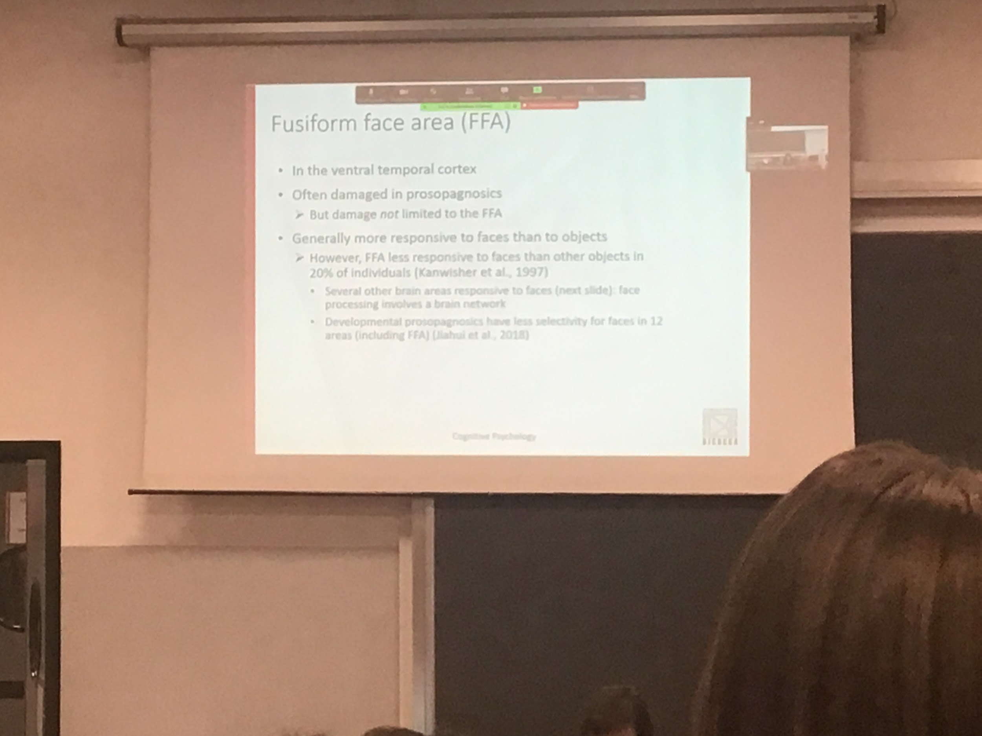

There are brain areas in the inferotemporal cortex that are important for face recognition

FFA often damaged in prosopagnosic

Generally more response to faces than to object, in 20% of individual the Fusiform Face Area (FFA) does not respond much to faces

Recuperare immagine

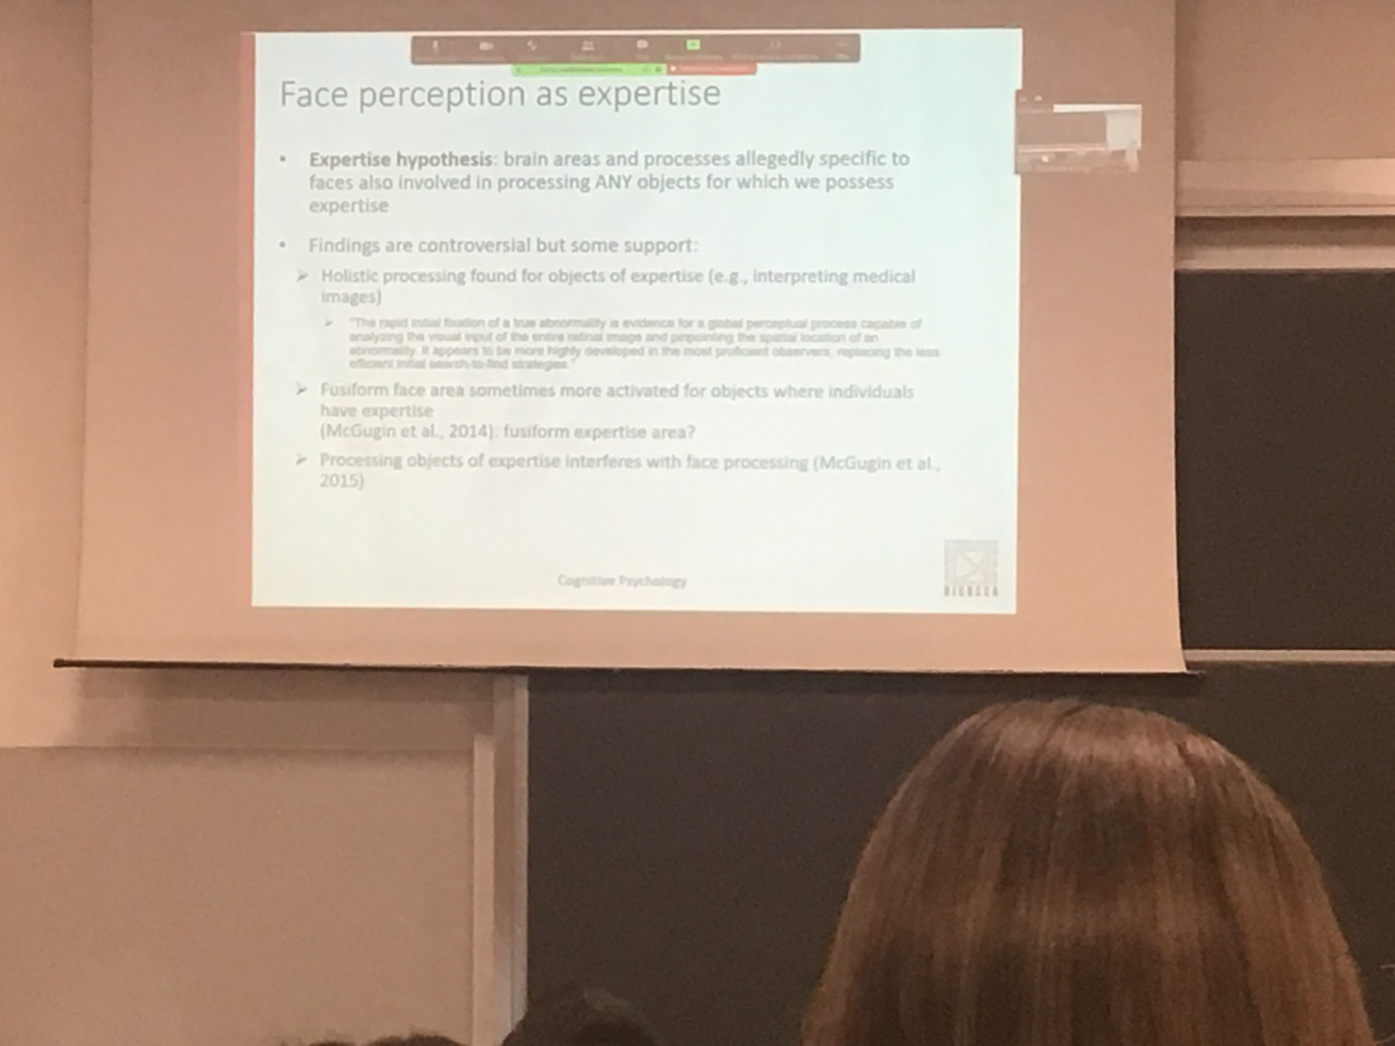

There seems to be an influence in expertise in face perception

Pictures of newborns we are not good to recognise them, if you are a nurse you are good

If I show you people of others ethnicity not very good to recognises their faces unless you have grown up in an environment where people of different ethnicity are

Hypothesis that we are face expert

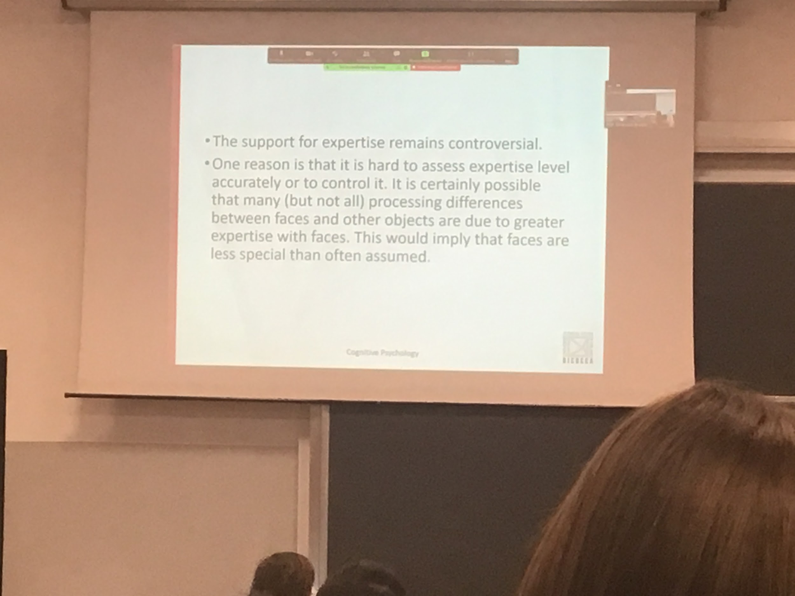

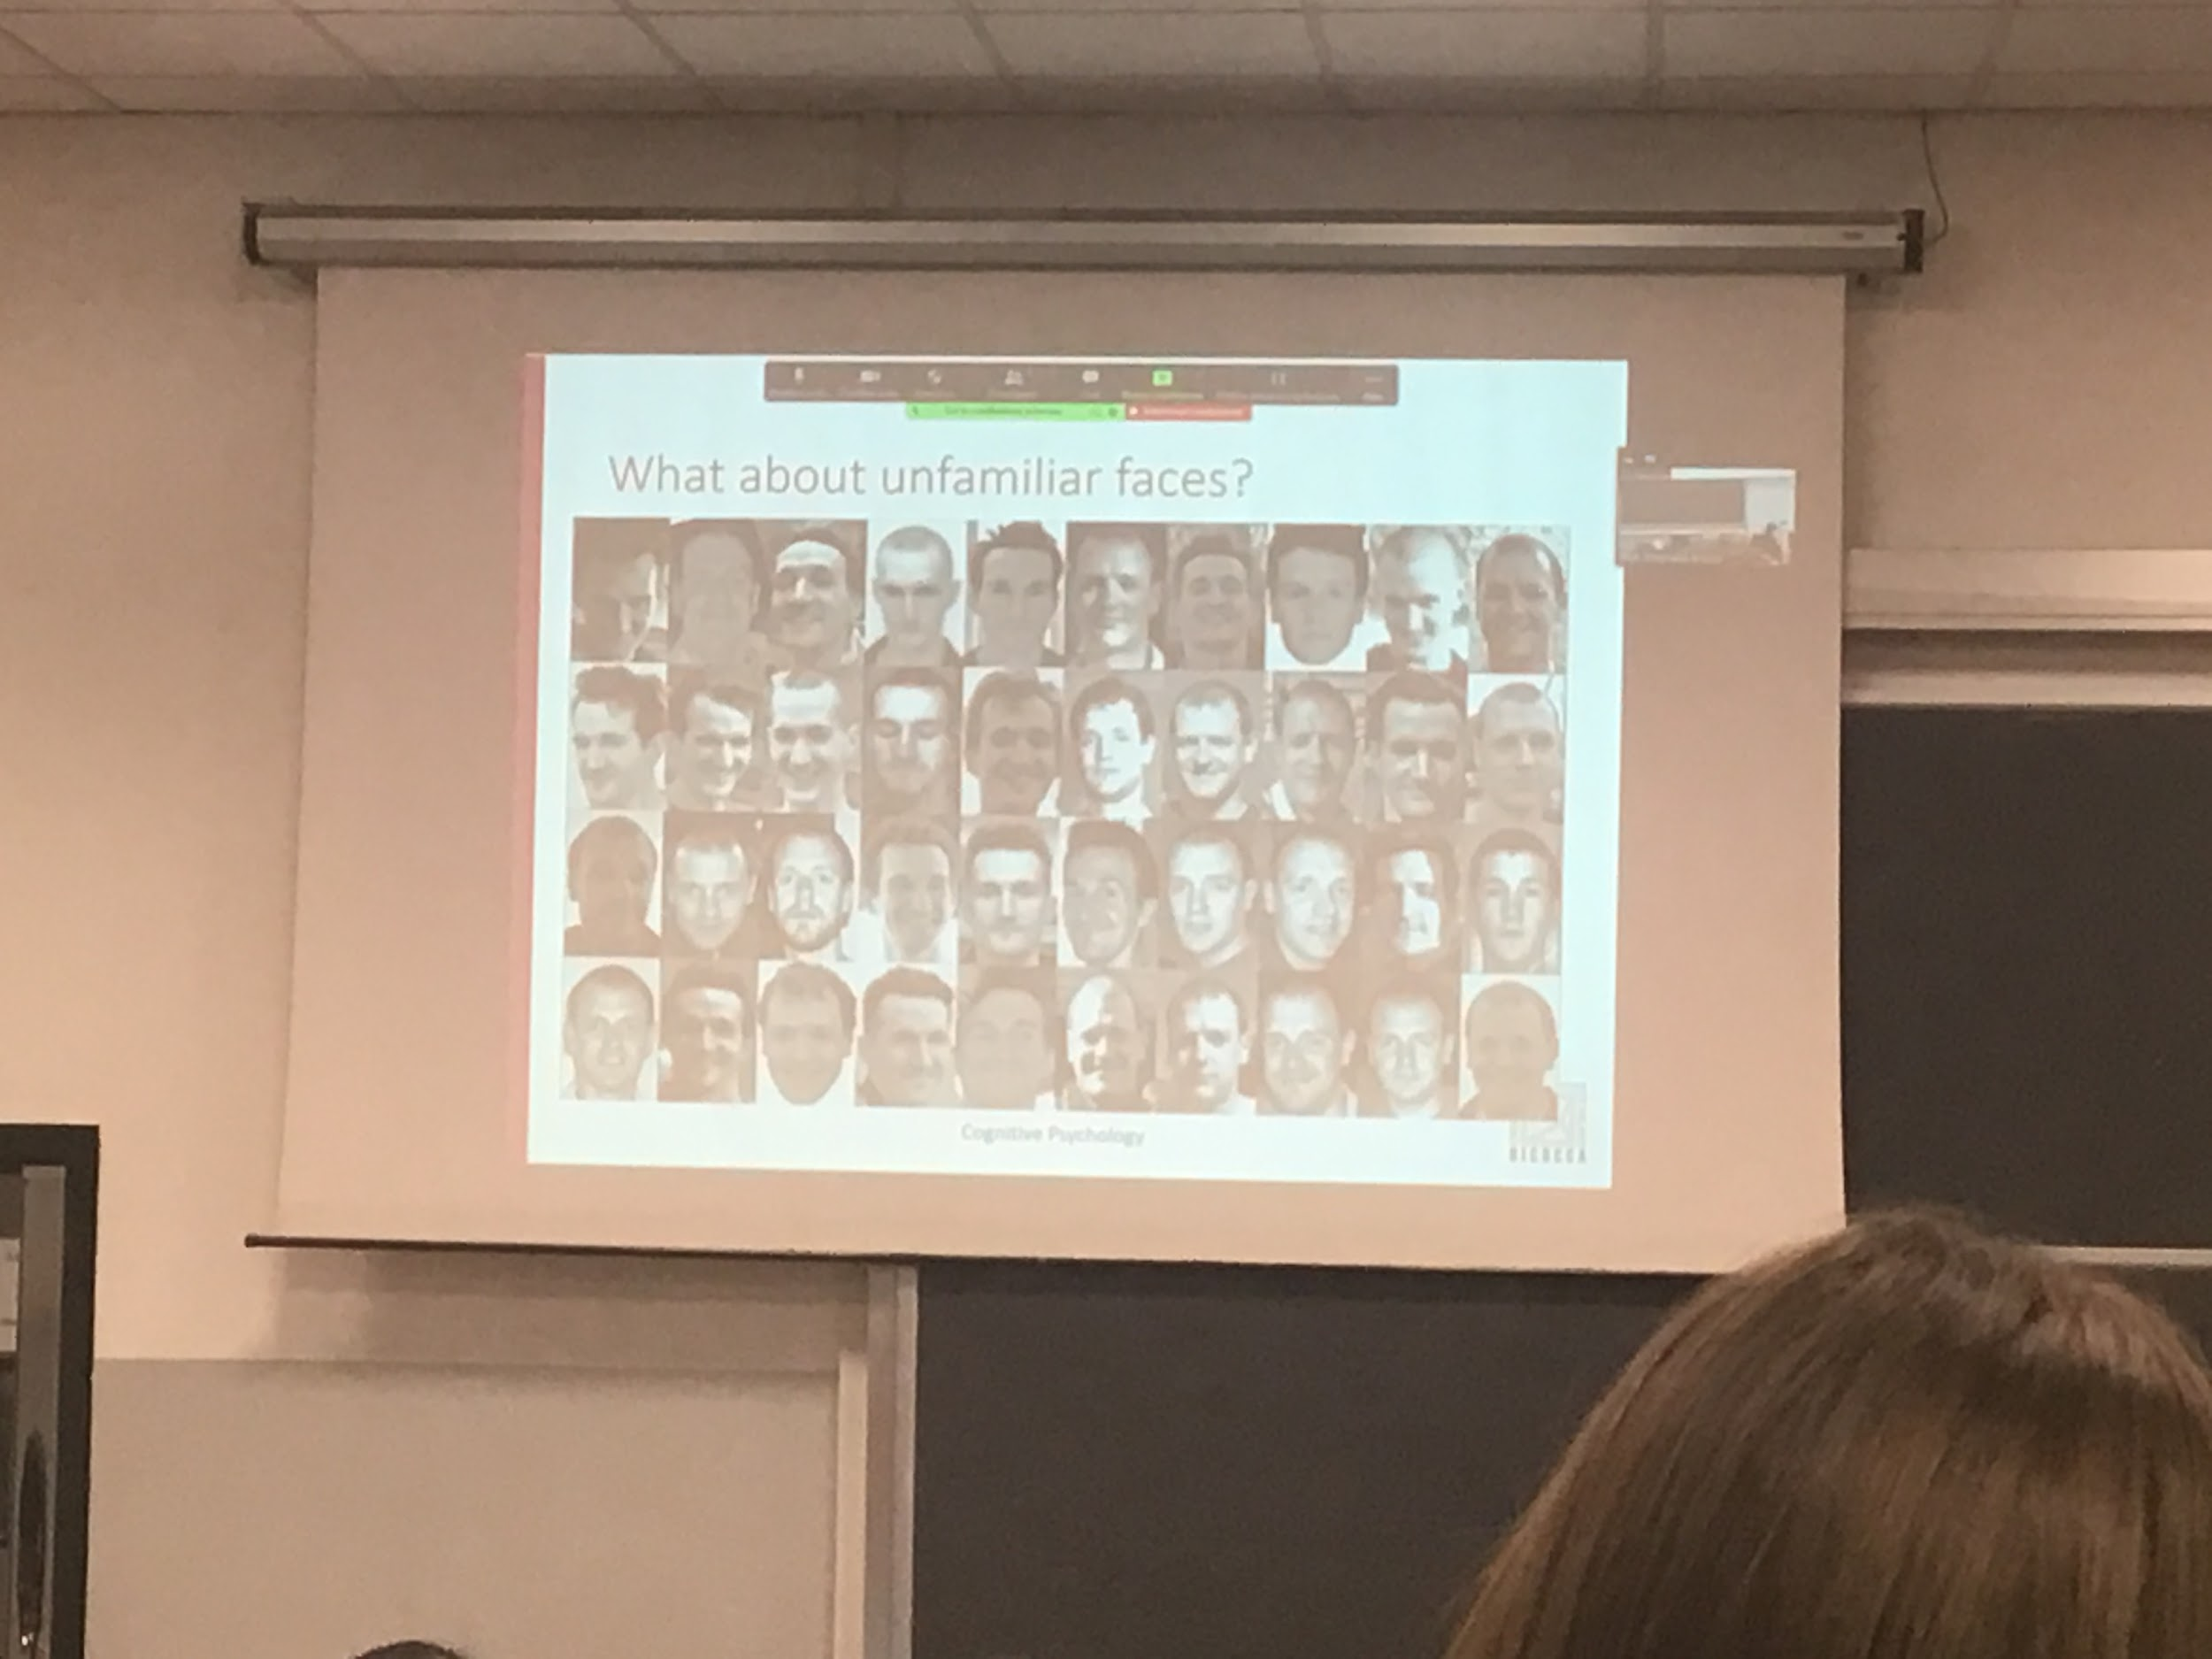

Good to recognise familiar faces, how about unfamiliar faces?

40 pictures. How many different people there are?

Even if we are very good in face recognition we are good with unfamiliar faces

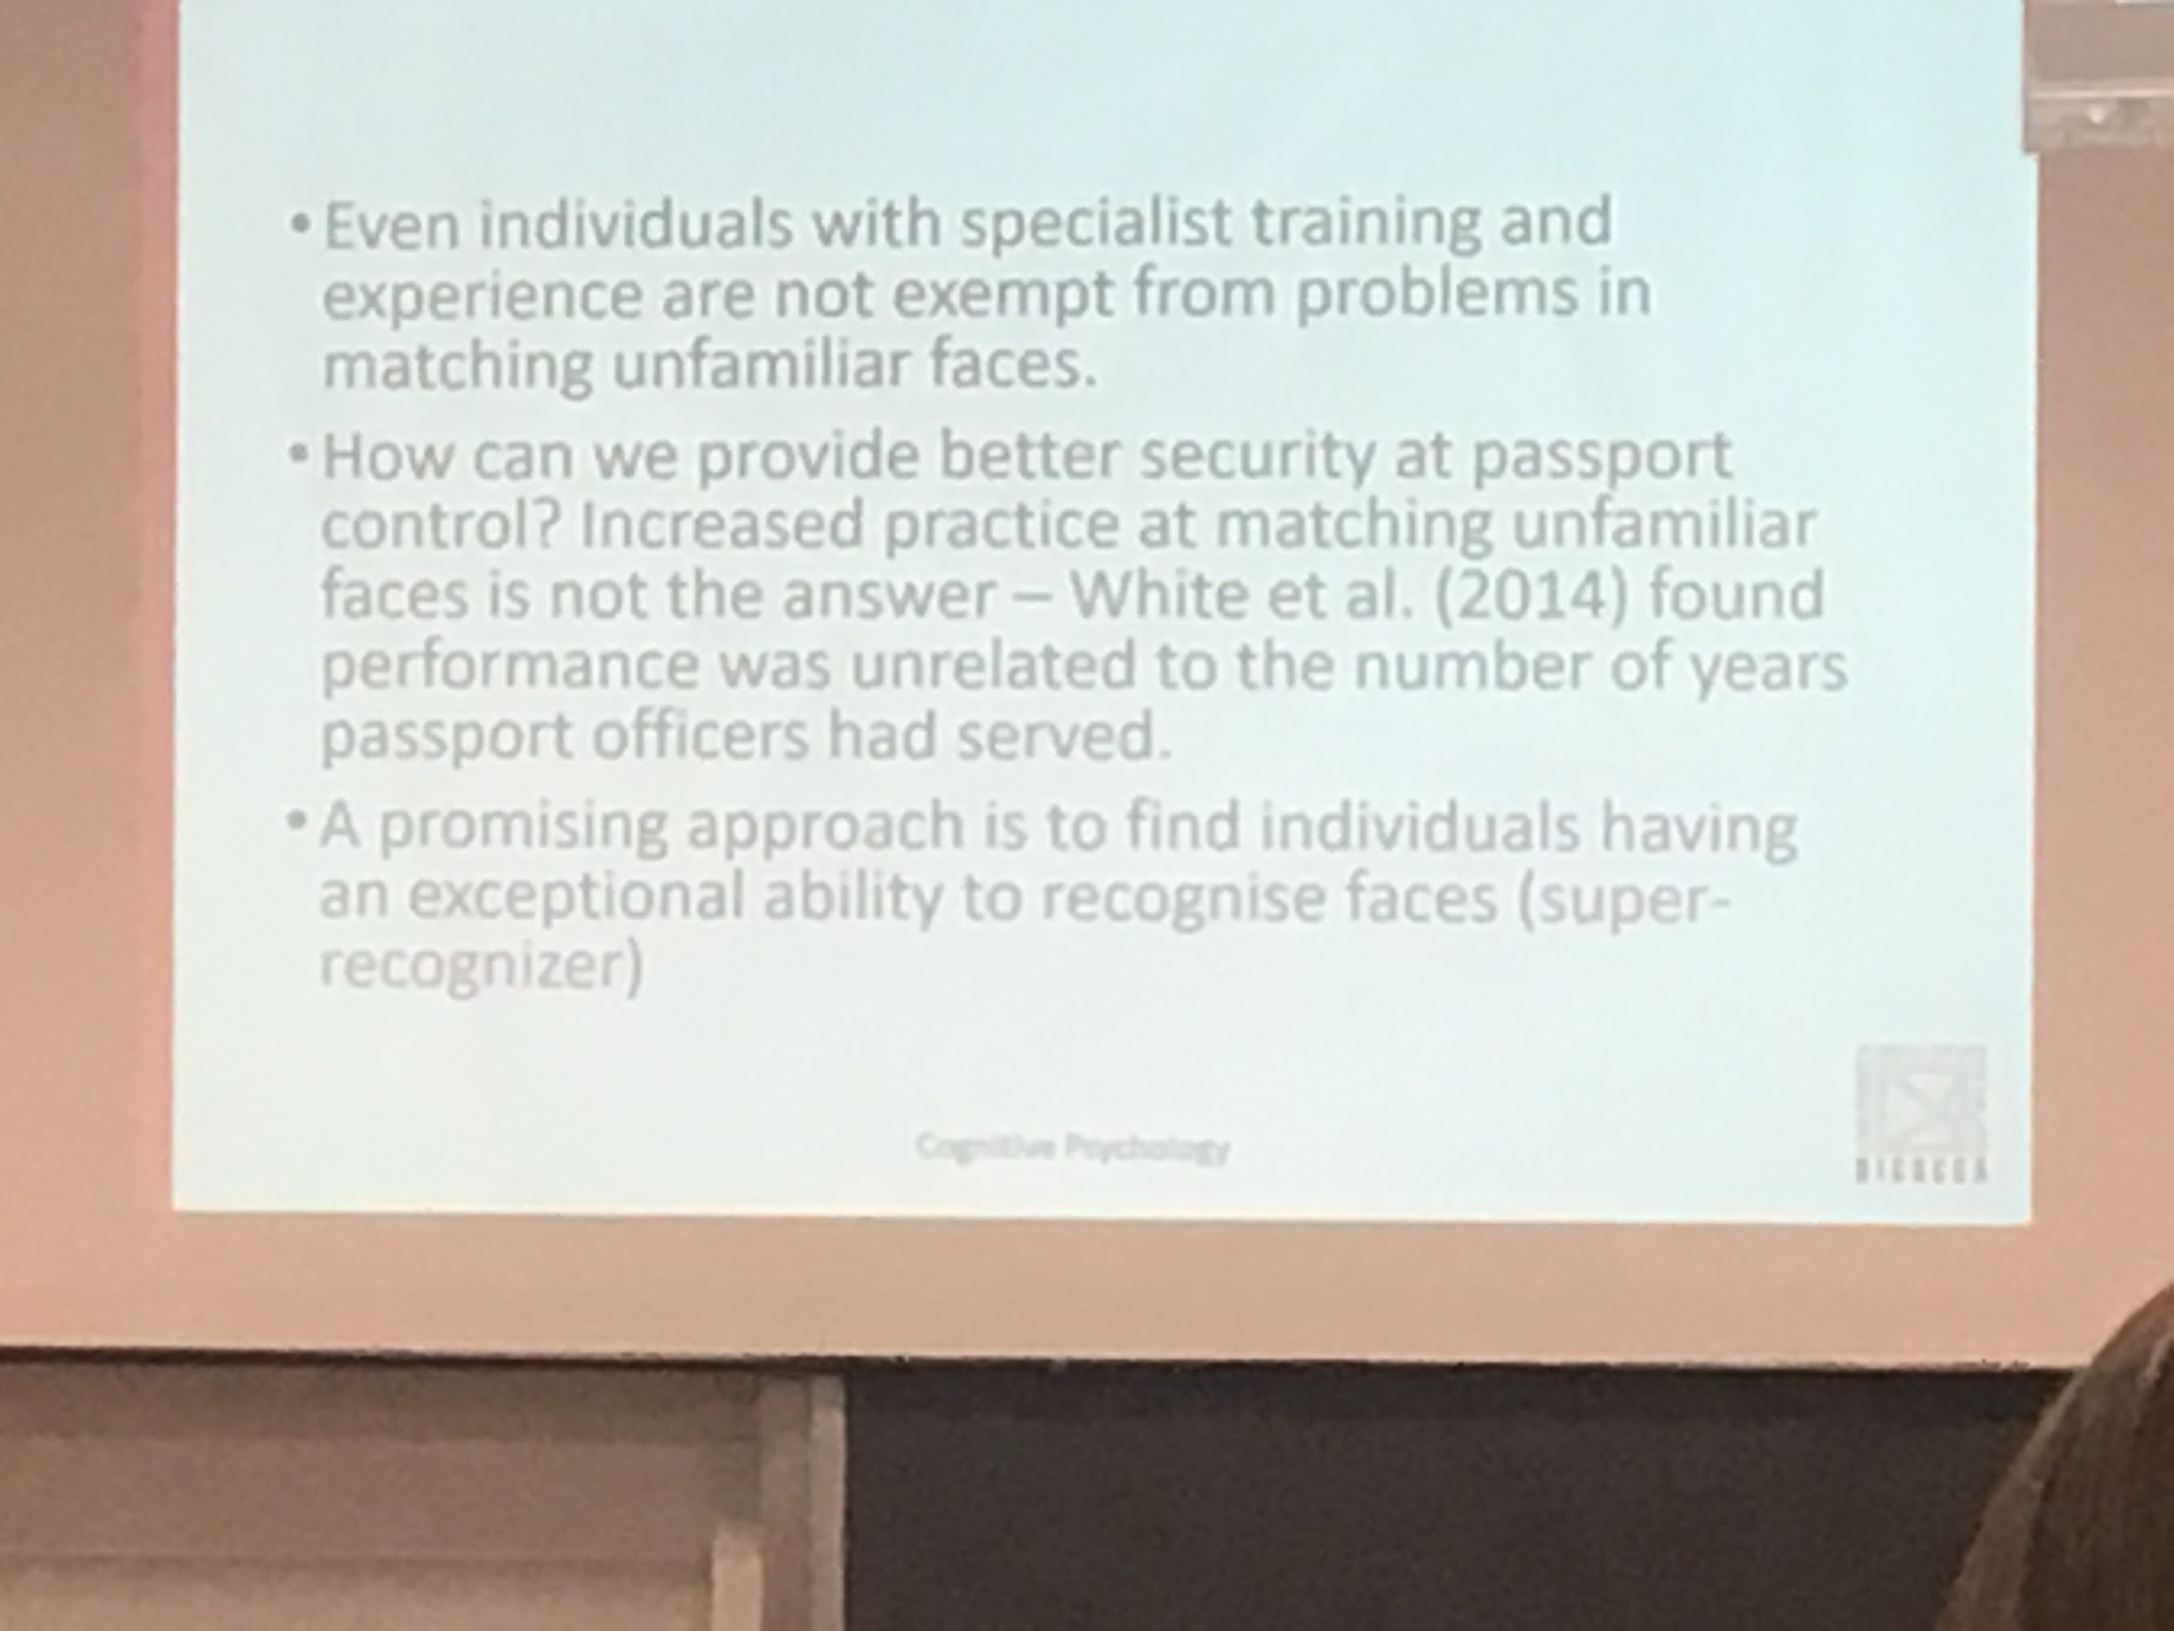

Not good with unfamiliar faces, difficult to associated faces pictures, not good with this type of match

We can not improve after a certain point the ability to match

There are super recogniser people (don’t know why): much much better than the average person to recognise faces

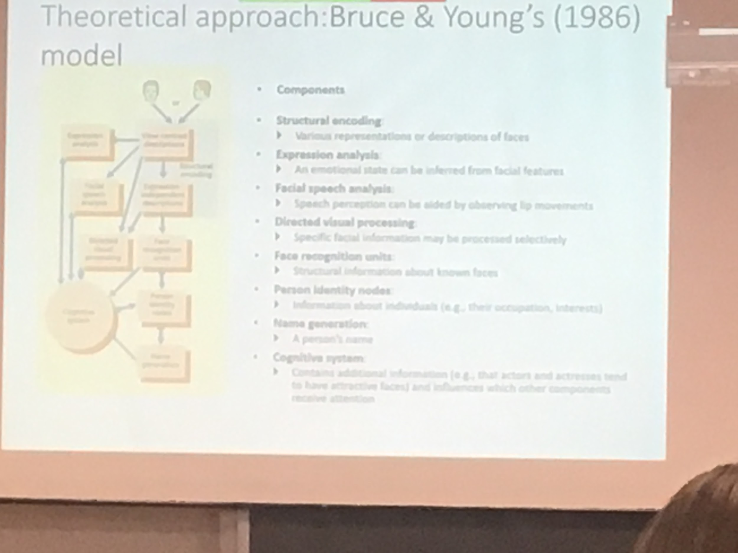

The most famous is Bruce & young’s model of 1986

Still a very important and testable proposal

From presentation of a face they proposed that two different description faces are done in *structural encoding*

* Viewer centre description
* Expression depended desperion

Different analysis that are done, one analysed the expression, one the facial speech, one directly process the visual structure and

face recognition units: compute structural informations of faces that I know, compare their representation of what is in our memory, then we can access the personal identity notes and then you arrive at the end to the generation of the person name

Cognitive system interacts with all different types of units

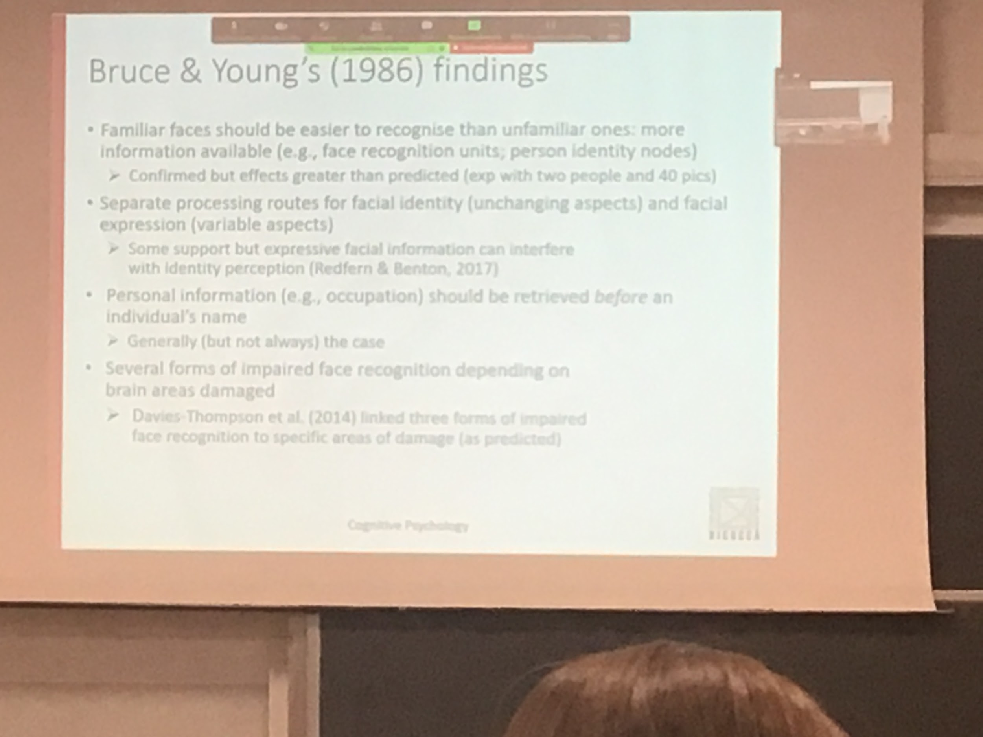

Familiar faces should be easier to be recognised, because we have the face recognition unit and the identity notes

If the representation can access these informations is much easier to recognise the face

The difference between familiar and unfamiliar is much larger

Personal information should be extracted before the name, we know the face is familiar but we don’t know the name, I have **familiarity before identity**

Face recognition is done in different modules

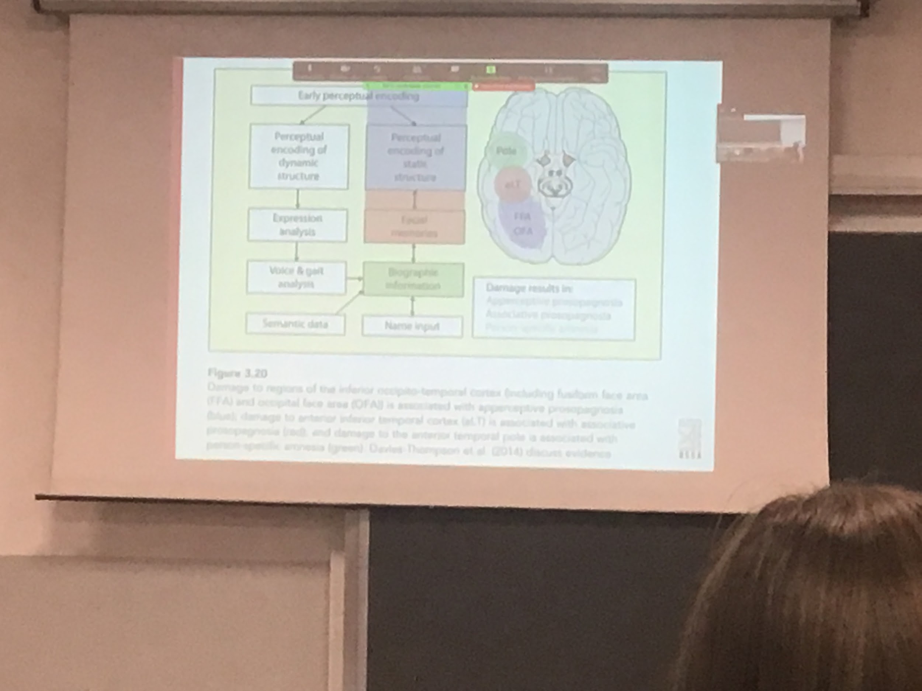

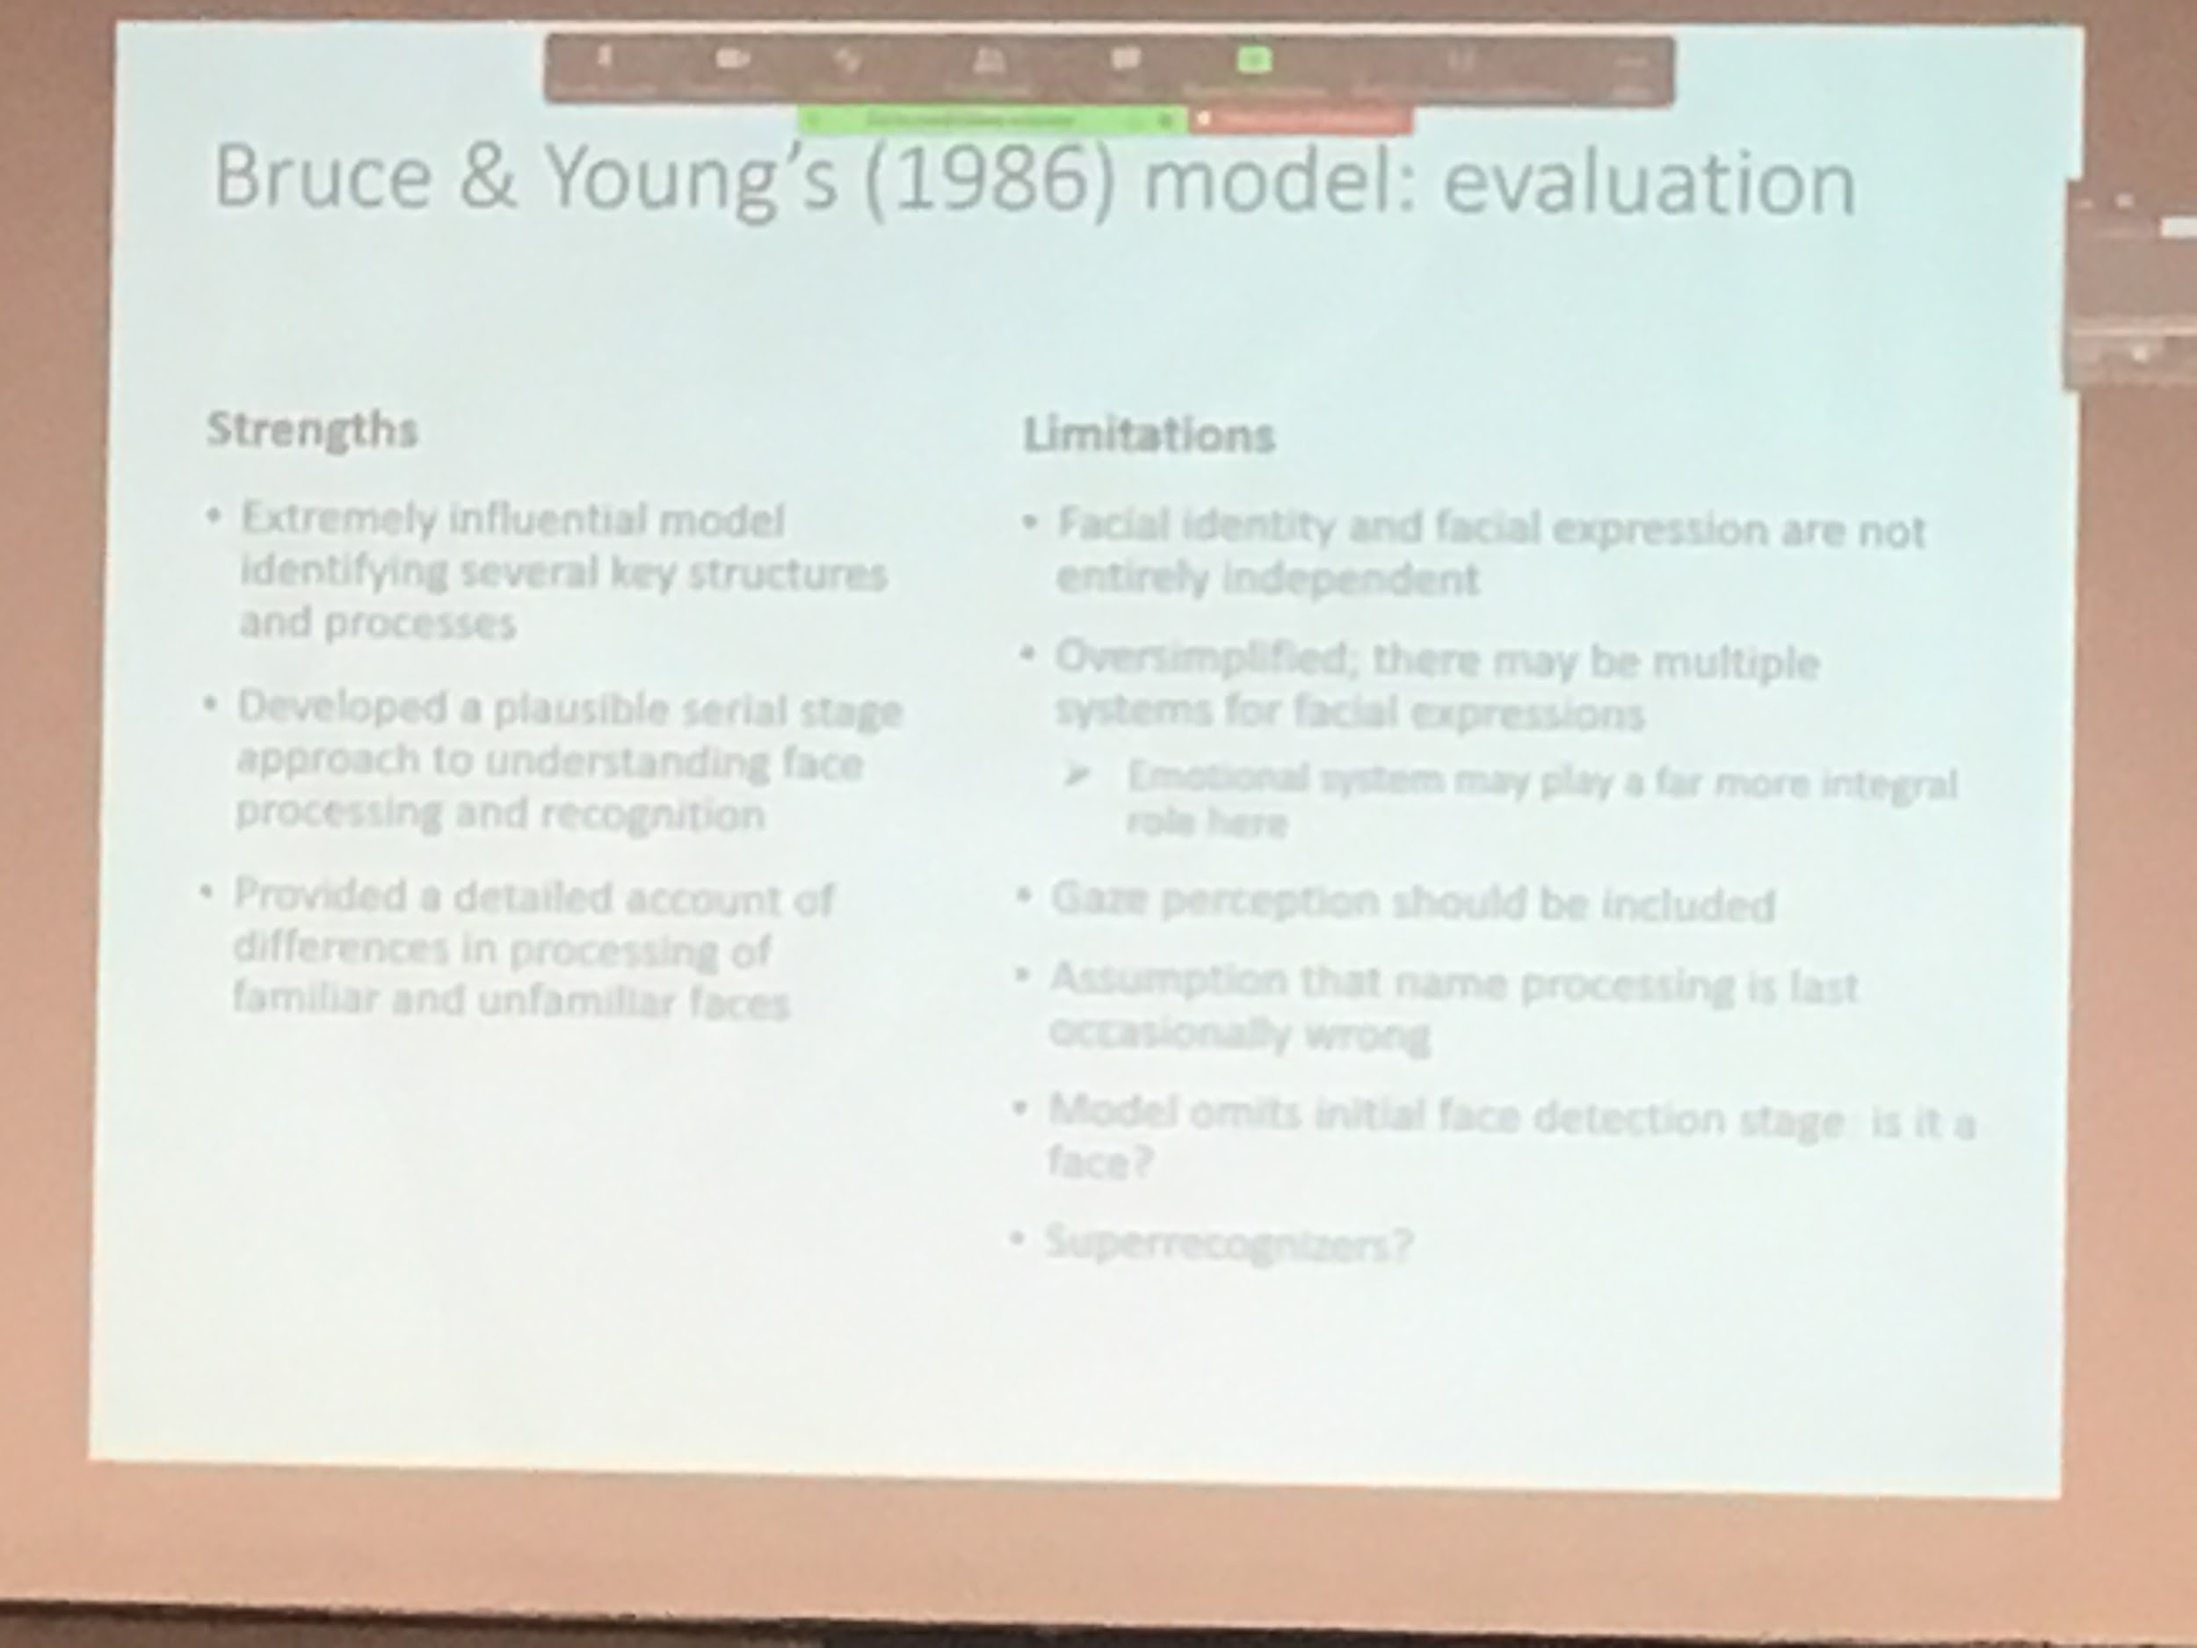

There is no information about gase perception

I am constantly coding gase perception

**Object and face recognition**

**Visual imagery**

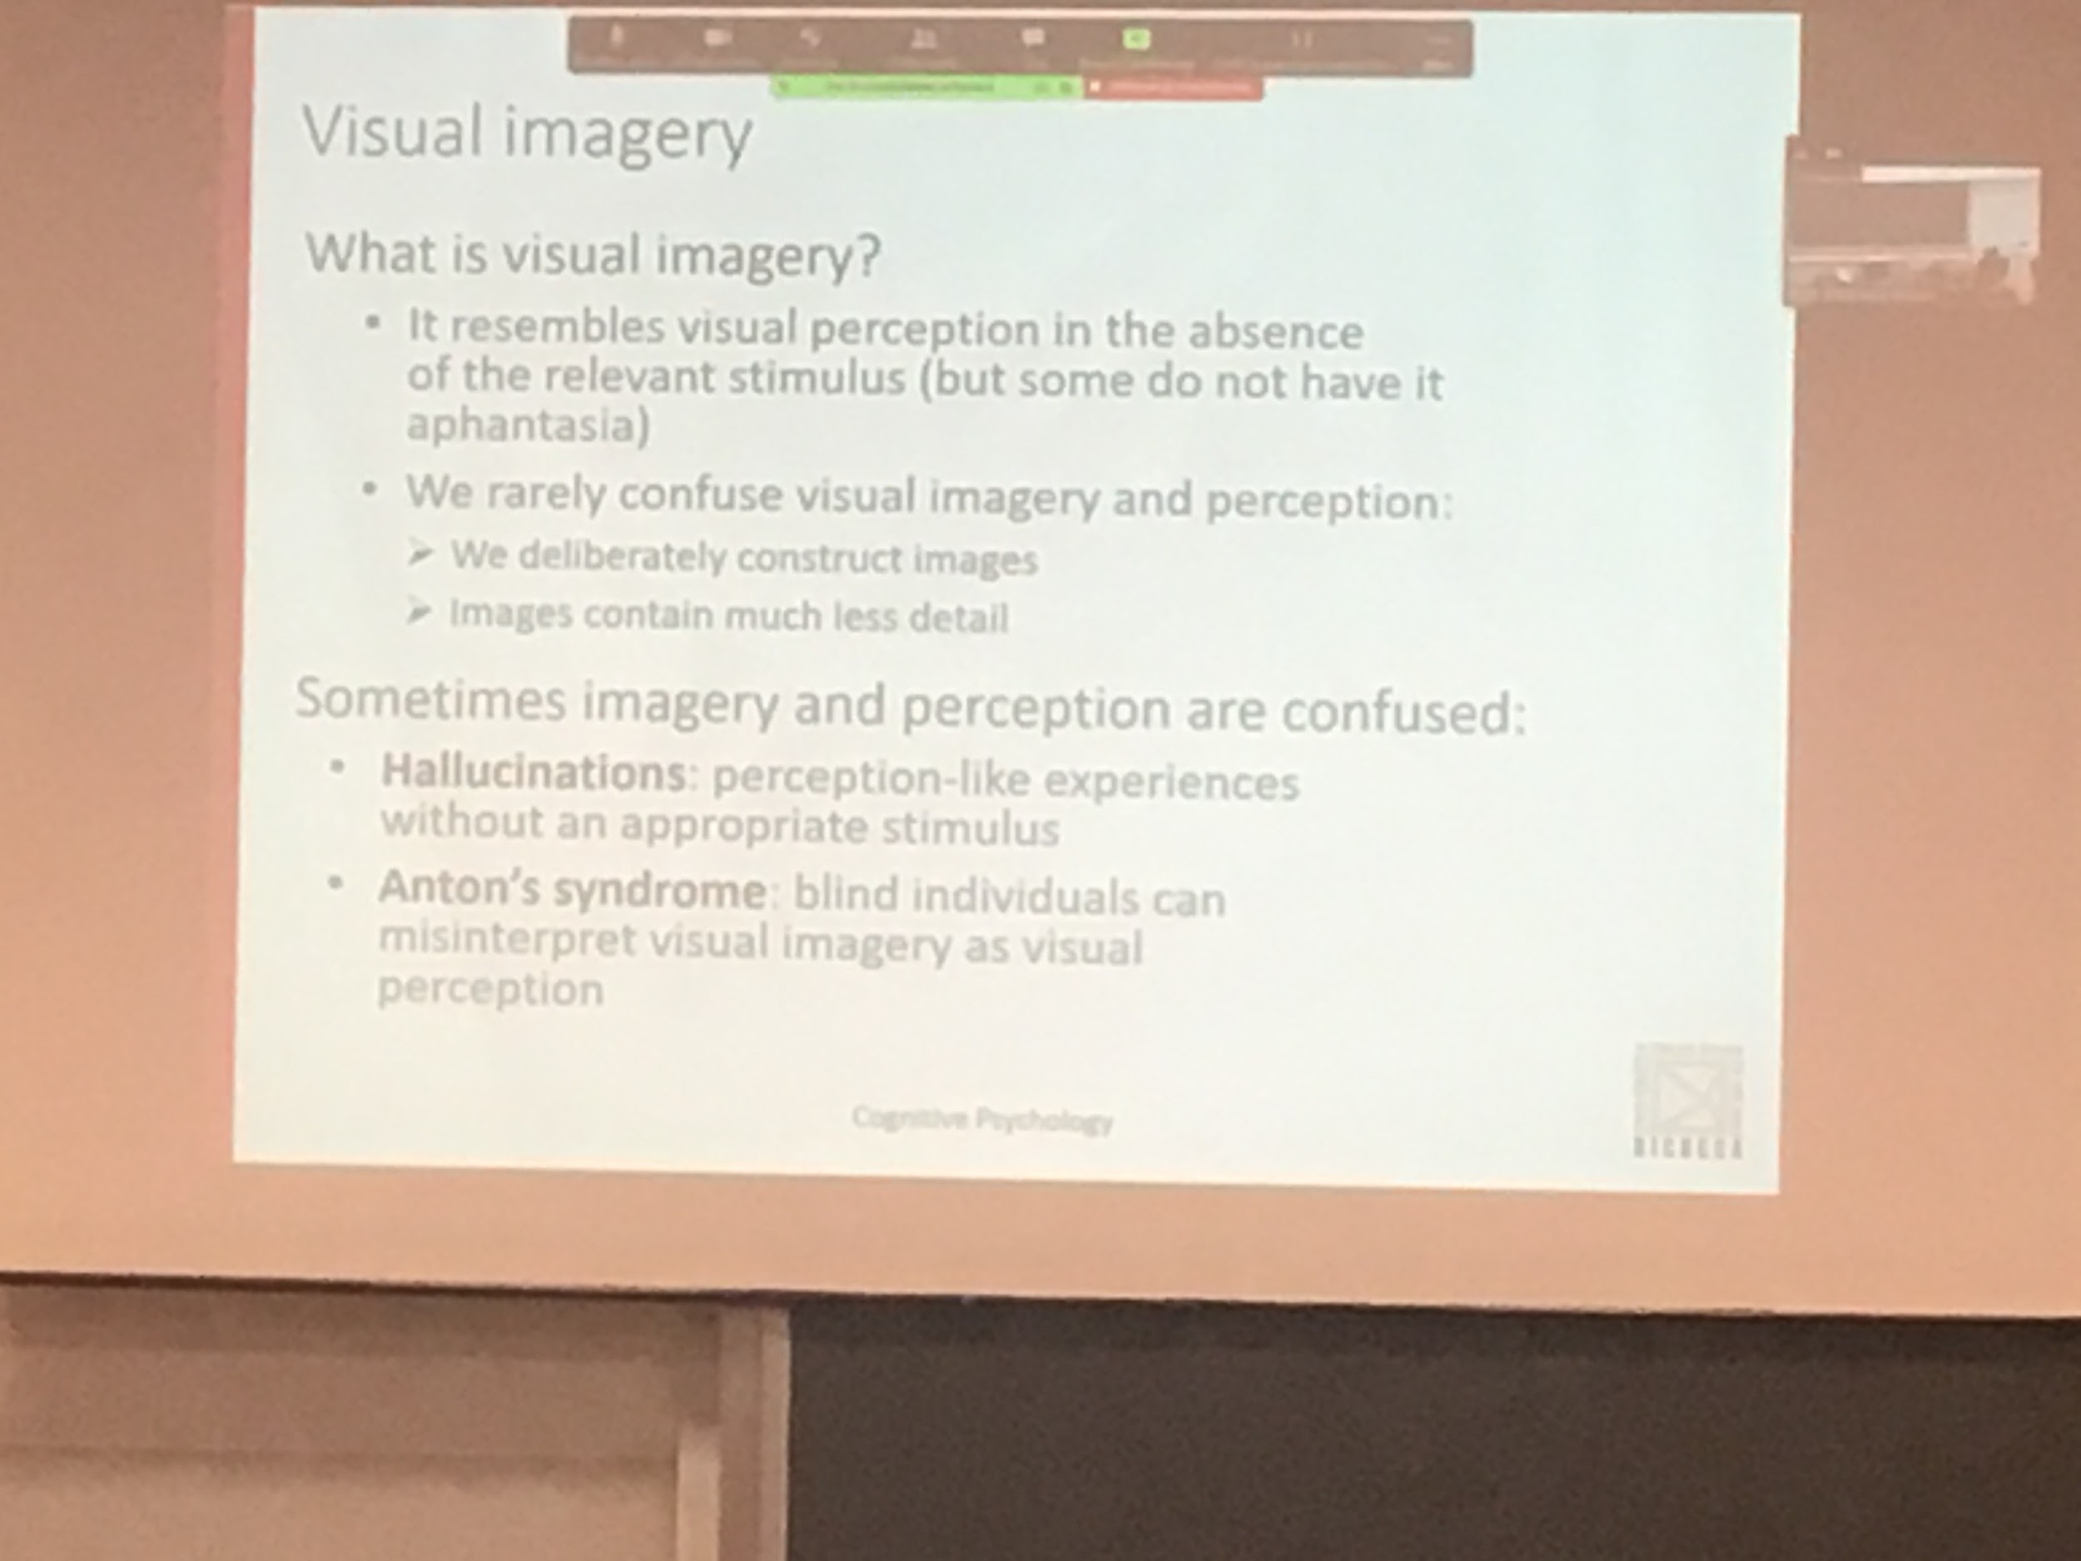

Our ability to imagine some kind of scene without any stimulus

Imagine your room, root to your house, taking into the memory a visual representation

Imagery: there is nothing really in front of us, we construct imagery, usually is much less detail than visual perception

We can image and create some absurd creation

We don’t have to confuse imagery with perception, an allocation is not imagery

* **Allucinnation**: we think we saw something that is not there but we think is real, we see the elephant sitting on the chair
* **Imagery**: conscious that your room is not there, representation of a naturalistic normal thing

People with some kind of deficit make some kind of error, they think that they see but actually their have misperception of seeing objects in front of them

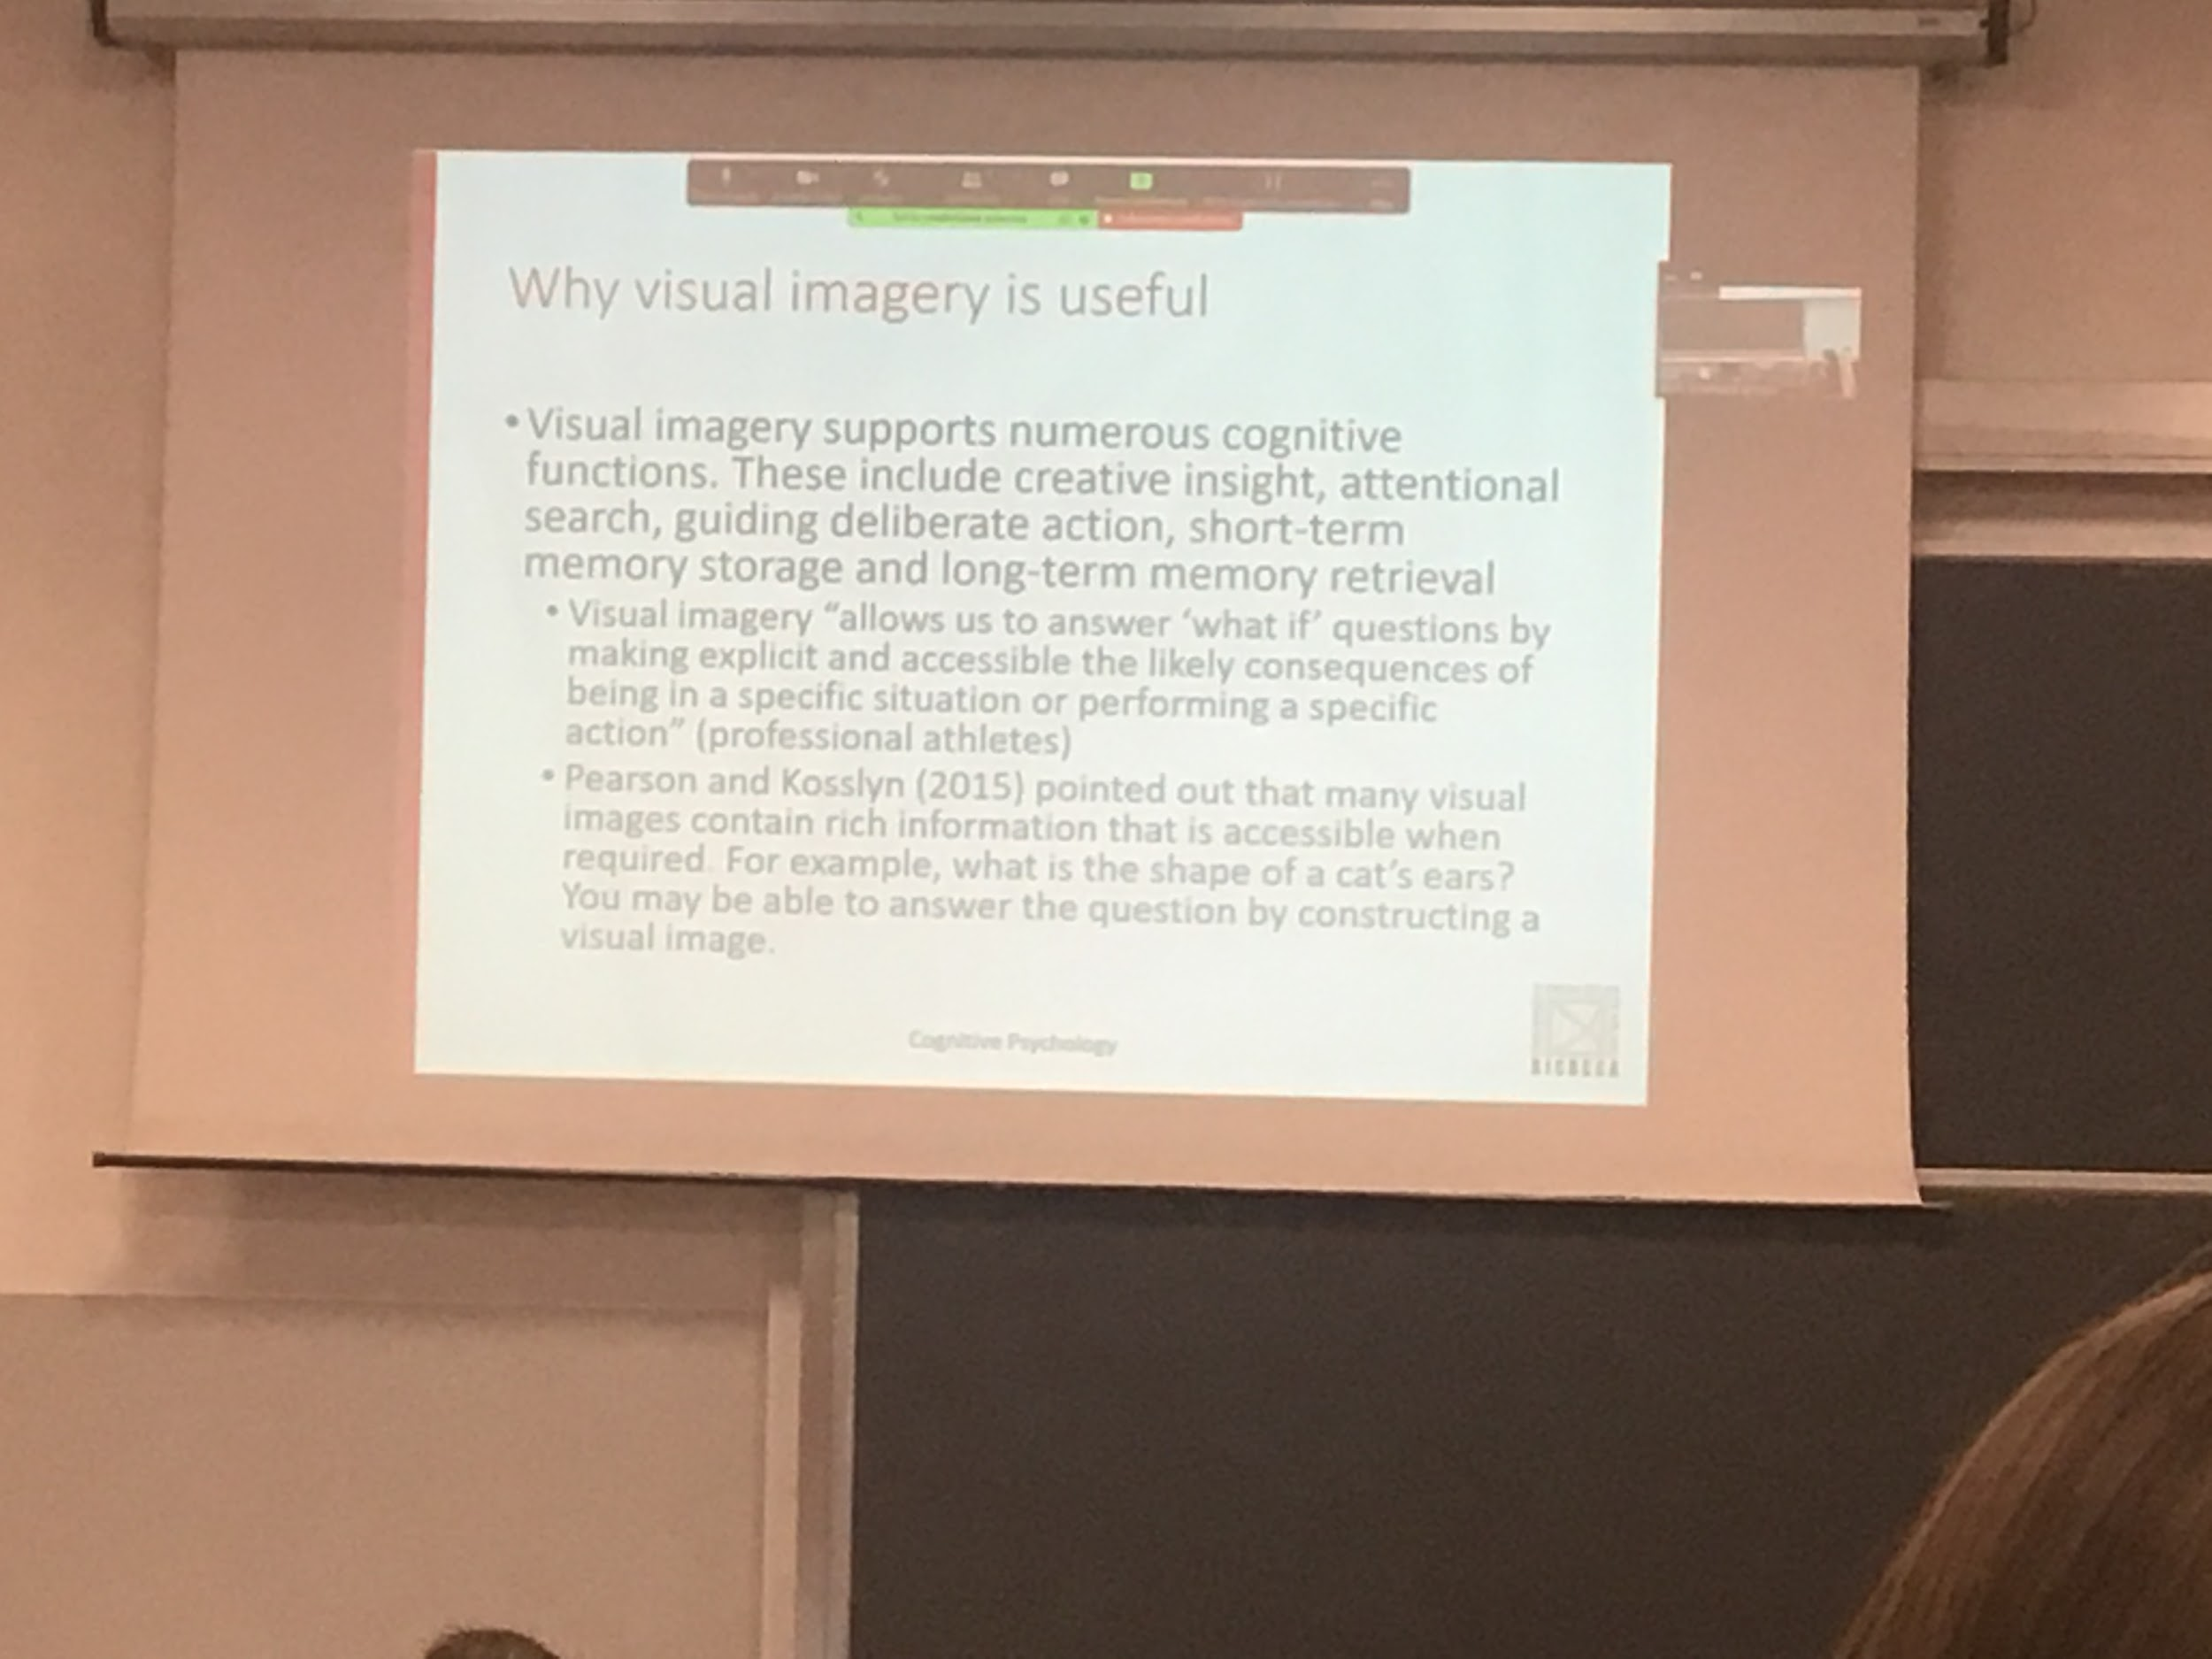

Visual imagery help us do a lot of things

We image solutions, try to think about different solutions

Can I use it to try to predict what is going to happen in different situations, allowing me to answer *if I do x what will happen?*

Doing mental practices, imagine what is going to happen when you do a specific movement improve your performance when you actually do that moment

Like doing practice without actually moving

For some people the visual representation is stronger than other aspects

Remember a specific part of a paper where something was written

